Appropriate Rainwater Harvesting Storage Capacity for Households: A Case Study of Central Gonja District

Issaka Z¹., E. Mensah², W. A. Agyare¹ and E. Ofori¹

1. Department of Agricultural Engineering, College of Engineering
2. Kwame Nkrumah University of Science and Technology, Kumasi, Ghana.
ebenmensah@gmail.com

Abstract Rainwater harvesting capacity is determined primarily by mean annual rainfall and roof catchment area. Household water consumption is influenced by activities of individuals in the household. Tradition and culture may also influence water usage pattern. However, some of these factors vary significantly from one community to the other. There is therefore variation in storage capacity of household tanks. The study looked at the appropriate storage capacity for households in the Central Gonja District in the Northern Region, Ghana. Data was collected on daily household water consumption through a survey using questionnaire in Buipe, Yapei and Mpaha areas of the Central Gonja District. The dry-season water demand vis-a-vis rainwater supply approach was used to determine the capacity of storage tanks required to meet dry season demand. The results showed that the roof sizes of the houses were adequate to supply households with rainwater during the critical period of five months (dry spell).
[Issaka Z, E. Mensah, W. A. Agyare and E. Ofori. Appropriate Rainwater Harvesting Storage Capacity for Households: A Case Study of Central Gonja District. World Rural Observ 2012;4(4):57-63]. ISSN: 1944-6543 (Print); ISSN: 1944-6551 (Online). http://www.sciencepub.net/rural. 8

Keywords: Domestic Rainwater Harvesting (DRH), household, water supply and demand, Central Gonja District.

1.0 Introduction
Water scarcity situation is severe in developing countries, with about 1.2 billion people in 20 “water-scarce” developing countries without access to “safe water” (World Health Organisation, 1997). According to World Resources Institute (WRI, 2000) more than one billion people in developing countries do not have access to clean water whilst two billion lack adequate sanitation. Africa is noted to be the poorest of the World continents in terms of annual fresh water renewal. The United Nations Environmental Programme (UNEP) estimates showed that 250 million people in Africa will be at risk of water stress with less than 1700 m³ of water available per person per year by 2020 and up to 500 million by 2050 (Falkenmark et al., 1989). Sub-Saharan Africa is making the slowest progress in meeting the Millennium Development Goals (MDGs) target, and one-third of the population still need safe drinking water (United Nations Joint Monitoring Programme, 2008). In Ghana, 22 % of the population and over 30 % of the rural population lack access to safe drinking water (Allison, 2007). Ghanaians still suffer from water shortages, 50 % of the population uses unimproved sources of drinking water. In rural areas people depend on rivers, streams, hand dug-wells and rainwater for their water needs. Most of these water sources are polluted and serve as the main sources of water-borne and water-related diseases (Gyau-Boakye and Dapaah-Siakwan, 1999). About 70 % of diseases in Ghana are linked to insufficient rural water supply and sanitation coverage (International Fact-Finding Mission, 2002). The water supply situation in the Central Gonja District is grim and water scarcity is regarded as one of the root causes of water related diseases and poverty in the area. Residents of the district rely on boreholes, unprotected streams, dams, rivers, dug-outs and impounded reservoirs for their domestic water needs. Some of these water sources serve as drinking places for animals as well, and the health risks posed by this situation are endless and far reaching.
A storage system is the main and most expensive component of a domestic rainwater harvesting system. It usually make up to about 90 % of the total cost. Storage unit helps to collect and conserve excess rainwater (Cresti, 2007). According to Rees (2000) the different types of storage facilities based on size can be grouped into three: (1) Small tank being any container of up to seven days storage or up to 1,000 litres, (2) Medium tank being any tank up to several weeks of storage or between 1,000 and 20,000 litres and (3) Large tank takes up to several months of storage or above 20,000 litres of capacity. Examples of small size storage containers used in developing countries include plastic bowls or buckets, clay or ceramic pots and old oil drums (Cresti, 2007). These storage vessels can supply household water demand for few days depending on family size.
Studies have shown that one of the most growing domestic water resources is rainwater and the major harvesting source is the roof-top (Engmann, 1993). In line with this, the Ghana Science Association (GSA) has advocated for a building code, which makes it mandatory for all designs of buildings to incorporate rainwater harvesting systems. Rainwater harvesting is the capture, diversion, and storage of rainwater for a variety of purposes (Appiah, 2008). The storage facilities commonly used in the Central Gonja district is the blue plastic and metal barrels with storage capacity ranging from 250 to 400 litres. Also, most people in the district collect rainwater with buckets, clay pots, basins and ‘Garawa’ with capacity of 2 to 40 litres. These storage facilities are small and are not able to store enough water for period of their demand. A properly sized storage facility could meet household water demand during the critical period of drought. However, the size of a storage tank required to meet household water demand is dictated by rainwater supply, household water demand, and length of dry spell, the roof catchment area, and budget (Texas Water Development Board-TWDB, 2005). A storage tank with capacity 16,000 litres can complement other available water sources for a household size of six (6) members for a period of 10 to 12 months (Brett and Thomas, 2003). Further, a properly maintained storage facility is capable of providing safe water for domestic purposes.
Domestic rainwater harvesting is growing in the Central Gonja district, and the use of rainwater has changed from its function as mere water augmentation to ultimate water source for domestic activities due to lack of safe alternative water sources. The increasing interest in rainwater harvesting has necessitated a study to determine appropriate size of storage tanks that will meet household water demand in the Central Gonja district.

2.0 Materials and Methods
2.1 Study Area
2.2 Location and Size
The Central Gonja District lies between longitude 1º 5’ and 2º 58’ West and latitude 8º 32’ and 10º 2’ North. The Central Gonja District is a newly created District which was carved out of the West Gonja District in 2004. It shares boundaries in the north with Tamale Metropolis, Kintampo North district of Brong-Ahafo Region in the south, East Gonja district in the East and West Gonja district in the West. The district covers a total land area of 8,353 Km² about 12 % of the total landmass of the Northern Region (Dickson and Benneh, 2004). The three major towns Buipe, Mpaha and Yapei areas were chosen based on the high population and large number of buildings with corrugated iron roofing sheets which presents the potential for rainwater harvesting. Figure 1.0 shows the location map of Central Gonja District and the Study towns.

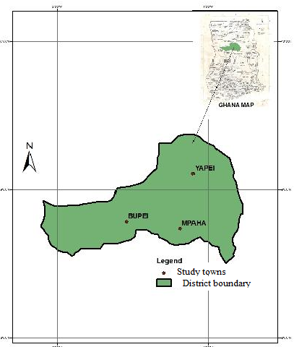
Fig. 1.0: Location map of Central Gonja District showing study towns

2.2 Demography and Household Characteristics
The district has 86,345 people and annual growth rate of 3.1 % projected according to the 2000 population and housing census. Sixty percent (60 %) of the super structures of housing are constructed with mud bricks and over 20 % of these buildings are roofed with corrugated iron sheets, whilst the rest are roofed with thatch (Dickson and Benneh, 2004). The main occupation engaged by the inhabitants of the district is Agriculture.

2.3 Climate and Water Resources
The mean annual rainfall in the district is 1200 mm. The rainy season starts from March or April to October. The daily temperature is between 18 - 42 °C (Dickson and Benneh, 2004)
The main sources of water in the district are boreholes, rivers, dams, streams, hand dug-wells, springs and harvested rainwater for domestic water needs. The Black Volta (mean annual flow rate of approximately 219 m³ s⁻¹) flows in the Southwest-Southeast direction, the White Volta also flows in the North-South direction with a mean annual flow rate of approximately 303.3 m³ s⁻¹ and merges with the Black Volta in the extreme south east to form the main Volta (Dickson and Benneh, 2004).

2.4 Topography and Geology
The land form of the Central Gonja District is low lying but gently undulating at altitudes ranging between 150 m to 300 m above sea level (Dickson and Benneh, 2004).
The geology of the district is underlain by consolidated sedimentary formations, which due to the degree of consolidation and compaction behave essentially as basement complex rocks. The rock formation is principally Voltaian (92 %) and a little Dixcove granite (8 %) in the extreme west (Dickson and Benneh, 2004).

2.2 Methodology
Measurements of roof catchment areas of selected houses using measuring tape were done. Household interviews using questionnaire were also used to collect information on water demand and consumption patterns. Ten years (1999 - 2009) rainfall data from the Tamale Meteorological Department was collected and analyzed. The number of dry days (dd) was determined and the average annual rainfall (R) was computed as follows;

R$=\sum_{i}^{\text{10}}{P}$, mm/year [2.1]

Where, P is the Total annual rainfall data for 10 years.
A survey was carried out to look at storage facilities and practices that were carried out at Buipe, Yapei and Mpaha areas to assess the existing rainwater harvesting and water storage practices and facilities. A total of sixty (60) households were sampled and members interviewed using questionnaire. Houses which practised domestic rainwater harvesting were selected and their roof catchment areas measured using a measuring tape. Information was also solicited from households on socio-economic, water collection and storage practices and daily water consumption using simple random sampling.

The annual volume of rainwater harvested (S) was determined for each roof area size using the formula below;

$S=R×K×A_{v}$, m [2.2]

Where;
R: Mean annual rainfall (m)
K: Run-off coefficient for roof
A_{V}: Average roof catchment area (m²)

Information on household daily domestic water consumption (Q) in Buipe, Yapei and Mpaha was also collected. Women, children and other main stakeholders were interviewed. The average quantity of water consumed (Q_{v}) by households in each community was computed and the per capita water consumption was also determined for each of the three communities, using equation 2.3 below:
$C=\frac{Q_{v}}{n×1\text{day}}$, litres/person/day [2.3]

Where;
Q_{v}: Average household water consumption (litres)
C: Per capita water consumption (litres/person/day)
n: Average household size
The capacity of the storage tank was computed in relation to the roof area size of each category by equation 2.4 below:
Storage capacity=$\text{dd}×n×C$, m³ [2.4]
Where;
dd: number of dry days
n: Average household size
C: Per capita water consumption (litres/person/day)

The Dry-season water demand with respect to rainwater harvesting approach was used to compute the storage capacity. The idea is to store the excess rainwater from the rainy season for future use during the dry season (Gould and Nissen-Peterson., 2006).

4.0 Results and discussions
4.1 Household Socio-Economic Characteristics
The size of household determines the quantity of water consumed in a household. The average household size was 9 persons in the study communities. This excluded members who reside outside the household for more than six months. The relatively high household size is as a result of polygamous marriage practised by the people in these communities.
Eighty-four percent (84 %) of the respondents depended on agriculture as their main source of livelihood whilst 16 % relied on the non-agriculture sector. The average seasonal household income was US $ 401.27. According to the Presbyterian Church of Ghana (Northern Presbytery) Water Project in the district, the present cost of constructing and installing an 30 m³ concrete tank ranges from US $ 1,100 to US$1,250, depending on the availability of materials and labour. The average seasonal household income is sufficient to install smaller storage containers like earthen pots and old plastic or metal barrels. Hence the common storage facilities in the study area are barrels and earthen pots. These storage containers have smaller storage capacity that cannot store enough amount of water to meet household water demand during the dry season.

*(US $ 1.00 = GH¢ 1.57)

4.2 Seasonal Unreliability of the Water Sources
Dugout wells, springs, boreholes and rainwater harvesting were identified as sources of domestic water supply in the study area. These water sources are highly affected by seasonal variation especially in the dry season. In Mpaha, the people rely on rainwater, dam and borehole for their water supply, but the long dry spell leaves them with water shortages. This is because the capacity of their rainwater harvesting tanks is not large enough to store water for the dry season. Demeke (2009) indicated that some boreholes and dugouts dry up in dry season, forcing women and children to travel longer distances in search of water. The inhabitants of Buipe and Yapei also depend on rivers, boreholes and dugouts for their water needs. However, heavy rainfall in the rainy season leaves the surface water bodies flooded and polluted by runoffs.

4.3 Distance and Time Spent on Water Collection
Majority of the respondents (86 %) walked 2 km to and fro each day on average to fetch water in the dry season. The average distance from the community to the dam in Mpaha is 2 km. Such a distance is too long to walk while carrying ‘Garawa’, a 40-litre container head load of water. Respondents in Buipe and Yapei walk 1 km per trip to collect water. All the respondents collected water at an average distance of 0.5 km in the wet season, which may be a recipe for reduction in per capita water consumption in the study communities. The World Health Organisation (WHO) recommends 0.20 km as a convenient distance fetching water (Sharma, 1996). Therefore, the distance covered by the people to fetch water is more than what is recommended by WHO.
Time allocated to water collection differ among households and communities. Generally, households allocate more time walking long distances during the dry season than in the rainy seasons. For a return trip an average distance of 3 km is covered in the dry season to collect water from rivers, which corresponds to an average return trip time of 2 hours. More time is spent collecting water in the dry season than in the wet season. Women in Oyo State, Nigeria spent about one (1) hour daily to collect water at an average distance of 0.50 km (Sangodoyin, 1993).

4.4 Household Water Consumption
The average daily household water consumption was 232, 192, 216 litres in the rainy season for Buipe, Yapei and Mpaha communities respectively. In the dry season, the average daily household water consumption drops to 194, 162, 180 l/day for Buipe, Yapei and Mpaha respectively. The quantities of water consumed per activity showed little variation in all the three communities (Figures 2 and 3). The quantity of water consumed by households in the dry season was lower because of water scarcity during this period, which makes households to adapt to lower water consumption strategies. Also, women and children can only carry small quantities for the long distance. The average per capita consumption of water in the dry season was 21, 18, 20 l/p/day in Buipe, Yapei and Mpaha respectively of a 9-person household. Generally, the water quantities consumed daily exceeded the WHO minimum amount of 20 l/p/day of safe water needed for hygienic and domestic purposes (WHO, 1996). However, Gleick et al. (1997) estimated 50 l/p/day consumption or supply as adequate with 25 l/p/day for drinking and sanitation and 25 l/p/day for bathing and cooking. According to the United Nations Development Programme (UNDP, 2006) report, the per capita water consumption in Ghana is 36 l/p/day. Considering Gleick’s and UNDP estimates, the quantities of water used by households in the study area, regardless of seasonal variation are insufficient for healthy living. The reason for low consumptions levels may be due to inadequate water supply options, resulting in water consumption levels not matching-up with demand (London Economics, 1999). There was little variation in household water consumption between the three communities. The relatively high household water consumption in Buipe and Mpaha may be attributed to the availability of boreholes which are closer to households. However, the boreholes are comparatively far from the households in Yapei due to the type of water bearing formation of the area. The location of water source is a significant determinant of water consumption level (Demeke, 2009). This means that households located nearer to the water source are likely to use water more than others located farther away.

4.5 Harvested Rainwater Storage Capacity
The water demand was compared to the mean water supply to determine whether it is sufficient to meet the dry season mean water demand. In the Central Gonja district, the mean annual harvested rainwater supply is presented in Tables 1and 2 below.

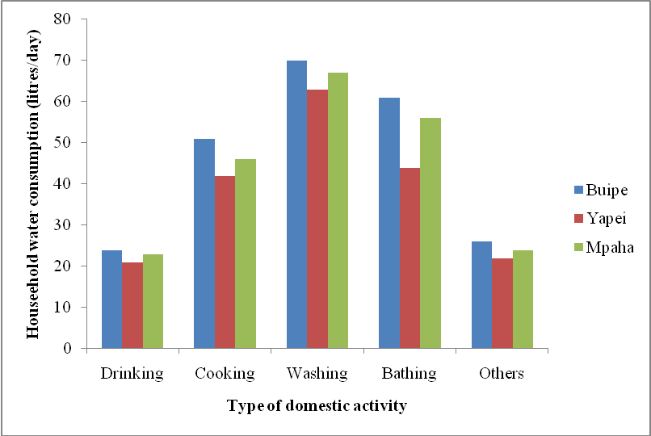
Fig. 2.0: Average daily household water consumption and type of domestic activity for the rainy season
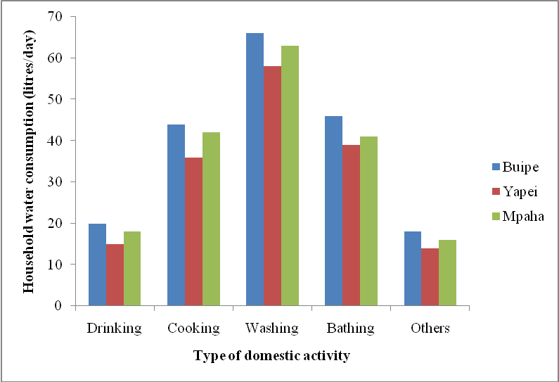
Fig. 3.0: Average daily household water consumption and type of domestic activity for the dry season

Table 1: Annual rainwater supply
Community | Annual Demand (l/year) | Supply (litres)  (36 m²) | Supply (litres)  (72 m²) | Supply (litres)  (108 m²)
Buipe  Yapei  Mpaha | 28,350  24,300  27,000 | 38,880  38,880  38,880 | 77,760  77,760  77,760 | 116,640  116,640  116,640

Table 2: Household water demand for the dry season
Roof area size | R (lites) | K | A (m²) | S (litres/year)
Small roof (36 m²)  Medium roof (72 m²)  Large roof (108 m²) | 1200  1200  1200 | 0.9  0.9  0.9 | 36  72  108 | 38,880  77,760  116,640

Where;
R: Rainfall
K: Run-off coefficient for roof material
A: Roof catchment area
S: Annual rainwater supply

Table 3: Annual water demand and annual water supply
Community | C (l/p/day) | n | Water demand = C × n × N_{o}
Community | C (l/p/day) | n | Monthly (l/month)  (30 days) | Annual (l/year)  (5 months)
Buipe  Yapei  Mpaha | 21  18  20 | 9  9  9 | 5,670  4,860  5,400 | 28,350  24,300  27,000
Where;
N_{o}: Number of month
N: Average household size
C: Per capita water consumption

The roof area for the smaller houses in Buipe, Yapei and Mpaha areas does not harvest the quantity that is enough for sustainable system (Table 3). The annual water demand in all the communities exceeds the annual rainwater supply. However, the annual rainwater harvested from the roof catchment areas of the houses is greater than the annual water demand in all the three communities.
In the Central Gonja district, the longest period of the dry season is from November to March. Adequate water has to be stored for a period of five (5) months. During this period, the minimum water consumption levels in the communities are 21, 18 and 20 l/p/day respectively. The annual water demand for Buipe Yapei and Mpaha are respectively 28,350, 24,300 and 27,000 litres. The storage capacity was sized with 20 % safety factor. From Table 3, a storage capacity of 30,000 litres (30 m³) will be able to store harvested rainwater to meet the annual household water demand in the dry season.

4.6 Water Storage
Thirty-four (34) rainwater storage tanks were surveyed with storage capacities ranging from 500 - 10,000 litres, and constructed with different materials such as concrete, polyethylene, and metal. Twenty-four (24) of the tanks were subsidized by the Ghana Presbyterian Church and 8 were financed by individual households. Plastic and metal barrels (250 litres) were the most common water storage facility constituting 68 % of households whilst concrete and plastic tanks constituted 22 % and 10 % respectively. The period of water supply in households varied from 1 week to 3 months, but the rainwater stored is used within a week and is not able to bridge water shortages in the dry season.

4.7 Cost Implication
The cost of constructing a rainwater harvesting tank varies considerably depending on location, type of materials and degree of labour used. A storage capacity of 30,000 litres (30 m³) will be adequate for most households to harvest and store water for the critical period. In the Central Gonja District the cost of constructing a 30 m³ concrete tank is between US $ 1,100 and US$ 1,250. However, the presence of the Black and White Volta Rivers have enough available sand that could be mined for constructing concrete tanks to reduce cost of production. The cost of constructing a 30 m³ concrete tank in the North-East of Brazil is around US $ 1,000 depending on the materials used (Gould and Nissen-peterson, 2006). The average household income (US $ 401.27) in the Central Gonja District is relatively low for installing a concrete rainwater storage tank of 30 m³ capacity.

4.8 Maintenance
Major problem found with rainwater harvesting system in the study area was found to be leakages from the gutters. Majority (76 %) of the households had leakages in gutters and storage tank whilst 24 % could not find any problem with system.

5. Conclusions
The study showed that rainwater harvesting has the potential of meeting water demand during the dry season in the study area for houses using iron roofing sheets material with roof areas of 36 m² or more, given the climatic and socio-economic characteristics of households in the Central Gonja district. The annual rainwater harvested from small to large houses exceeded the annual domestic water demand by households in the dry season. A storage capacity of 30 m³ for rainwater harvesting by a household in the study area will be able to collect water to meet household demand during the dry period.

References
- Allison, H. (2007). Clean water song hits Ghana. Science direct. 2-7pp.

Appiah (2008). Physicochemical Analysis of RoofRun-off in the Obuasi Area [Master’s thesis]. Kwame Nkrumah University of Science and Technology, Kumasi, Ghana. 31-35pp.
- Brett, M. and Thomas (2003). Better, Faster, Cheaper; Research into roofwater harvesting for water supply in low-income countries. ARCSA conference Austin, USA.
- Cresti, D. (2007). Analysis and design of household water catchment systems for rural Rwanda [Master’s thesis]. Massachusetts Institute of Technology, Cambridge, MA. 41- 52pp.
- Demeken, A. (2009). Determinants of Household Participation in Water Source Management: Achefer, Amhara Region, Ethiopia [Master’s Thesis]. Cornell University, Ithaca, NY. USA. 21-24pp.
- Development Technology Unit (DTU, 2000-2003). Domestic Roof water harvesting technologies, Department of Engineering, University of Warwick, Coventry, UK. [www.eng.warwick.ac.uk/DTU/rwh/components1.html], (accessed 13/10/2010).
- Dickson, K. and Benneh, G. (2004). A New Geography of Ghana, fifth edition. Longmans Group Limited, London.
- Dolphyne, F. A. (1991). The Emancipation of Women- An African Perspective. University Press, Accra, Ghana.

Engmann, E. O. (1993). Rainwater harvesting in Ghana, challenges. 19th WEDC Conference: Water, Sanitation, Environment and Development, Accra, Ghana.

Falkenmark, M., Lundqvist, J. and Widstrand, C. (1989). Macro-scale water scarcity requires micro-scale approaches. Natural Resources Forum 13: 258-267pp.
- Gleick, P., Raskin, P., Kirshen, P., Pontius, G., and Strzepek, K. (1997). Water Futures: assessment of long-range patterns and problems. Background report for the comprehensive assessment of the freshwater resources of the world. Stockholm Environment Institute, Stockholm.
- Gould, J. and Nissen-Petersen, E. (2006). Rainwater Catchment Systems for Domestic Supply. ITDG Publishing (Intermediate Technology Department Group), Warwickshire, UK.

Gyau-Boakye and Dapaah-Siakwan and Dapaah-Siakwan, P. and Dapaah-Siakwan, S. (1999). Groundwater: solution to Ghana’s rural water supply industry? The Ghana Engineer, May 1999. [www.home.att.net/africatecatech~/GhIE/ruralwtr/ruralwtr.htm],(accessed18/10/2010).

IFFM (International Fact-Finding Mission) 2002. Report of the International Fact-Finding Mission on Water Sector Reform in Ghana, August 2002.
- London Economics (1999). Ghana urban water sector-willingness and ability to pay, demand assessment and tariff structure study, Final report, July 1999.
- Rees, D. (2000). Tarpaulin Tank. DTU Technical Release Series, Department of Engineering, University of Warwick, Coventry,UK. [www.eng.warwick.ac.uk/DTU/pubs/tr/rwh/rwhtr05/tr05.htm], (accessed 03/15/2011).

Sangodoyin, A. (1993). Women’s role in rural water supply and development: trends and expectations in Nigeria. The Environmentalist 13 (4), 255-61pp.

Sharma, N. (1996). African water resources: challenges and opportunities for sustainable development. World Bank Technical Paper No. 331, Africa Technical Department Series.

TWDB (Texas Water Development Board) 2005. Water conservation best Management practices guide, 96101pp. [http://www.twdb.state.tx.us/assistance/conservation/Task Fo

WCITFBMPGuide.pdf], (accessed 25/09/2010).

UND P (United Nations Development Programme) 2006. Human Development Report-Average water use per person per day. [www.data360.org], (accessed 30/08/2011).

WHO (World Health Organisation) 1996. “Water and Sanitation”, Fact sheet No. 112. [h ttp://www.who.org/hinf/fs/fact112.html], (accessed 21/04/2011).

WRI (World Resources Institute) 2000. World Resources 2000-2001. People and Ecosystems: The Fraying Web of Life. WRI, Washington, D.C.

WHO (Word Health Organisation) 1997. Guidelines for drinking water quality. 2nd edn. Vol. 1, 173p.

11/10/2012

