Yield performance of Pleurotus pulmonarius (Fries.) quelet, cultivated on different agro-forest wastes in Nigeria

Jonathan SG¹, Nwokolo VM¹, Ekpo EN²

Mycology & Biotechnology unit, ¹Department of Botany & Microbiology, University of Ibadan, Ibadan. Nigeria. ²Pathology Unit, Department of Forest Conservation & Protection. Forest Research Institute, Ibadan. Nigeria
gbolagadejonathan@gmail.com

Abstract: Yield performance of Pleurotus pulmonarius (Fries.) quelet, were monitored on four agro-industrial wastes, (coir fibre, oil palm waste, sawdust of Gmelina arborea and rice straw). The most abundant mineral element in P. pulmonarius was K (30.20mg/100g).This was obtained on rice straw at 10% concentration; while the least mineral element was Cu (0.006mg/100g). The highest values of Ca and Mg obtained were 3.90 and 2.67mg/100g respectively on sawdust and palm wastes. The values of Fe obtained, varies from 0.007 to 0.12mg/g at 10% and 40% of coir fibre. Manganese has values varying from 0.03mg/g for P. pulmonarius at 0% and 0.09mg/g at 40% RBL rice straw. Highest mean stipe length (6.68±0.49) was found in P. pulmonarius produced from rice straw while the least mean stipe length (4.08±2.16) was found on oil palm waste. The highest pileus diameter (7.08cm) was found on rice straw while the mean height obtained from the four substrates, were relatively close with values varying between 6.0 and 9.3cm. Rice straw produced the highest yield with total mean weight of 93.33±3.The implications of these observations are discussed.
[Jonathan SG, Nwokolo VM, Ekpo EN. Yield performance of Pleurotus pulmonarius (Fries.) quelet, cultivated on different agro-forest wastes in Nigeria. World Rural Observ 2013;5(1):22-30]. ISSN: 1944-6543 (Print); ISSN: 1944-6551 (Online). http://www.sciencepub.net/rural. 5

Keywords: P.pulmonarius, fruitbodies, substrates, biological efficiency, food values.

Introduction:
In Nigeria, higher fungi including mushrooms are important constituents of forest produce. These organisms grow on virtually all agro-industrial wastes including most abundant biomolecule of the biosphere, known as cellulose (Chang and Miles, 1999; Gbolagade, 2005). Presently,have been utilized as food in different regions of the world.Besides,they are gaining much attention in pharmaceutical industries, medicines and agro allied companies (Aina et al., 2012a; Jonathan et al, 2012a).
Mushrooms are eukaryotic organisms that have a cell containing the polysaccharide, chitin, along with lipids and proteins Aina et al, 2012b; Jonathan et al, 2013a). Some reproduce sexually while many reproduce asexually in a variety of ways. (Zoberi, 1972, Alofe et al., 1998). Edible mushrooms are nutritionally endowed fungi (mostly Basidiomycetes) that grow naturally on the trunks, leaves and roots of trees as well as decaying woody materials (Chang and Miles, 1992; Gbolagade, 2006). Recently, mushrooms with other fungi were reported to be grouped into the plant kingdom (Lindequist et al., 2005). They are conspicuous and can be found in soil, air, water, plants, decomposed organic matters and animals of all regions of the world having sufficient moisture to enable them grow (Jonathan et al., 2008). Many agricultural and industrial by-products can find uses in mushroom production (Chinda and Chinda, 2007). Some of these materials litter and sometimes pollute our environment. Waste land and waste materials are useful in the cultivation of mushrooms. The media (substrate) for mushroom production include rice straw, rice bran, wheat straw, pulp, corncobs, cocoa shell wastes, cotton seed bulb, cotton wastes from textile industry, brewers grain, saw dust (a big waste in timber industry), maize husks and cassava peelings (Stanley et al., 2011, Jonathan et al, 2012b).
Pleurotus pulmonarius is an edible white rot fungi (WRF) commonly known as the Indian Oyster, Phoenix Mushroom, or the Lung Oyster. It belongs to the Kingdom: Fungi, Division: Basidiomycota, Class: Agaricomycetes, Order: Agaricales, Family: Tricholomataceae Genus: Pleurotus, Species: pulmonarius (Alexopolous et al., 1996. and Jonathan et al., 2012c).
Edible mushrooms provide high quality proteins that can be produced with greater biological efficiency than animal protein. Mushrooms are rich in fibers, minerals and vitamins and have low crude fat content and high proportion of polyunsaturated fatty acids Harkonen et al. (1995). Furthermore, mushroom proteins contain all the essential amino acids required for man. About 50-70% dry weight are carbohydrates, 15-50% dry weight are proteins and 1-15% dry weight are fats (Harkonen et al., 1995; Jonathan et al., 2013b) and containing vitamins and inorganic minerals (Miles and Chang, 1997; Chang and Mshengeni, 2001).
Today, P. pulmonarius is a potential protein source especially in developing countries where animal protein is scarce and expensive (Quimio et al., 1990; Jonathan et al, 2012c). Presently, sawdust is the major substrate used in commercial cultivation of P. pulmonarius of in Nigeria. Due to technology advancement, the so called waste (sawdust) is now been used greatly for the production of briquette, shelf, board, office table and furniture generally. The ongoing publicity of mushroom as a high source of protein with low cholesterol content which over ride meats and other fatty foods, may soon diminish due to the fore-scarcity of the sawdust.
Hence, other agricultural wastes such as pawpaw leaves, rice straw, coconut husk, corn cob, sugar cane bargass etc. which are not in high demand presently, can be a remedy for the above mentioned problem. With the upsurge in unemployment rate in developing countries, small-scale mushroom cultivation with these agriculture and forest fruit wastes could serve as a means of employment and for more income generation. Meanwhile, with new findings on the yield and nutritional compositions of P. pulmonarius grown on agricultural wastes, based on this we would be able to establish the yield performance and nutritional composition of P. pulmonarius as well as the phytochemical contents of agricultural wastes.
With the present economic situation, many people can hardly afford meat and fish hence there is a need of turning to mushrooms as an alternative source of protein.
Most agricultural waste (that can be useful for the cultivation of P. pulmonarius ) litter and sometimes pollute our environment. Cultivation of P.pulmonarius will provide protein rich food as well as rid the environment of agricultural wastes.
To evaluate production and nutritional quality of the edible mushroom (Pleurotus pulmonarius) cultivated on coir fibre, Oil palm waste, sawdust (Gmelina), and rice straw supplemented with rice bran as an additive and compare yield performances of this mushroom cultivated on the four different substrates also to determine the proximate and nutritional composition of P. pulmonarius

2. Materials and methods
2.1 Collection of samples
Pleurous pulmonarius used for this experiment was collected from the Mushroom Unit of Pathology Section of the Forestry Research Institute of Nigeria. The substrates used for this research were: Coir fibre (Coconut husk fibre), Oil palm waste, Sawdust (Gmelina arborea) and Rice straw (Oryza sativa L.), Coconut husk was obtained from Araromi Badagry, Lagos Nigeria, Oil palm waste was obtained from Oje market, Ibadan Oyo State Nigeria, saw dust was collected from Bodija saw mill in Ibadan while Rice straw was obtained from African Rice Unit, of the International Institute of Tropical Agriculture, (IITA.) Ibadan. Oyo State, Nigeria.
The additives used were rice bran (Oryza sativa L.) and Lime (CaCO3). The lime was added to obtain PH ranging from 6.5 to 7.5 as suggested by Owen (2007). The rice bran was obtained from African Rice Unit of the International Institute of Tropical Agriculture (IITA) Ibadan, Oyo State.The wheat grain used for spawn production was purchased from Bodija market, Ibadan, Nigeria

2.2 Experimental set up
The experiment was set up using Complete Randomised Design (CRD) with 3×4×5 arrangements.

2.3 Preparation of Substrates
The coconut husks were pulverised at the Department of Geology, University of Ibadan using Highland Park Milling Machine after pounding with mortar. The rice straw were cut into 3-5cm (Stanley, 2011) at Botany Department of The University of Ibadan.

2.4 Bagging of the substrates
2.8kg of each of the substrates was weighed on the weighing balance in five places. Since the substrates were non-composted the actual weights were taken as 70% of the total weight that is;
2.8kg × 70/100 = 1.96kg / (This is the Actual Weight)
To the first 2.8kg of each substrate, 1% actual weight of lime was added that is;
1.96kg × 1/100 = 0.0196kg of lime added no rice bran (This represented the control 0% level of rice bran).
To the second 2.8kg of each substrate, 1% actual weight of lime and 10% Actual weight of rice bran were added that is;
1.96kg × 10/100 = 0.196kg=196g was added, (This represented the 10% level of rice bran)
To the third 2.8kg of each substrate, 1% actual weight of lime and 20% Actual weight of rice bran were added that is;
1.96kg × 20/100 = 0.392kg=392g was added, (This represented the 20% level of rice bran)
To the fourth 2.8kg of each substrate 1% actual weight of lime and 30% Actual weight of rice bran were added that is;
1.96kg × 30/100 = 0.588kg=588g was added, This represented the 30% level of rice bran)
To the fifth 2.8kg of each substrate, 1% actual weight of lime and 40% Actual weight of rice bran were added that is;
1.96kg × 40/100 = 0.784kg=784g was added, (This represented the 40% level of rice bran)
Each of these aforementioned measured substrates was then mixed with water enough to soak the substrate but which when squeezed with the hands dropped no water. After mixing thoroughly with rice bran, lime and water, 500g of each rice bran level substrates were packed into autoclavable polythene bags in three replicates. The mouth of each polythene bag was tied with rubber band and pasteurized in drums for 6hrs.

2.7 Inoculation of substrates bags
The substrate bags were allowed to cool down after pasteurization, holes were bored aseptically into the substrate bags and 25grams (5%) of P. pulmonarius spawn was used to inoculate the various bags of rice bran level (0-40% substrates). The bags were kept in a dark room for mycelia ramification of the various substrates , the mycelia growth was measured each week for five weeks and the various substrate bags when fully ramified were exposed and kept in the mushroom house of Pathology unit of Forestry Research Institutes. These were watered daily and when the mushroom started sprouting, they were harvested, weighed for fresh and dry weight, pileus diameter, stipe length were measured separately.

2.8 Yield and biological efficiency
The total weight of all fruiting bodies harvested for all the flushes were measured as Total Yield of the mushroom while the Biological Efficiency (B.E) was also calculated as given by Chang et al. (1981) using the formula:

B.E= WM/WDS × 100%

WM=Weight of fresh or dried mushroom harvested (g)
WDS=Weight of dried substrate.

2.90 Mineral elements analyses
Analysis of mineral elements (sodium, manganese, iron, copper, zinc, magnesium, calcium and potassium) contents were done by standard methods (AOAC, 2005) for P.pulmonarius.

2.91 Statistical Analyses
Data obtained were analyzed using Analysis of Variance (ANOVA). The means were separated with Duncan Multiple Range Test (DMRT) using Statistical Packages for Social Science (SPSS) Version 18.

3.0 Results
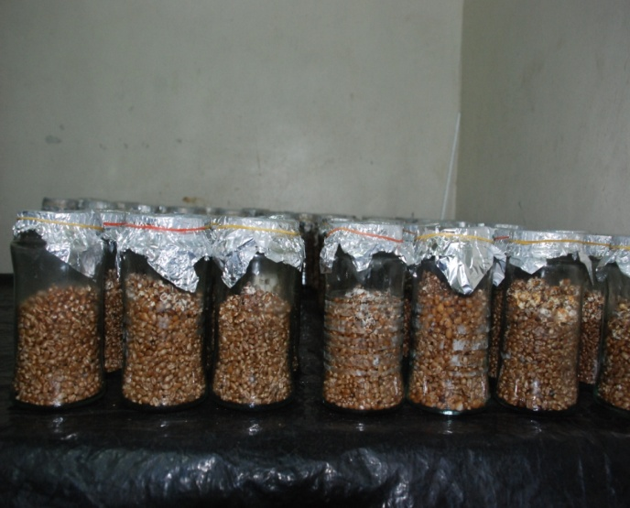
Plate 1: Freshly inoculated wheat grain for mother spawn
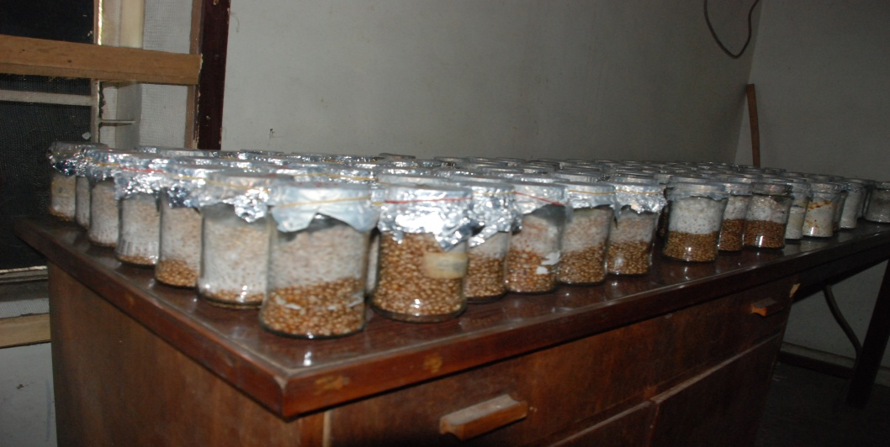
Plate 2: Ramifying wheat grain bottles
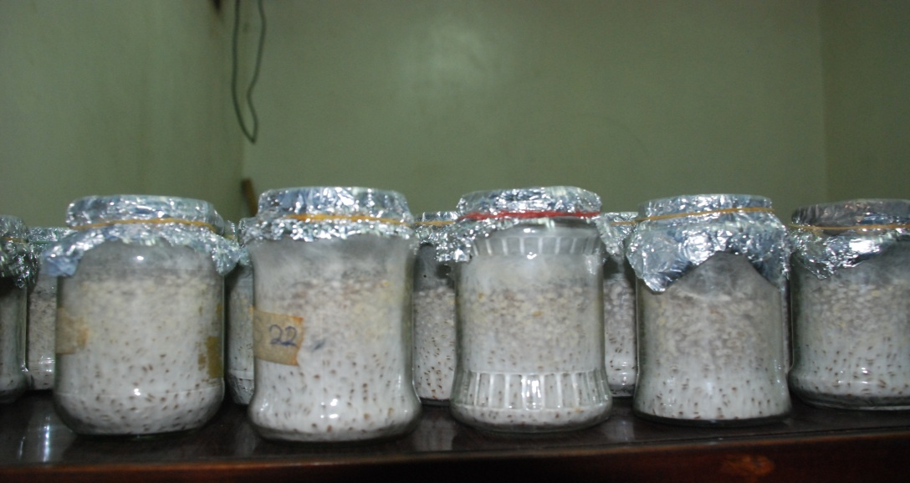
Plate 3: Fully ramified spawn bottles

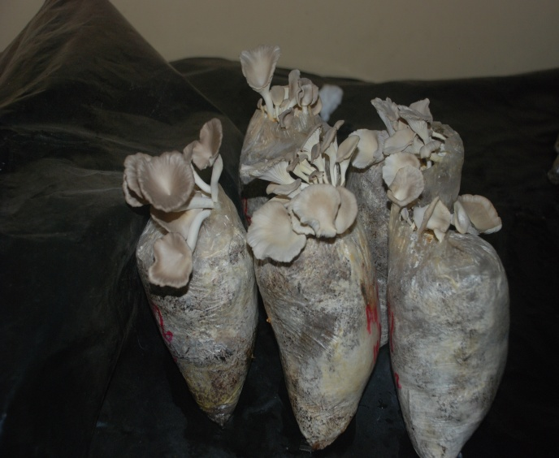
Plate 4: P. pulmonarius cultivated on coir fibre

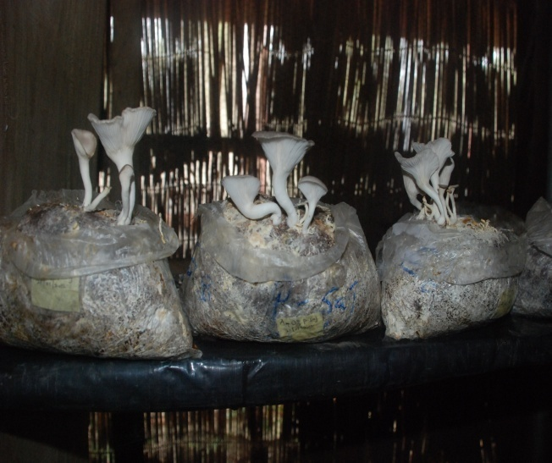
Plate 5: P. pulmonarius cultivated on oil palm waste

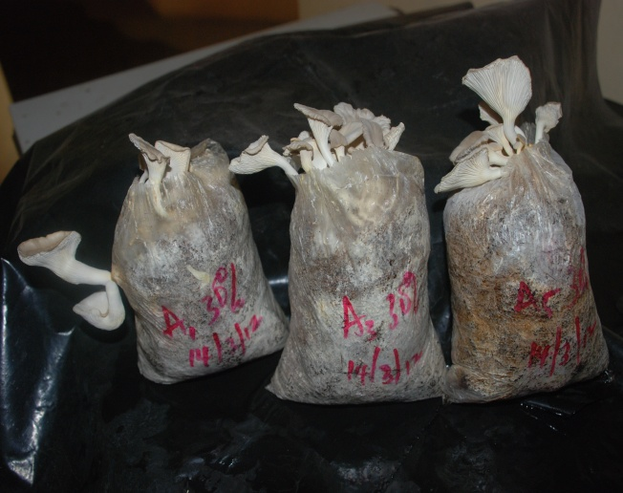
Plate 9: P. pulmonarius cultivated on saw dust
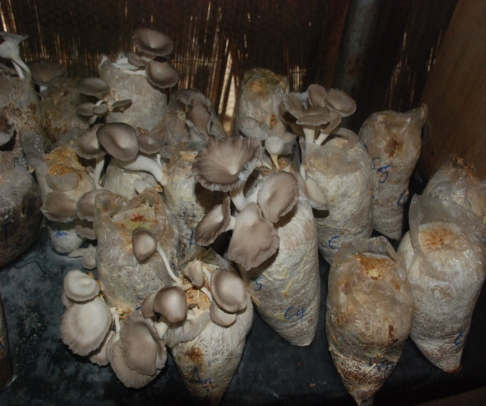
Plate 10: P. pulmonarius cultivated on rice straw

3.1 Mineral elements composition of P. pulmonarius cultivated on different substrates
Table 1 shows the mineral element compositions of P.pulmonarius on different substrates at different RBL. The mineral content of P. pulmonarius harvested were observed to be varied with various substrates .It was observed from Table 1 that RBL. was found to be richer in potassium followed by calcium and magnesium while manganese was the least.
The values of potassium ranges from 20.0mg/100g for P.pulmonarius harvested at 0% RBL of rice straw to 30.20mg/100g for those harvested at 10% RBL of rice straw. Calcium values obtained ranges from 2.30 mg/100g for P.pulmonarius harvested at 30% RBL for rice straw to 3.90mg/100g for those harvested at 10% RBL of saw dust. The calcium content ranges from 2.30-3.90mg/100g with the least

Plate 6:Growing sporophore of P.Pulmonarius
Value (2.30mg/g) for mushroom cultivated at 30% RBL rice straw and the highest value (3.90mg/100g) for those at 10% RBL sawdust. The Mg content of the mushroom obtained ranged from 0.97 to 2.67mg/100g in which the lowest was found at 0% RBL rice straw and the highest value was obtained for P. pulmonarius at 20% RBL of oil palm waste.
The highest Zn value of 0.76mg/100g was recorded for P. pulmonarius cultivated at 20% RBL of coir fibre. Highest Na content (1.15mg/100g) in P. pulmonarius cultivated on 20% RBL of rice straw and the least (0.012mg/100g) in 40% RBL of oil palm waste. The iron content varied from 0.008 to 0.12mg/100g with the highest value recorded for the mushroom cultivated with 10% RBL added to rice straw.
However, copper and manganese had highest values for P pulmonarius grown with 10% oil palm waste (0.09/100g).

Table 1: Mineral elements composition of P. pulmonarius cultivated on different substrates at different rice bran level (%)
Mineral element composition (mg/100g)
Substrates Rice bran Na Mn Fe Cu Zn Mg Ca K
Level (%)
Coir fibre 0 .091^{c} .04^{c} .010ª 010ª .59^{c} 1.13^{b} 3.02^{d} 24.9^{b}
10 .012ª .05^{b} .007^{c} .009^{d} .67^{b} 1.37ª 3.20^{c} 26.3^{ab}
20 .080e .05^{c} .009^{d} .010^{bc} .76e 1.14^{b} 3.52^{b} 21.5^{c}
30 .084^{d} . 08ª .010^{c} .009de .31ª 1.06^{b} 3.43^{b} 27.2ª
40 .094^{b} .0 9ª .011^{b} .0 10^{ab} . 45^{d} 1.15^{b} 3.73ª 26.5ª
Oil palm 0 .064^{c} .04e .010^{c} .011ª . 43^{c} 1.04^{d} 2.94^{b} 23.4e
waste 10 .042e .60^{c} .011^{b} .010^{b} .52a 1.34^{b} 3.50ª 28.2ª
20 .095ª 05^{d} 008e .009^{d} .51^{b} 2.67ª 2.90^{b} 24.2^{d}
30 . 064^{b} .07^{b} .010^{d} .009^{d} .35e 1.05^{d} 2.75^{c} 27.2^{b}
40 . 037^{d} .09ª .011ª .010^{c} .39^{d} 1.18^{c} 2.70^{c} 25.8^{c}
Sawdust 0 . 090^{c} . 04^{b} .0 11^{c} .009^{c} .40^{c} 103.^{e} 3.00^{c} 25.5e
10 1.00ª .06^{b} .011ª .010^{b} .50^{b} 1.32ª 3.90ª 28.1^{c}
20 . 094^{b} .05^{d} .008ª .020ª .52^{b} 1.18^{d} 3.20^{c} 25.1^{d}
30 . 099ª .08^{c} .010^{d} .023^{d} .38^{c} 1.10^{b} 3.80^{b} 26.5^{b}
40 .088^{d} .08ª .011^{b} .023e .35^{b} 1.19^{c} 3.50^{b} 27.0ª
Rice straw 0 1.02^{b} .05^{d} .010^{c} .012^{c} .30e . 97e 2.50ª 20.0e
10 .084e .0 7^{b} .0 12ª .0 006ª .38ª 1.35ª 2.40^{ab} 30.2e
20 1.15ª .05e .008ª .008e .31^{d} 1.07^{c} 2.50ª 26.0^{c}
30 1.00^{c} .06^{c} .010^{d} .009^{d} .35^{c} 1.01^{d} 2.30^{b} 28.0^{b}
40 .094^{d} .08ª .012^{b} . 010^{b} .36^{b} 1.22^{ab} 2.40^{ab} 24.0^{d}
Each value is the mean for three replicates. Mean carrying the same alphabet are not significantly different (P≤0.05) using DMRT

3.2 Growth analyses of the P.pulmonarius
Table 2 showed that P. pulmonarius was harvested up to four times on oil palm waste and sawdust and five times in coir fibre and rice straw. The mean stipe length (cm) per flush measured, ranges from 5.8-7.3cm with P.pulmonarius harvested from rice straw having the highest mean stipe length at the second flush and those from oil palm waste having the least mean stipe at the second flush. The total mean value ranges from 4.08±2.16 to 6.68±0.39cm.

Table 2: Effect of substrates, on stipe length per flush of P.pulmonarius
The mean stipe length (cm)
Substrate flush 1 flush 2 flush 3 flush 4 flush 5 Total Mean±SD
Coir fibre 6.4 7.1 5.7 6.2 6.3 6.34±0.46ab
Oil palm waste 5.8 4.3 5.1 5.2 - 4.08±2.16c
Sawdust 6.0 5.3 6.8 7.1 - 5.04±2.68b
Rice straw 6.2 7.3 6.4 7.2 6.3 6.68±0.49a
Each value is the mean for three replicates. Mean carrying the same alphabet are not significantly different (P≤0.05) using DMRT, SD=Standard Deviation

Table 3 shows that mushroom produced from rice straw had the highest mean values of pileus diameter(7.3cm) for second flush while oil palm waste (with four flushes only) had the lowest mean pileus diameter value of 5.20cm for fourth flush. The total mean pileus diameter ranges from 5.21±2.72 to 7.08±0.17cm. There is also significant (P≤0.05) difference between the total mean pileus diameter per flush across the four substrates.
Figure 1 shows that P.pulmonarius cultivated on rice straw and coir fibre has the highest mean mushroom height of 9.3cm at second flushes while those cultivated on oil palm waste has the least mushroom height of 6.0cm at the fourth flush. Total mean mushroom height ranges from 5.18±2.72 to 8.86±0.39cm. There is significant (P≤0.05) difference in the total mean height of P.pulmonarius produced from the four substrates.

Table 3: Effect of substrates, on pileus diameter per flush of P.pulmonarius
The mean pileus diameter (cm)
Substrate flush 1 flush 2 flush 3 flush 4 flush 5 Total Mean±SD
Coir fibre 7.2 6.9 6.7 7.1 6.8 6.94±0.19b
Oil palm waste 6.1 6.0 5.7 5.2 - 4.60±2.40d
Sawdust 6.1 7.0 6.8 6.1 - 5.21±2.72c
Rice straw 7.0 7.3 6.8 7.1 7.2 7.08±0.17a
Each value is the mean for three replicates. Mean carrying the same alphabet are not significantly different (P≤0.05) using DMRT, SD=Standard Deviation

Table 4: Effect of substrates on mushroom height per flush of P.pulmonarius
The mean mushroom height (cm)
Substrate flush 1 flush 2 flush 3 flush 4 flush 5 Total Mean
Coir fibre 8.2 9.3 7.9 8.6 8.2 8.46±0.49ab
Oil palm waste 7.4 6.4 6.1 6.0 - 5.18±2.72c
Sawdust 8.1 8.2 8.4 9.2 - 6.78±3.53b
Rice straw 8.2 9.3 9.0 8.7 9.1 8.86±0.39a
Each value is the mean for three replicates. Mean carrying the same alphabet are not significantly different (P≤0.05) using DMRT.

3.4 Effect of substrates and rice bran level on P. pulmonarius yield
Table 4 shows that rice straw had the highest total mean yield followed by coir fibre, sawdust and oil palm waste with mean yield values of 93.33±32.02g, 66.36±10.1g, 58.94 ±3.58g and 26.70±8.53g respectively. There was significant difference between the yields obtained from the four substrates. At rice bran levels 20% RBL has the highest yield followed by 10% RBL across the different substrates.

Table 5: Effect of different substrates at different concentration levels of rice bran on yield (weight/g) of fresh P,pulmonarius
Substrate Rice Bran Level
0% 10% 20% 30% 40% Total Mean Weight±SD
Coir fibre 8.22 16.16 19.20 13.21 9.17 66.36±10.01b
Oil palm waste 4.72 6.00 7.03 5.20 4.00 26.70±8.53d
Sawdust 6.28 15.09 18.80 10.48 7.30 58.94±3.58c
Rice straw 13.61 23.74 25.72 15.63 14.65 93.33±32.03a
Each value is the mean for three replicates. Mean carrying the same alphabet are not significantly different (P≤0.05) using DMRT, SD= Standard Deviation

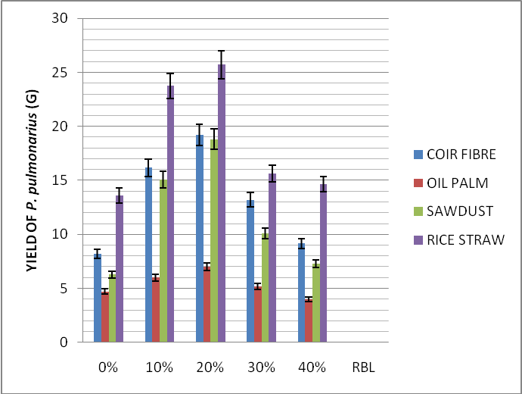
Fig 1: P. pulmonarius yield (g) as exibited by different substrates atdifferent rice bran level (RBL)

4.0 Discussion
The potassium content obtained from this study was similar to the observation of Patil et al. (2010) whom obtained similar values for potassium in P. ostreatus cultivated on soya bean straw. High potassium content and low sodium values of P.pulmonarius might be responsible for its prescription for people with high blood pressure.
The calcium content of P. pulmonarius obtained were also similar to that observed by Fasidi and Kadiri (1991) recorded for Termitomyces robustus and Lentinus subnudus who reported that Ca content of Termitomyces robustus was higher in pileus than other parts. Also this results conformed to the findings of Kulsum et al. (2009) whom assessed yield of oyster mushrooms with cow dung supplement in different substrates. The values obtained for iron could also be compared with the findings of Patil et al. (2010) for P. ostreatus cultivated on different lignocellulosic agro-wastes. Similar observation on Pleurotus sp was also reported by Syed et al. (2009).
Kalac and Svocoda (2010) had earlier reported that mineral elements in diet are essential for metabolic reactions, healthy bone formation, and transmission of nerve impulses regulation of water and salt contents which makes it suitable for consumption.
The ramification was an indication that P. pulmonarius could perform and utilize the substrates at different RBL with optimum level at 10% and 20%. This results were in accordance with the findings of Merta and Bhandel (1998) and Gbolagade et al.,(2006) who separately observed complete colonization of mycelia growth of Pleurotus spp Lentinus squarrosullus on different growing media agar plates.
All the growth parameters (mushroom height, stipe length and pileus diameter) as seen on Table 4, 5 and Figure 1 and showed that the fruit bodies from these substrates could attract high market value as the fruit bodies are sizable. Values obtained were relatively good for the mushroom produced from the four substrates used.
This agrees with the findings of Candy (1990), Kadiri and Fasidi (1992) and Okwujiako (1992) who reported that agriculture wastes are good growth media for Pleurotus sp. In order of fructification, mushrooms from rice straw fruited first followed by mushrooms from sawdust and oil palm waste respectively. Fruit bodies produced from rice straw were able to fruit first due to the richness of nutrients which are necessary for the formation of fruit bodies. This is supported by Chang and Buswell (1996) who reported nutrient and organic matter richness as factor necessary for the formation of fruit bodies.
The result obtained from the total mean yield is an indication that all the substrates used proved suitable for mushroom production though the oil palm waste yield was low with rice straw having the best performance. This is similar to the study of Obodai et al. (2003) in which it was observed that rice straw performed the best for P. ostreatus mushroom cultivation when compared with banana leaves, maize stover, corn husks, rice husks and elephant grass .The yield performance by these substrates can be attributed to the presence of supplements such as lime and rice bran which also play a vital role in mushroom cultivation by aiding the yield of fruiting body. Lime is known to neutralize the PH of the soil thereby making it possible for lime to neutralize the PH of different substrates thus aiding the microorganism activities on the substrate and as a result contributing to yield performance of the fruiting bodies. Similar findings was recorded by Gbolagade et al..(2006) who addressed the effect of different supplement on the yield of Lentinus subnudus in which it was observed that supplement such rice bran contributed to the high yield of mushroom and also aid sporophore emergence. The yields recorded in the mushroom produced were relatively high and this is an indication that all the substrates used supported the yield of P. pulmonarius. The yield obtained in saw dust was lower than those of rice straw and coir fibre also due to the fact that P.pulmonarius has to break down the lignin content of the wood. It was also observed that 20% RBL had the best mean yield for the four substrates followed by 10% RBL.
Result showed that 10% and 20% RBL were the most suitable substrates for the production of P. pulmonarius. This indicates that 20% and 10% are the most appropriate levels of additives to be added as supplement along with the substrate. This was in agreement with Jonathan et al., 2012d, who reported that rice bran supported the best mycelia growth and fruitbody yield in Pleurotus ostreatus cultivation. The low yield recorded by oil palm waste despite different RBL might be due to complex lipid present in it. This also was in consonance with the findings of Lim (1981) who reported that oil palm waste may contain complex lipids which may hinder easy asses of the fungus to simpler carbon sources, thus reducing the mycelia colonization and yield.
Rice straw produced the highest dry weight mean which was in accordance with Obodai et al. (2003) whom reported that rice straw as the best substrate for P. ostreatus cultivation when compared with banana leaves, maize stover, corn husk, rice husk and elephant grass. There were significant difference between the four substrates but there were no significant difference between 10% and 20% RBL for dry P.pulmonarius. The results were similar to those obtained for fresh P.pulmonarius, indicating a close relationship between the fresh and dry yield.
The result of B.E obtained showed that the yield was a function of B.E. thus meaning that B.E. is dependent on yield. The highest values of B.E. obtained in rice straw and coir fibre could be attributed to yield as both were found to give the best yield. At RBL, it could be deduced that the P.pulmonarius made best use of the substrates at lower levels of rice bran (0-20%). The highest B.E. could have been due to efficient and effective utilization of substrates by P. pulmonarius. Shah et al. (2004) evaluated 64.69% of B.E. for mushroom grown on fermented sawdust. Obodai and Vowotor (2002) also obtained 50.93% of B.E. for P. ostreatus. The regression equation showing the relationship between B.E. and spent substrate in Figure 1 was an indication that P. pulmonarius made good use of the substrate since the R² was found to be high R~0.60. Similar findings were observed by Pathmashini et al. (2008) on the efficacy of different spawn types on sawdust media, in which the B.E. was strongly and positively correlated with yield.

Correspondence to:
Dr Segun Gbolagade JONATHAN Mycology Biotechnology unit, Department of Botany, & Microbiology, University of Ibadan, Ibadan. Nigeria
E-mail: gbolagadejonathan@gmail.com
Tel: 2348164746758

References
- Aina, DA.Jonathan SG Olawuyi, OJ. Ojelabi, DO and Durowoju, BM (2012a).Antioxidant, antimicrobial and phytochemical properties of alcoholic extracts of Cantharellus cibarius – Nigerian mushroom. New York Science Journal 5(10):114-120
- Aina DA, Oloke JK, Jonathan SG and Olawuyi OJ(2012b) .Comparative assessment of mycelial biomass and exo-polysaccharide production of wild type and mutant strains of Schizophyllum commune grown in submerged liquid medium Nature and Science 10(10):82-89
- Alexopolous, C. J., Mims, C.W. and Blackwell, M. 1996. Introductory Mycology (4th Ed.) New York, John Wiley.Alofe, F. R., Odu, E. A. and Illoh, H. C. 1998. Mushrooms, Man and Nature. Edible wild mushrooms on decaying wood in Obafemi Awolowo University Campus. The Nigerian Fields. 63:3–18.
- AOAC, 2005. Official Methods of Analysis. 18th ed. Association of Official Analytical Chemists.Washington D.C.
- Candy, C. I. 1990. The cultivation of pleurotus in Mauritania proceedings 1st conference on African mycology Mauritania. Pp 5-10.
- Chang S. T., Lau, O. W. And Cho, K. Y. 1981. The cultivation and nutritive value of Pleurotus Sajor-caju. European Journal of Applied Microbiology and Biotechnology. 12:58-62.
- Chang, S. T. and Miles, P. G. 1992. Mushrooms Biology, A New Discipline. Mycologist 6: 64-65.
- Chang, S. T. and Buswell, J. A. 1996. Mushroom nutriceuticals. World Journal of Microbiology and Biotechnology. 12: 473-476.
- Chang, S. T. and Mshigeni, K. E. 2001. Mushroom and their human health, their growing significance as potent dietary supplements. The University of Namibia, Windhoek, pp 1-79.
- Chinda, M. M. and Chinda, F. 2007. Mushroom Cultivation for Health and Wealth .Apara Printers and Converters Limited, Lagos. P.23-87.
- Fasidi, I. O. and Kadiri, M. 1991. Changes in nutrient contents of Termitomyces robustus (Beeli) Heim and Lentinus subnudus Berk during sporophore development. Acta Botanica Hungarica 36:167-172.
- Gbolagade J.S 2005. Bacteria associated with cultures of Psathyrella atrombonata (Pegler), and Schizophyllum commune (Fr.Ex.Fr), Nigerian edible mushrooms .Acta Phytopathologica. Et Entomologica Hungarica. 40 :( 2-3), 333-340
- Gbolagade J.S,2006. Bacteria associated with compost used for cultivation of Nigerian edible Mushrooms: Pleurotus tuber-regium (Fr.) Singer, and Lentinus squarrosulus (Berk.) African Journal of Biotechnology.5 (4) :338-342
- Gbolagade J.S, Fasidi,I.O , Ajayi E.J and Sobowale A.A 2006. Effect of physico-chemical factors and semi-synthetic media on vegetative growth of Lentinus subnudus (Berk.), an edible mushroom from Nigeria. Food Chemistry. 99:742-747
- Härkönen, M., Saarimäki, T. and Mwasumb, L. 1995. Edible mushrooms of Tanzania. Karstenia 35 suppl. (ed. S. Stenroos), Helsinki.
- Jonathan, S. G., Kigigha, L. T. and Ohimain, E. O. 2008. Evaluation of the inhibitory potentials of eight edible higher Nigerian fungi against pathogenic micro-organisms. Afr J Biomed Res 11:195-202.
- JonathanSG,Adegboyega AA and Oyelakin AO.2012a.Cultivation of Pleurotus pulmonarius Fr. Singer on fermented and non fermented sawdust New York Science Journal 5(11):36-40
- Jonathan SG,Olawuyi OJ and Oluranti OO 2012b. Studies on Immunomodulatory and prophylactic properties of some wild Nigerian mushrooms: Academia Arena :4(9):39-45
- Jonathan S.G.Popoola KOK., Olawuyi OJ Ajiboye M. and Oyelakan A. O 2012c. Insect and fungal pests of some mushrooms collected from university of Ibadan, Nigeria campus. Nature and Science10(9):142-147.
- Jonathan S.G Okon, C.B.Oyelakin A.O and Oluranti O,O 2012. Nutritional values of oyster mushroom (Pleurotus ostreatus) (Jacq. Fr.) Kumm cultivated on different agricultural wastes.Nature and Science; 10(9):186-191
- Jonathan SG, Oyetunji OJ, Olawuyi OJ and Uwukhor PO 2013.Application of Pleurotus ostreatus SMC as soil conditioner for the growth of soybean (Glycine max). Academia Arena :5(1):54-61.
- Kadiri, M. and Fasidi, I. O. 1992. Secondary plant products in some Nigerian mushrooms. Nigerian Journal of Botany 5: 187–192.
- Kalac, P. and Svocoda, L. 2000. A review of, trace element concentrations, in edible mushrooms. Food Chemistry, 69, 273- 281.
- Kulsum, U., Hoque, S. and Ahmed, K. U. 2009. Effect of different levels of cow dung with sawdust on yield and proximate composition of oyster mushroom. Bangladesh Journal of mushroom. 3(2): 25-31
- Lim, W. C. 1981. The microbiology of paddy straw compost for the cultivation of Volvariella volvacea. Mushroom Science. 11: 595-602.
- Lindequist, I. L, Nieder mayer T. H. and Julich, W. D, 2005. The phermalogical potential of mushroom Evid. Based Compliment Alternative medicine 2:285-299.
- Merta, K. B. and Bhandel, M. S. 1988. Mycelial growth variation of six Pleurotus species at different temperatures. Indian Journal of Mushroom. Vol 14: 64-65.
- Obodai, M. and Vowotor K. A. 2002 Performance of different strains of Pleurotus species under Ghanaian conditions. Journal of Food Technology in Africa. 7(3): 98-100.
- Obodai, M., Cleland-Okine, J. and Vowotor, K. A. 2003. Comparative study of the growth and yield of Pleurotus ostreatus on different lignocellulosic by-products, Journal of Industrial Microbiology and Biotechnology. 30: 146–149.
- Okwujiako, I. A. 1992. Studies on the cultivation of edible mushroom (pleurotus tuberregium (fries) singer. Tropical Journal of Applied Sciences 2.
- Owen, M. 2007. Acid or Alkaline? What PH Means:In Garden speak.http:www.plantea.com
- Pathmashini, L., Arulnandhyl , V. and Wijeratman P. S. W. 2008. Efficacy of different spawn types on sawduast media. Journal of tropical agricultural research and extention. 11:55-59.
- Patil, S. S., Ahmed, S. A., Telang S. M and Baig M. V. 2010. The nutritional value of P. Ostreaus cultivated on different lignocellusic agro-wastes. Innovative Romanian food biotechnology 7:66-76.
- Quimio, T. H, Chang, S. T, and Royse, D. J. 1990. Technical guidelines for mushroom growing in the tropics. FAO plant production and protection paper 106. Rome Italy. citrinopileatus strain.
- Shah, Z. A., Ashraf, M. and Ishtiaq, M. 2004. Comparative Study on Cultivation and Yield performance of Oyster Mushroom (Pleurotus ostreatus) on Different Substrates (Wheat Straw, Leaves, Sawdust). Pakistan Journal of Nutrition. 3: 158 – 160.
- Stanley, H. O., Umolo, E. A. and Stanley, C. N. 2011. Cultivation of oyster mushroom (Pleurotus pulmonarius) on amended corncob substrate Agriculture and biology journal of america ISSN Print: 2151-7517, http://www.scihub.org/ABJNA
- Syed, A. A., Kadam, J. A., Mane, V. P., Patil, S. S. and Baig, M. M. 2009. Biological efficiency and nutritional contents of Pleurotus florida (Mont.) Singer cultivated on different agro-wastes. Nature and Science, 7(1), 44-48.
- Zoberi, M. H. 1972. Tropical Macrofungi. Macmillan Press. London

2/21/2013

