Cypermethrin Adsorption unto Sodium Chloride-Activated Cacao Theobroma(Cocoa) Pod Using Digital GC

M. Turoti* and E. Bello

Department of Chemistry, Obafemi Awolowo University, Ile-Ife, Osun State, Nigeria
*muyiwaturoti@yahoo.co.uk

Abstract: Varying particle sizes of 125, 250, 500 and 1000µm obtained from raw cocoa pods were separately first carbonized at 500⁰C and then activated with varying concentrations of NaCl at 700⁰C. The physico-chemical parameters including moisture content, bulk density, ash content, pH, dry matter and carbon yield of each activated carbon product were determined. The elemental compositions of both carbonized and activated carbon were also determined. The adsorption studies of these carbons onto cypermethrin, at an average concentration that is commonly employed for spraying the cocoa fruits by some selected farmers, were carried out using the digital gas-chromatographic techniques. The results showed that among the different carbon matrices 125µm particle size activated with 5M NaCl having 6.50% moisture content, bulk density of 0.33gcm⁻³, 3.10% ash content and pH of 10.40 was most effective at 94.34% removal of the pesticide. It was found that the equilibrium data fitted into the isothermal models of Langmuir at q₀ of 22.73mg/g and the Freundlich constants at n = 5.102 and K_{F} = 25.41.
[M. Turoti, E. Bello. Cypermethrin Adsorption unto Sodium Chloride-Activated Cacao Theobroma(Cocoa) Pod Using Digital GC. World Rural Observ 2013;5(2):20-29]. ISSN: 1944-6543 (Print); ISSN: 1944-6551 (Online). http://www.sciencepub.net/rural. 5

Key words: Carbonized, activated carbon, cypermethrin, cocoa pod husks, GC

1. INTRODUCTION
A pesticide is any chemical agent used to kill or control undesired insects, weeds, rodents, fungi, bacteria, or other organisms (Pengman, 1996). There has been tremendous production of synthetic pesticides due to their importance to man in both agricultural and non-agricultural sectors. Pesticides are toxic and are potentially hazardous to human, animals, other organisms and the environment. The toxicity of a pesticide is an index of its capacity or ability to cause injury or illness (Lorenz, 2007). These pesticides pose a lot of hazards to the ecological systems. For instance, apart from the immediate health implications there is the remote consequence of causing global warming as a result of photochemical reactions on these chemicals. An avalanche of research works has been devoted in isolating some of these pesticide residues from many phases of the environment including water supplies. It is a common view that there is differential sensitivity of individuals to the same exposure of a particular pesticide but the need to circumvent or reduce pesticide effects from the environment cannot be overemphasized (Schwartz, 1996., Lorenz, 2007). Acute effects from exposure to certain pesticide include birth defects, toxicology to a foetus, production benign or malignant tumours, nerve disorders, blood disorders, genetic mutations, endocrine disruption and reproductive effect (Lorenz, 2007).But for the intervention of some remediable measures that are now available, particularly in the use of adsorption technology, the disadvantages of using most pesticides outweigh the advantages.
1.2 Adsorption of Pollutants and Pesticides by Activated Carbons
Adsorption of pollutants present in water or any other environmental medium has been successfully executed using activated carbons produced from agricultural by-products. These include palm kernel shells (Wu et al, 1999), groundnut shells (Gimba et al., 2010), coconut shells (Mozammel and Masah, 2002), rice husks (Singh and Srivastara, 2001), corn-cobs (Tsai et al., 2001). For pesticide removal, activated carbons include those sourced from groundnut shells (Gimba et al, 2010) were used to remove dichlorvos from an aqueous medium. It seems that works on pesticide removal by activated carbons from agricultural by-products are scanty. The fundamental technology involved in the utilization of activated carbon is in the development of highly micro-porous network within the carbon matrix, specific surface areas and optimum pH (Abdul and Aberuagba, 2005., Gimba et al., 2009). These important features can be attained with suitable choice of activating agent, activation temperature and time. The adsorption efficiency of the particular activated carbon (sorbent) would then depend on its physico-chemical parameters as well as the structure and chemical composition of the adsorbate. The small tiny pores in the activated carbon structure makes removal of very small organic matter possible. Removal of pesticides from contaminated water by activated carbon adsorption is considered as one of the best available technologies (Mishra & Bhattacharya, 2007).

1.3 Cypermethrin, Its Health Hazards and Studies on its Removal.
Cypermethrin(Cyano(3-phenoxyphenyl)methyl-3-(2,2-dichloroethenyl)-2,2dimethyl cyclopropanecarboxylate) is a synthetic pyrethroid insecticide/pesticide that is extremely effective against a wide range of insect and pests (Jones, 1995). Cypermethrin is similar to the pyrethrins in pyrethrum extract (which comes from the chrysanthemum plant). Pyrethroids, including cypermethrin were designed to be effectively longer in active life than pyrethrins (Bouya et al., 2012). It is a widely used pyrethroid pesticide for crop production and fruit tree treatment (Bouya et al, 2012).
The insecticide is both a stomach and a contact poison that affects the nervous system of vertebrates and invertebrates, by affecting voltage-dependent sodium channels and inhibiting ATPase enzymes (Jin and Webster, 1998). Cypemethrin is extremely toxic to aquatic organisms, and should not be applied on or near water, or in a windy environment. Due to its high lipophilicity and low water solubility, cypermethrin has a strong potential to bioaccummulate in aquatic animals (Jones, 1995). Cypermethrin was the first pyrethroid to be reported as having caused a human fatality. In Greece a man died 3 hr after eating a meal cooked in a 10% cypermethrin concentrate used in error instead of oil. Nausea, prolonged vomiting with pain, tenesmus, and diarrhea are among the effects of ingesting this pesticide. Once released or drawn into surrounding waters through natural underground channels. cypermethrin go through a variety of biochemical and geochemical processes in aqueous environments. The water solubility of cypermethrin is very low, 4 ppb at 20⁰C (Kollman and Segawa, 1995). Cypermethrin is extremely hydrophobic and will quickly move from an aqueous solution to suspended particulates (Fitzpatrick, 1982). Soils and sediments are the main environmental reservoirs for cypermethrin (Bacci et al., 1987). It has been adsorbed from wastewater using granulated cork and granulated activated carbon (GAC) (Valentina et al.,2007). Adsorption studies on wastewaters from cypermethrin manufacturing process using activated coconut shell carbon were carried out by Bhuvaneswari et al., 2007. From their report it was found that carbon dosage, pH of medium, and contact time affected the removal of COD. Studies on removal of cypermethrin by carbons produced from cocoa pod have not been reported.

1.4 Activated Carbon from Cocoa Pod
Cocoa pod is an agricultural product of the cocoa harvesting industry. It forms about 80% of the cocoa fruit. Approximately 5.25 x 10³ tons of cocoa pods were produced in Nigeria between October 2008-September 2009 (Agritrade, 2010). Each tree yields 20-30 pods per year (Cadbury, 2012). The pods are left behind on the farm to decompose as wastes or burnt but both methods present serious environmental challenges. A negligible quantity of the product is used in the manufacture of local soap and as fertilizers due to the presence of potash in them. Awolumate (1982) worked on the production of livestock feeds from CPH while (Adeyanju et al, 1975) have reported the use of dried pod as a substitute for maize in swine ration, in milk production of dairy cows and in the manufacture ration of sheep and goat or at various levels in the starter diets of chicks up to six weeks of age (Adegbola and Omole,1973). Olugbenga et al., (2011) prepared an activated carbon from cocoa pod husk activated with CO₂ which they utilized for the removal of Remazor Black B reactive dye from aqueous solution. Cocoa is exported to many countries and at present constitutes the largest income earning in the agricultural sector of some countries. A consideration of the present study is the choice of the non-toxic sodium chloride, as the activating agent, which is relatively cheap and available. Also with the readily available and cheap cocoa pod, as precursor, renders the cost of production of activated carbon cocoa pods (ACPH) relatively low, and may be found effective in removing this pesticide from an aqueous medium.

2.0 METHODOLOGY
2.1 Sampling and Sample Treatment
At an average of 15 pods per tree, about 250 freshly harvested cocoa pods were procured from an agricultural farm centre located in the North Local Government of Ondo State, Nigeria, in December, 2011.
They were thoroughly washed with distilled water, broken into smaller pieces with the aid of clean and dry mortar/pestle and then sun-dried. Further crushing and drying were carried out and thereafter they were oven dried at 70-80⁰C for about 24hrs to avoid thermal degradation of the pods. Pulverization was effected using a laboratory milling machine in the Department of Pharmaceutical Chemistry, Obafemi Awolowo University, Ile-Ife, Nigeria. Using different Endecott sieves, four particle sizes of 125, 250, 500 and 1000µm were obtained and stored into well-labelled air-tight different plastic containers for further use. The activating agent, sodium chloride was of high quality grade (BDH,UK),was obtained from the store of Chemistry Department, Obafemi Awolowo University ,Ile-Ife, Nigeria. The target sorbate, cypermethrin (formula,wol.wt= 416.30g/mol Eastsun Chemical Co. Ltd. Sanghai, China, was procured from Growell Agro Services. Ile-Ife, Osun State, Nigeria.

2.2 Activation by Two-Step Process
This involved carbonization requiring heating the raw material of a particular particle size at relatively low temperature in vacuum for a period of time and then cooled to room temperature. After this, the activating agent is introduced and heated to higher temperature before cooling to room temperature. With little modification the method adopted was as described earlier (Gimba et al., 2009).
3.0g of the raw cocoa pod husk of 125µm particle size was weighed separately into four, clean and dry glass crucibles and introduced into a carbolite furnace at 500⁰C for 5 minutes after which they were quenched in distilled water and sun dried for 4hrs. They were then allowed to dry at room temperature for 24hrs after which they were stored in air-tight plastic containers for the next step of activation. The activating agent was sodium chloride. This procedure was repeated in turn, using the 250, 500 and 1000µm particle sizes. In each of previously weighed clean three crucibles, 10.0cm³ of 0.5M, 1M or 5M NaCl were mixed with 0.9g of the 125 µm particle sized carbonized cocoa pod husks to form flaky pastes. The three crucibles and their contents were introduced into the Carbolite furnace at 700⁰C for 5minutes after which they were separately quenched in cold water, washed with distilled water and dried to constant weights at the room temperature (26-27⁰C).The activated carbons were stored in three air-tight plastic containers after labelling them. The activation procedure was repeated in turn, using the 250, 500 and 1000µm particle sizes. The samples of the ACPH are contained in Table 2.

2.3 Characterization of Carbonized and Activated Carbon from Cocoa Pod Husk
Elemental Analysis: The samples were first digested before the analysis. 0.5g of a sample was introduced into the digestion tube, mixed with 4.0cm³ of H₂SO₄ and 2.0cm³ of H₂O₂ followed by heating in a block digester at 270⁰C for 30 minutes. It was removed and allowed to cool at room temperature after which another 2.0cm³ of H₂O₂ was added and heated continuously till completion of digestion indicated by a clear solution. Elemental analysis of carbonized and activated cocoa pod husks was executed using Atomic Absorption spectrophotometer (AAS),Aanalyst 800,Perkin Elmer) at the International Institute of Tropical Agriculture, Ibadan, Nigeria.
Moisture and Dry matter content %, ash content and carbon yield,%, as well as bulk density(gcm⁻³)and pH were determined according to the method described in an earlier study (Gimba et al.,2009).

2.4 Preparation of Cypermethrin Stock Solution
An interactive survey with some farmers, who engaged cypermethrin in spraying their cocoa pods in the rural community where the pods were procured, was conducted. The usage involved mixing certain quantity of the pesticide with water and poured into the spraying machine for application to the pods. The average concentration was found and this was employed in preparing the stock solution of the adsorbate (cypermethrin). 0.25cm³ of cypermethrin was added to 10cm³ of distilled water in a 100cm³ volumetric flask, shaken for about 5minutes and then made up to the mark with distilled water producing a white suspension. This was the ratio used for all the adsorption studies in this work since the farmers normally employ this proportion prior to application of the pesticide.

2.5 Adsorption Studies of Cypermethrin
Batch (discontinuous) adsorption was carried out using the method of Rozada et al., (2003) with little modification. 0.60g of ACPH obtained from 125µm particle size CPH activated by 5M NaCl was weighed into a 250cm³ Erlenmeyer flask. 10cm³ of the stock solution was added to the CPHAC and left standing for 24 hours. The content of the flask was filtered using Whatman No.40 filter paper and the filtrate was subjected to determination of the concentration of unadsorbed cypermethrin by digital gas chromatography (GC/FID/ECD, SRI Japan).The difference in concentration from that of the stock was obtained. A blank with same amount of the liquid without the adsorbent was subjected to the same procedure to serve as the control. The above procedure was repeated using 0.80, 0.7 and 0.6g of the 125µm ACPH separately. Using the same procedure, 0.90g of ACPH obtained from each of 250, 500 and 1000µm particle sizes were separately treated for adsorption and subsequent determination of cypermethrin concentration.
2.8 GC/FID/ECD conditioning.
The gas chromatography machine SRI 8610 equipped with a flame ionization detector (FID) and an electron captured detector (ECD) was used in this analysis. The capillary column used was HP-5MS, 30x25mm ID x 0.25µm film. An air sample from the Tedlar bag was injected into a 1cm³ sample loop using the inbuilt vacuum pump interface and the event program. Before injecting any sample into the sampling loop, the FID detector temperature was raised to 300°C and the ECD detector temperature to 350°C. The system was operated on a Argon carrier at 20 PSI for the ECD, while hydrogen and air were supplied to the FID/methanizer using a built-in air compressor at 20psi.Gas chromatographs were recorded and analyzed with the Peak Simple Chromatography Data System Software (Version 3.72). Before and after sample analysis, calibration gases were used to ensure that the GC was functioning properly. Blank samples were also run between samples using the same procedure to check any contamination from previous analysis.

3.0 RESULTS AND DISCUSSION
3.1 Elemental Analysis
As presented in Table 1, concentration of elements (ppm) increased from the carbonized to activated carbons of the cocoa pods. This could be attributed to the fact that the elements became more vulnerable to detection by the reduction of the amount of interfering or masking agents such as protein/volatile components as one proceeds from carbonization during the first step to the second step of activation which led to the production of the ACPH in line with Mozammel and Masahirom (2002) and Gimba et al., (2009). The transformation was effected by heating to 500⁰C during the first step and then to 700⁰C for the second step. The elemental increase was most pronounced for Ca, Mg and K i.e. alkali/alkaline earth metals. However, such significant increase would be expected to produce more alkaline activated surfaces of the ACPH compared to the CCPH. Such alkaline surfaces could also be facilitated by the appropriate choice of activating agent that can deposit an alkaline product on the surfaces of ACPH (see table 2).

Table 1. Elemental Analysis of carbonized (CCPH) and activated(ACPH)
Sample | Ca | Mg | K | Na | Mn | Fe | Pb | Al | Cl | Br
CCPH  ACPH | 7.009  16.244 | 0.2658  59.344 | 3.654  7.677 | 0.664  1.266 | 0.103  0.265 | 0. 065  0.114 | 0.006  0.198 | 0.002  0.102 | O.264  3.251 | 0.017  2.852

Table 2: Physico-chemical parameters of cocoa pod husk
Parameters
Samples(µm) %Moisture % Dry Matter % Ash % Carbon Yield pH Bulk Density
125µm 5M NaCl 6.50 93.50 3.10 18.04 10.40 0.28
125µm 1M NaCl 7.85 92.15 5.75 33.26 10.30 0.36
125µm 0.5M NaCl 5.95 94.05 3.80 21.97 10.30 0.34
250µm 5M NaCl 8.30 91.70 4.90 28.00 10.40 0.33
250µm 1M NaCl 6.10 93.90 5.85 33.83 10.50 0.33
250µm 0.5M NaCl 7.15 92.85 4.95 28.63 10.50 0.31
500µm 5M NaCl 5.95 94.05 6.05 34.59 10.20 0.32
500µm 1M NaCl 5.40 94.60 6.00 34.70 10.40 0.32
500µm 0.5M NaCl 5.20 94.80 3.10 18.24 10.20 0.31
1000µm 5M NaCl 6.05 93.95 6.40 37.00 10.10 0.30
1000µm 1M NaCl 5.25 94.75 6.15 35.57 10.20 0.26
1000µm 0.5M NaCl 5.50 94.50 4.20 24.71 10.10 0.27
500µm Carbonized 7.05 92.95 7.45 43.00 9.50 0.35
Raw Sample 4.69 95.30 8.55 49.45 5.70 0.62

3.2 Physico-Chemical Parameters
These parameters are as shown in Table 2. It can be seen that for the same molar concentration of the activating agent the moisture content (%) generally decreased with increasing particle size of the activated carbon. The moisture content of the 500 µm increased with increased molar concentration of the activant but no such linear relationship for the other particle sizes. For this reason, the moisture content of the 500µm particle size of the carbonized was used. On the basis of this, it could be seen that most of the activated carbons have lower moisture contents than the carbonized carbon. As it can be seen, the ACPH that had the smallest moisture content (5.20%) possessed the greatest dry matter content (94.80%).
Adsorption efficiency of an adsorbent generally has some inverse dependence on its moisture content. It has been reported that moisture contents has this pattern of relationship with porosity network of adsorbents (Aziza et al., 2008., Gimba et al., 2010). Sorbent with high moisture content is expected to swell less reducing pore size expansion for sorbate adsorption.
Ash content is a measure of inorganic impurities in carbons (Bansode et al., 2003). In Table 2, two carbon matrixes, 500µm and 125 µm activated with 0.5M and 5M NaCl respectively had the same ash content of 3.10% and hence may be expected to have the least inorganic component. Generally, sorbents with less ash content have higher sorption uptake and the level of ash content has been found dependent on the ash content of the starting material (Ahmedna et a.l., 2000). In this report, the ash content of the activated samples were all lower than the ash content of the carbonised and raw material samples, increasing in that order (Table 2). However, ash content may be dependent on the type of activating agent (AA) as pointed in an earlier work (Gimba et al., 2010). In this study, as the same AA (NaCl) was used, ash content largely depends on the concentration of the AA (Table 2). The carbon yields (%) of the activated carbons were lower than those of the carbonized and raw material samples and in some matrixes the carbon yields were significantly lower in the ACPH. For instance, the two samples that had the same ash content, as mentioned above, also had almost the same carbon yield of 18.24 and 18.04 (%) respectively. Chemical activation, as employed in this study, enhances the weakening of the cellulose material and release of volatile organic matter of the precursor structure resulting into microporous activated carbon (Malik et al., 2006). The organic matter clogs the carbon pores and the greater the evolution of volatiles from the matter during activation, the greater the porosity of the activated carbon. It is a common view that the more porous a carbon the greater its adsorbate uptake.
The bulk density has been viewed as an important parameter in adsorptive technology as higher density generally gives rise to better retention of adsorbate per unit volume of the adsorbent (Jibril et al, 2007).Table 2 shows that the density of the carbonized and ACPH ranged from 0.26-0.36 and for the same molar concentration of the AA bulk density generally decreased with increasing particle size. The bulk density of the samples generally decreases as the raw material went through carbonization to activation that led to the ACPH carbon products. One would therefore expect the raw or carbonized carbon that had higher bulk density to be more effective in sorbate adsorption as claimed by earlier studies (Gimba et al., 2009; 2010). The generally lower values of the bulk densities of the activated compared to those of the raw and carbonized samples might have arisen from the relatively low activation temperature at 700⁰C yielding ACPH with less density since the earlier studies were carried out at 800⁰C for the same activation time. However, the earlier studies employed a different precursor, groundnut shell and NaCl as AA in only one case.
The pH of the carbon surfaces increased from the raw material (5.70) to the carbonized (9.50) and then to the narrow range of 10.10-10.50 for the activated samples. The raw cocoa pod was acidic while the carbonized and activated forms were alkaline in tandem with earlier studies (Gimba et al., 2009; 2010). These results were also in agreement with a much earlier work which showed that alkaline surfaces are characteristic of activated carbons having vegetable origins (Cheremisinoff and Ellerbusch, 1978). Such alkaline surfaces have been found favourable to adsorbing methylene blue(dye) from aqueous medium (Abram,1973, Gimba et al., 2009) as well as dichlorvos, a pesticide from the same medium (Gimba et al., 2010). The amount of adsorbate uptake is expected to be more favourable as the carbon surfaces become more alkaline (Abram, 1973). The increase in pH of the adsorbents could be as a result of chemical activation with NaCl which resulted in higher pH in line with a previous work (Gimba et al, 2009)
NaCl → Na⁺_{(aq)} + Cl⁻_{(aq)}
H₂O → OH⁻_{(aq)} + H⁺_{(aq)}

Net: NaCl _{(aq)} NaOH_{(aq)} + HCl_{(aq)}
HCl_{(aq)} HCI_{(g)}
At a relatively high temperature of 700⁰C used for activation in this work, HCl_{(aq)} would probably have gasified (HCI_{(aq)} HCl_{(g)}) in the carbolite furnace and leaving NaOH_{(s)} on the surfaces of the ACPH. This could be an additional reason for the relatively high pH of the ACPH samples.

3.3 Batch Adsorption Study of Cypermethrin by Activated Cocoa Pod
The present study centres on some key factors that affected the adsorption of the test pesticide using some of the prepared activated cocoa pod husk(ACPH).The selected carbon samples were based on the earlier sections of this report and a few preliminary studies. These included the observation that greater removal of the test pesticide by all the ACPH than all the CCPH in line with earlier workers (Gimba et al., 2009).The batch adsorption study considered the effects of sorbent particle size, molar concentration of the activating agent (NaCl) and sorbent dosage on the adsorption of the pesticide (cypermethrin). The possible fittings of the batch data into the Langmuir will be considered.

3.4 Effect of Particle Size of ACPH
Table 3 shows that adsorption of 1.52 gdm⁻³ cypermethrin increased with decreasing particle size of the ACPH using 5M of the activating agent (AA). The choice of the molar concentration was based on a preliminary investigation which showed that for each particle size of the ACPH, the higher the concentration (for the experimental 0.5,1 and 5M of the AA) the greater the removal of the pesticide. Thus the 125µm/5M NaCl) had 94.342% removal of the pesticide from the aqueous medium while the 1000µm particle size had only 54.737% removal. This could be attributed to the common view that surface area increases as particle size of a sorbent decreases (Itodo et al, 2010).The increase in surface area creates greater effective contact points or collision with the sorbate and hence increases the sorption efficiency of the carbon sample in line with a recent work (Khazaei et al., 2011). Also the bigger the particle size the greater the inter-particulate distance, the greater the level of porosity of the carbon matrix and hence relatively low adsorption capacity. On the other hand, for the same residence time, smaller particle sizes enjoy greater association (smaller inter-particulate distance), less or delayed passage of sorbate solution and greater level of adsorption by the ACPH particles. The smaller the particle size the greater the association of the adsorbent particles, smaller volume for the same mass of the different particle sizes and hence the increased density which generally increases removal of the adsorbates (Khazaei, 2011). However, this trend could be reversed if there is better development of micropores in matrixes of smaller densities. It is clear from Table 2 that low level of moisture content and ash content as well as relatively high pH of ACPH accomplished by using 5M NaCl at particle size of 125 µm must have been responsible for the relatively high adsorption of the test pesticide.

Table 3. Batch equilibrium experimental data for cypermethrin adsorption showing the effect of particle size of adsorbent at 298K
Adsorbent  particle size(µm) | C₀(gdm-³ ) | C_{e}(gdm-³) | C_{a}(gdm-³) | %RE | M(g) | q_{e}(mg/g)
125  250  500  1000 | 1.52  1.52  1.52  1.52 | 0 .086  0.195  0.477  0.688 | 1.432  1.325  1.043  0.832 | 94.342  87.171  68.618  54.737 | 0.0143  0.0172  0.0I04  0.0083 | 15.933  14.722  11.588  9.244

3.5 Effect of ACPH Dosage
The mass of the 125µm particle size of the ACPH activated with 5M NaCl was varied for this aspect. Table 4 shows that adsorption of the test pesticide increased with increasing dosage of the carbon matrix. As it can be seen, 0.9g of the 125 µm particle carbon/5M NaCl had 94.342% removal of cypermethrin which decreased generally as mass of the adsorbent decreased. For instance 83.618% removal was obtained for the 0.6g of the same carbon matrix.
Increasing adsorbent dosage provides greater surface area and, generally, more adsorption sites with concomitant greater level of adsorption capacity(q_{e}).On the other hand, q_{e} i.e. the amount of adsorbate (cypermethrin) adsorbed per unit mass of the adsorbent decreased with increase in the adsorbent dose in line with a previous work (Mousavi et al, 2010).It is probably clear from Table 2 the summative effect of relatively low moisture content and ash content with the attendant high microporosity of a high carbon dosage enhanced the uptake of cypermethrin in this study (see Fig.1).

Table 4. Batch equilibrium experimental data for cypermethrin adsorption showing the effect of adsorbent dose at 298K
Adsorbent
Dose(g) C₀(gdm-³ ) Ce(gdm-³) C_{a}( gdm-³) %RE M(g) q_{e(mg/g)}
0.60 1.52 0.249 1.271 83.618 0.01271 21.183
0.70 1.52 0.194 1.326 87.237 0.0133 18.942
0.80 1.52 0.210 1.310 86.184 0.0131 16.375
0.90 1.52 0.086 1.434 94.342 0.0143 15.933
C_{0,} C_{e} , C_{a,} %RE, M & q_{e,} as in Table 3.

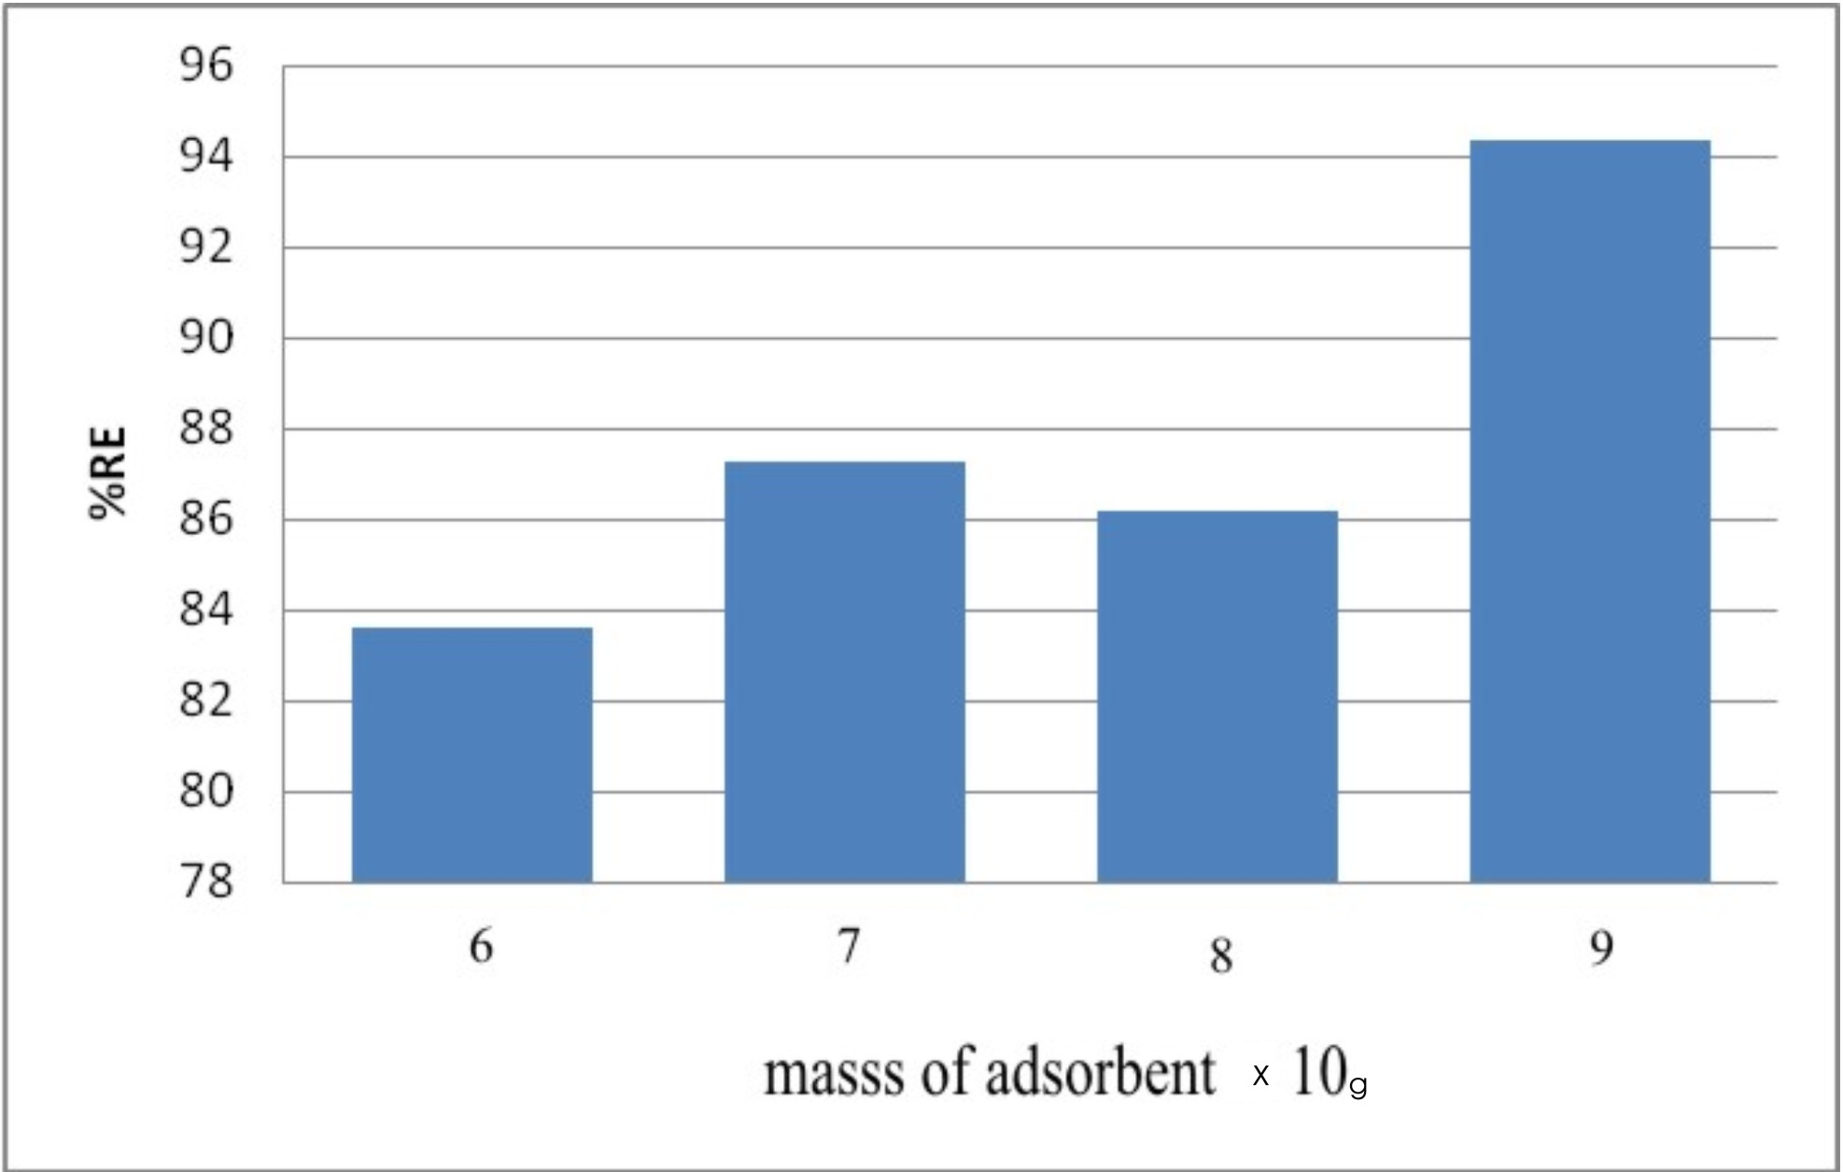
Sorption efficiency of cypermethrin uptake (%RE) by activated cocoa pod husk.

Figure 1. Sorption Efficiency of Cypermethrin Uptake (%RE) by Activated Cocoa Pod husks using different Adsorbent Dosage

3.6. Effect of Concentration of Activating Agent
This effect was investigated by varying the molar concentration of NaCl. Three different adsorbents were obtained using (5M, 1M and 0.5M) NaCl for activation. Table 5 revealed a direct relationship between molar concentration of NaCl and cypermethrin uptake. The trend follows 5M > 1M > 0.5M. This could probably be attributed to increasing density of solution as molar concentration of the AA increased (Jibril et al, 2007).The increasing molar concentration could also have contributed to increasing pH of the carbon surfaces leading to higher uptake by the carbon activated with 5M of the activating agent in line with the previous work(Gimba et al.,2009 ).Moreover increasing concentration of the AA might have led to enhanced production of micropores, lower ash content and higher pH values in the activated cocoa pod husks (table 2) which resulted in greater removal of the pesticide as shown in Figure 2.
The report so far has revealed that substantial amount of cypermethrin can be removed from an aqueous medium by employing appropriate particle size of ACPH sample activated with NaCl at an effective concentration.

Table 5. Batch equilibrium experimental data for cypermethrin adsorption showing the effect of concentration of activating agent at 298K
Conc, of AA | (moldm-³) C₀ (gdm-³) Ce(gdm-³) C_{a}( gdm-³) %RE M(g) q_{e(mg/g)}
0.5 1.52 0.189 1.331 87.566 0.0331 14.789
1.0 1.52 0.141 1.379 90.723 0.0179 15.322
5.0 1.52 0.086 1.434 94.342 0.0143 15.933
C_{0,} Ce , C_{a,} RE,M & q_{e,} as in Table 3.

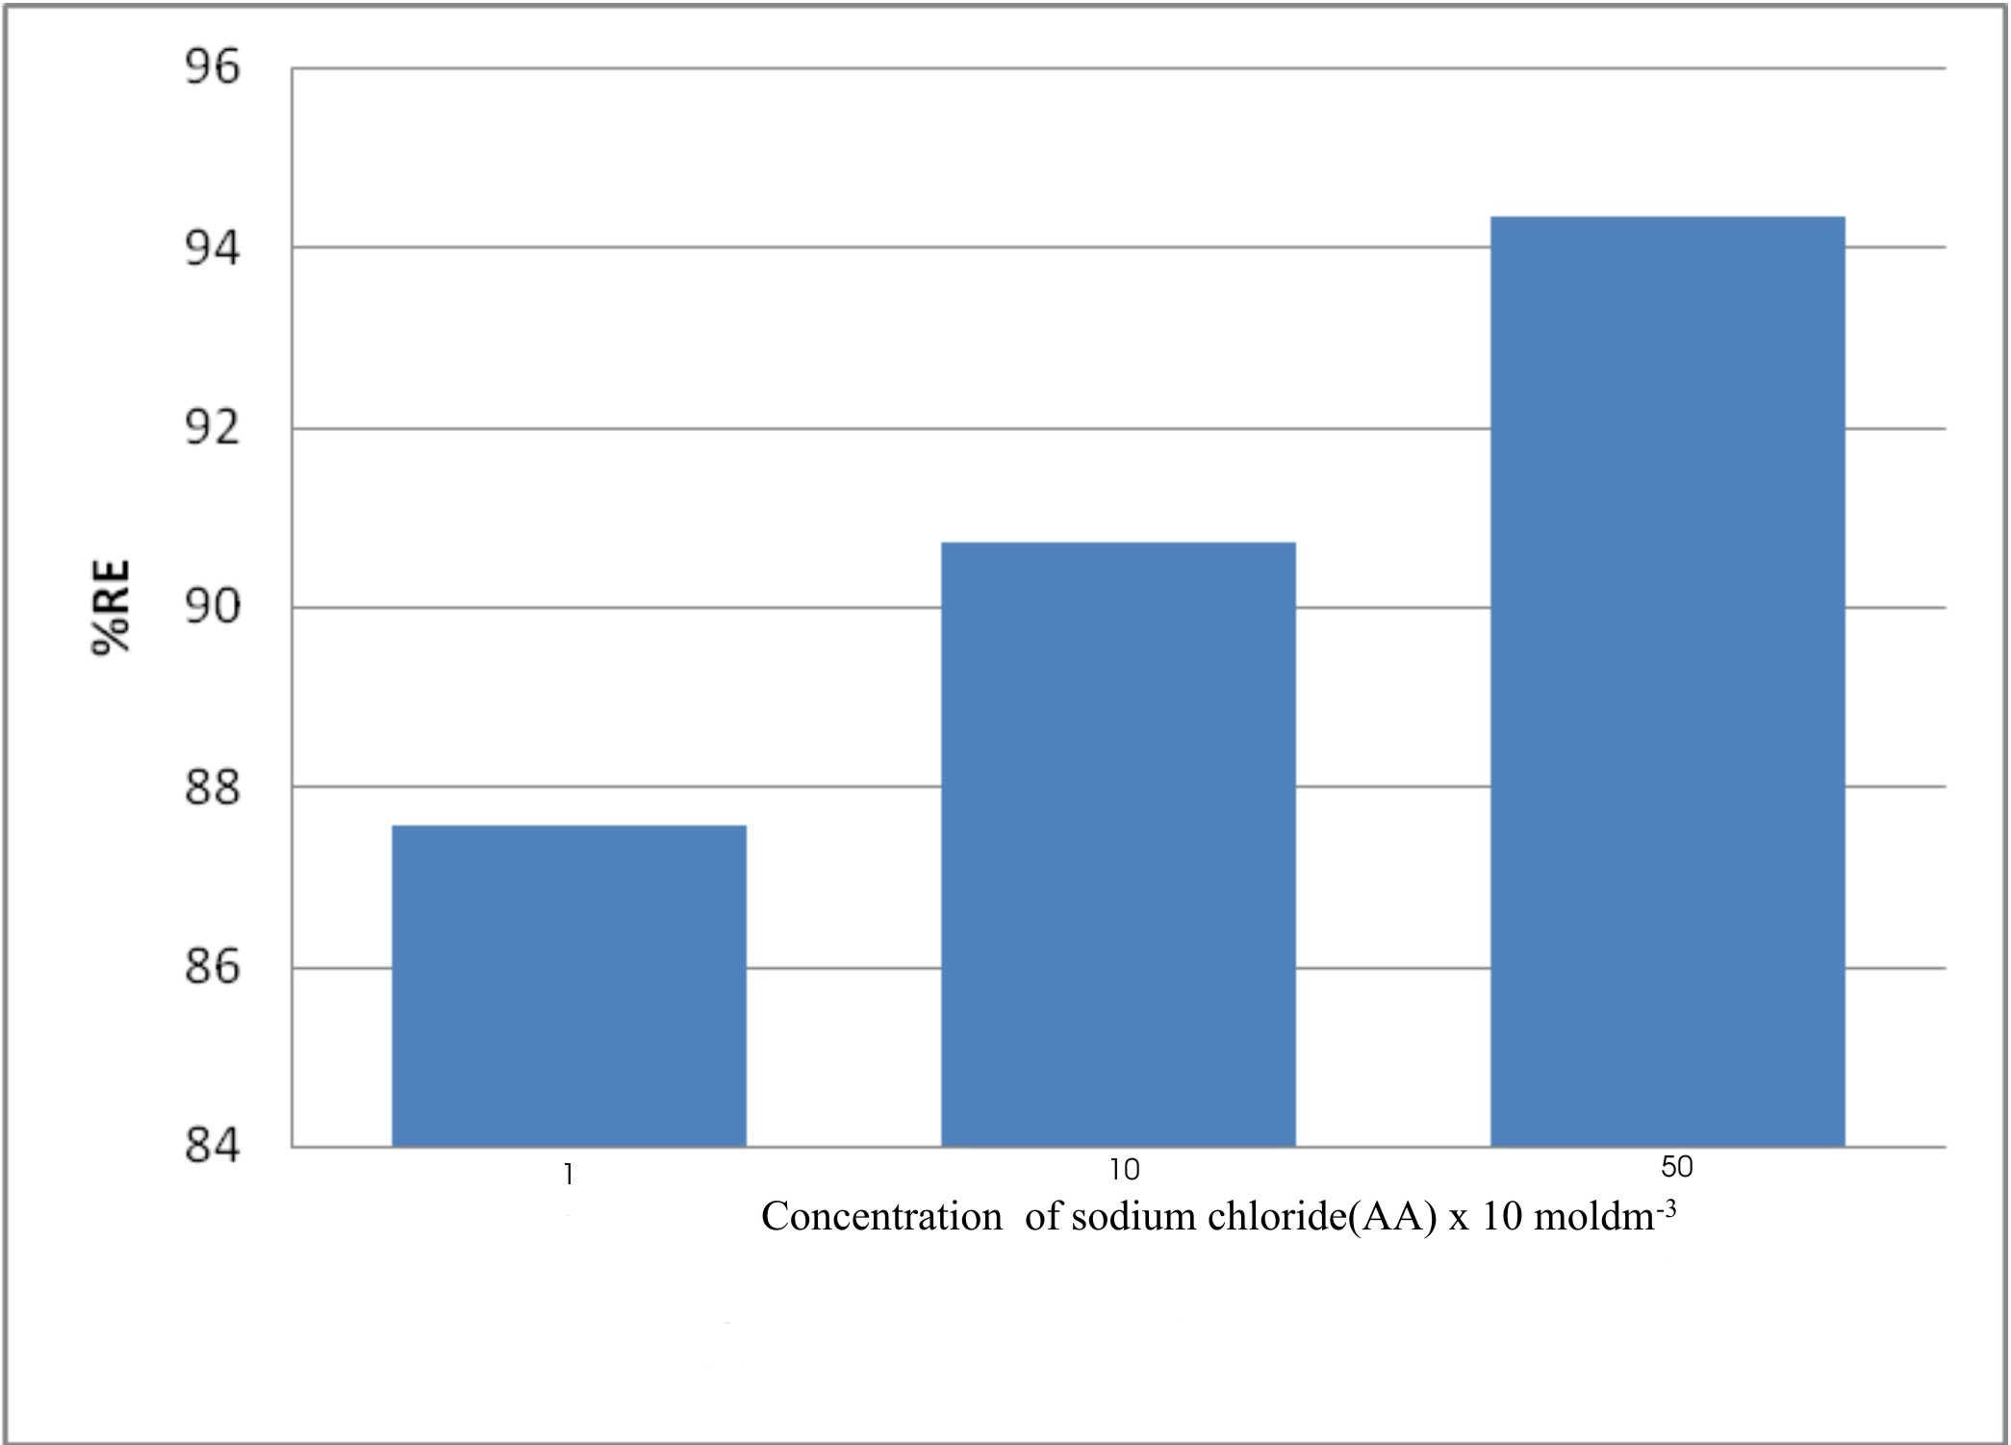
Figure 2. Effect of molar concentration of activating agent(NaCl) on sorption effciency of activated cocoa pod husk for cypermethrin.

3.7 Langmuir and Freundlich Isotherms
Langmuir plots involved plotting C_{e}/q_{e} against C_{e} and Freundlich plots were those of log₁₀ q_{e} against log₁₀C_{e. .}The good fit of the experimental data and the correlation coefficient (R²) indicates the applicability of the Langmuir isotherm model to the adsorption of cypermethrin by the ACPH in line with earlier works (Langmuir, 1916, Gimba et al., 2009, Olugbenga et al., 2011). The Freundlich isotherm parameters of n=5.102 (1/n=0.196) and k=25.41 showed that the adsorption data obtained in this work generally agreed with previous work (Gimba et al., 2009). It is known that small n (1< n < 10) indicates high adsorption capacity and the relatively high value of k shows high adsorption capacity ( Rozada et al.,2002,Weber Jr., 1973, Gimba et al.,2009).

Table 6. Langmuir and Freundlich Isotherms Parameters
Parameters | Isotherm
Parameters | Langmuir Freundlich
q₀ 22.73 -
K 43.99 25.41
R² 0.875
n - 5.102
1/n - 0.196
R_{L} 0.015 -

4. CONCLUSION
This work provides a procedure for obtaining carbonaceous adsorbents from the agricultural waste—cocoa pod. Removal of pesticide (cypermethrin) from solution using sodium chloride- carbon prepared from cocoa pod husk was achieved. There is an indication that cocoa pod husk could be an excellent precursor for preparation of AC that is effective for cypermethrin removal. From this study, adsorption of cypermethrin increased with increase in dosage of adsorbent and molar concentration of the activating agents as well as decrease in the adsorbent particle size. A relatively high removal of 94.32% cypermethrin by the ACPH products gives room for improvement possibly with higher activation temperature.

ACKNOWLEDGEMENT
Our profound appreciation goes to the technical staff of Department of Material Science and Engineering of the Federal University of Technology, Akure, Nigeria and those of the International Institute of Tropical Agriculture (IITA), Ibadan, Nigeria for their assistance during analysis of the carbons including the digital GC.
REFERENCES
Abdul A. Aberuagba F. Comparative study of the Adsorption of Phosphate by Activated Carbon from Corncobs, Groundnut shell and Rice-husk.A.U.J.T.2005;9{1}:59-63
Abram JC The Characteristics of Activated Carbon In: Proceedings of the Conferences Activated Carbon in Water Treatment. University of Reading, UK 1973;pp 1-29
Adegbola AA, Omole TA A Simple Technique For Preparing Discarded Cocoa Bean Meal For Use In Livestock Feed. Nig. Agric.J. 1973;10: 72-8.
Adeyanju SA, Oguntuga DB,Ilori JO, Adegbola AA.. Cocoa Husk in Poultry Diets. Mall Agric. Res. 1975; 4: 131-136.
Agritrade (“Cocoa Market Update” World Cocoa Foundation May 2010). www.agritrade.cta.int. Technical Centre for Agricultural and Rural Cooperation (CTA); (ACP-EU). 2010
Ahmedna M, Marshall W, Rao M.Production of Granular Activated Carbon from Selected Agricultural By-Products. Bioresources Technology. 2000;7(2): 113-123
Awolumate EO. Chemical Composition And Potential Uses Of Processing Wastes From Some Nigerian Cash Crops. Cocoa Research Institute of Nigeria. AnnualReport. Ibadan, Nigeria; 1982.
Aziza A, Odiakosa A, Nwajei G, Orodu V. Modification And Characterization Of Activated Carbon Derived From Bumper Sawdust And Disk Sawdust To Remove Lead (II) And Cadmium (II) Effluent Water. CSN Conference proceeding. Chemical Society of Nigeria. Deltachem 2008; 235-243
Bacci E, Calamari D, Gaggi C, Vighi M. Role of Evaluation Models to Asses Exposures to Pesticides.Chemosphere 1987; 16: 1373.
Bansode R, Losso J, Marshall W, Rao R, Portiere R. Adsorption Of Volatile Organic Compounds By Pecan Shell And Almond Shell Based Activated Carbons. Bioresource Technology 2003;90(1):175–18
Bouya H, Errami M, Salghi R, Bazzi LH., Zarrouk A., Al-Dyab SS., Hammouti B., Bazzi L Chakir A 2012. Electrochemical Degradation of Cypermethrin Pesticide on a SnO2 Anode. Int. J. Electrochem. Sci 2012; 3453 – 3465
Cadbury. Harvesting and Processing Cocoa Beans. www.cadbury.com.au 2012
Cheremisinoff PN,Ellerbusch F. Carbon Adsorption Handbook. Ann Arbor Science Publisher, New York 1978. pp. 241-280
Fitzpatrick RD. A gas-liquid chromatographic method for determination of cypermethrin (PP383) in crops, soils and water. Agriculture Chemicals Division, Research and Development Department, ICI America.
Gimba CE,Odike O,Egwakhide PA,Turoti,M, Akporhonor EE.New raw material for activated carbon. I.Methylene blue adsorption on activated carbon prepared from Khaya senegalensis fruits Cien. Inv. Agr. 2009; 36(1):107-114
Gimba CE,Salihu AA, Kagbu JA, Turoti M, Itodo AU,Sariyya AI. Study of pesticide (chlorvos) removal from aqueous medium by Arachis Hypogaea (groundnut) shell using GC-MS. World Rural Observation 2019;2(!):1-9
Itodo AU, Abdulrahman FW, Hassan LG, Maigandi SA, Itodo HU. Application of GC/MS Quantitation in the Adsorption of Herbicide by Sorbents from two Abundant Nut Shells. Researcher 2010; 2(2):64-73
Jibril B, Maamari R, Houache O, Aamri M, Qalhati M. Effect of H3PO4 and KOH on Pyrolysis of Bituminous Coal in Preparation of Activated Carbon. Journal of applied sciences Research 2007; 3(11): 1343 – 135
Jin H, Webster, GR.. Persistence, Penetration, and Surface Availability of Cypermethrin and Its Major Degradation Products in Elm Bark. J. Agric. Food Chem.1998 46:2851-2857.1998
Jones D,. Environmental Fate of Cypermethrin Environmental Monitoring & Pest Management Department of Pesticide Regulation Sacramento, CA. 1995
Khazaei I, Aliabadi M, Hamed MH. Use of Agricultural Waste for Removal of Cr(VI) from Aqueous Solution. Iranian Journal of Chemical Engineering 2011 Vol. 8, No. 4 (Autumn), IAChE.2011
Kollman W, Segawa R.Interim Report of the Pesticide Chemistry Database. Environmental Hazars Assessment Program. Department of Pesticide Regulation;1995
Lorenz. Potential Health Effect of Pesticides. Pesticides safety fact sheet. The Pennsylvania State University 2007. Accessed retrieved on from: http://www.pested.psu.edu/press
Malik R, Ramteke D, Wate S. Adsorption of Malachite green on groundnut shell waste based activated carbon. Waste management. 2006; 27 (9): 1129-1138
Mousavi HZ, Hosseynifar A., Jahed V, Dehghani SAM. 2010. Removal of Lead from Aqueous Solution Using Waste Tire Rubber Ash as an Adsorbent. Braz. J. Chem. Eng.2010;.27:.1
Mozammel HM, Masahirom O. Activated Charcoal from Coconut Shell Using Zncl₂ Activation. Biomass and Bioener. 2002; 22:397-400
Mishra S. Bhattacharya J. Batch Studies on Phenol Removal using Leaf Activated Carbon. Malaysian Journal of Chemistry 2007; 9(1): 051 - 059

Olugbenga SB, Mohd AA, Tan Tong S.. Utilization of Cocoa Pod Husk for the Removalof Remazor Black B Reactive Dye from Aqueous Solutions: Kinetic, Equilibrum and Thermodynamic Studies. Trends in applied sciences research 2011;6 (8): 794-812
Pengman JK. Guide to Environmental Issue. Government Printing Press, Washington 1996: 20
Rozada F, Calvo LF, Garcia AI, Villacorta JM, Otero M. Dye Adsorption By Sewage Sludge-Based Activated Carbons In Batch And Fixed Bed Systems. Bioresource Technology 2003; 87: 221-230
Schwartz HG. Microbial Degradation of the Pesticides isopropyl N–(3–chlorophenyl) carbamate and 2,4 – diisochlorophenoxy acetic acid in aqueoussolutions. Ph.D Thesis, California institute of Technology, Pasadena, California 1966:86
Singh, D.K. and N. Srivastava, Basic dyes removal from wastewater by adsorption on rice husk carbon. J. Chem. Technol. 2001; 8: 133-139
Tsai WT, Chang CV, Wang, CF, Chien SF, Sun HF. Preparation of activated carbons from corn-cobs catalyzed by potassium salts and subsequent gasification with CO₂. Bioresource Technology 2001; 78(2): 203 – 208
Valentina FD, Giuseppe P, Arminda CA, Miguel FC, Cristina DM. Adsorption Behavior of α-Cypermethrin on Cork and Activated Carbon. Journal of Environmental Science and Health, Part B: Pesticides, Food Contaminants, and Agricultural Wastes 2007; 42, (6):649-654
Weber Jr. W.J. the production and perfomance of activated carbon for water treated. A paper presented at a conference on “Activated carbon in water treatment” organized by the Water Research Association at University of Reading. 3rd – 5th April. 1973. 53 71
Wu F.C., Tseng R., Juang R.S. Porestructure and adsorption performance of the activat
ed carbons prepared from palm kernels. J.Hazard. Mater. 1999; B69: 287-302

