Antibacterial effect of Moringa oleifera on Multidrug Resistant Pseudomonas aeruginosa Isolates from Wound infections in Abeokuta, Ogun State, Nigeria.

^{1, 2}Akingbade OA, ³Akinjinmi AA, ⁴Ezechukwu US, ⁵Okerentugba PO, ⁶Nwanze JC, ⁶Onoh CC, ⁵Okonko IO

¹Department of Microbiology, Federal University of Agriculture, Abeokuta, Nigeria
E-mail: olusola.akingbade@yahoo.co.uk 08063529234
²Department of Microbiology, Federal Medical Centre, Idi Aba, Abeokuta, Nigeria
³Department of Chemical Pathology, Federal Medical Centre, Idi Aba, Abeokuta, Nigeria
⁴Department of Haematology and Blood Serology, Federal Medical Centre, Idi Aba, Abeokuta, Nigeria
⁵Medical Microbiology Unit, Department of Microbiology, University of Port Harcourt, P.M.B. 5323, Choba, East-West Road, Port Harcourt, Rivers State, Nigeria;
⁶Department of Pharmacology and Therapeutics, Igbinedion University, Okada, Edo State, Nigeria
mac2finney@yahoo.com, iheanyi.okonko@uniport.edu.ng; Tel.: +234 803 538 0891

Abstract: Medicinal plants have been found useful in the cure of a number of diseases including bacterial diseases. In this study, fresh leaves of Moringa oleifera was collected from Siun, Abeokuta, Ogun State and identified at the Department of Biological Sciences, Federal University of Agriculture, Abeokuta, Ogun State, Nigeria. Phytochemical analysis was carried out on the dry leaves using aqueous, methanol and ethanol solvent. The leaves were tested against five Pseudomonas aeruginosa strains using disc diffusion method. The phytochemical screening of ethanol extract of the M. oleifera revealed the presence of flavonoids, tannins, alkaloids and saponins compounds while methanol extract showed the presence of flavonoids and saponins. In aqueous extract, flavonoids, tannins, terpenoids, alkaloids and saponins compounds were detected. The extract showed different zone of inhibitions to the Pseudomonas aeruginosa isolates in the different solvents used. The result from this present study showed that left extract of M. oleifera had broadest spectrum of activity on the tested bacteria.
[Akingbade OA, Akinjinmi AA, Ezechukwu US, Okerentugba PO, Nwanze JC, Onoh CC, Okonko IO. Antibacterial effect of Moringa oleifera on Multidrug Resistant Pseudomonas aeruginosa Isolates from Wound infections in Abeokuta, Ogun State, Nigeria. World Rural Observ 2013;5(3):6-10]. ISSN: 1944-6543 (Print); ISSN: 1944-6551 (Online). http://www.sciencepub.net/rural. 2

Keywords: Antibacterial effect, Moringa oleifera, Multidrug Resistant, Pseudomonas aeruginosa, Wound infections, Phytochemicals

1. INTRODUCTION
Moringa oleifera is used as a highly nutritive vegetable in many countries. Its young leaves, flowers, seeds and tender pods are commonly consumed and they have some medicinal properties. Plants have many antimicrobial properties as secondary metabolites such as alkaloids, phenolic compounds, etc. The practice of complementary and alternative medicine is now on the increase in developing countries in response to World Health Organization directives culminating in several pre-clinical and clinical studies that have provided the scientific basis for the efficacy of many plants used in folk medicine to treat infections (Dilhuydy and Patients, 2003). Medicinal plants are plants containing inherent active ingredients used to cure disease or relieve pain (Okigboet al., 2008). The World Health Organization estimated that 80% of the populations of developing countries rely on traditional medicines, mostly plant drugs, for their primary health care needs (WHO, 2005).

In developing countries, large number of people die daily of preventable and curable diseases such as wound infections. Wound infection is one of the health problems that are caused and aggravated by the invasion of pathogenic organisms in different parts of the body. Previous studies from different parts of the country showed that Pseudomonas species, Staphylococcus aureus, Klebsiella species, Escherichia coli and Proteus spare the most common pathogens isolated from wound (Akingbade et al., 2012). According to Emori and Gaynes (1993), P. aeruginosa is currently one of the most frequently isolated nosocomial pathogens and the infections due to this organism are often difficult to treat due to antibiotic resistance. Despite improvements in antibiotic therapy Pseudomonas aeruginosa is intrinsically resistant to a number of antimicrobial agents frequently including multiple classes of antimicrobial agents (Smith et al, 2012). Bacterial contamination of wounds is an important cause of mortality. Rapidly emerging nosocomial pathogens and the problem of multi-drug resistance necessitate periodic review of antibiogram pattern of organisms isolated in wounds (Mehta et al., 2007).
The development of wound infection depends on the integrity and protective function of the skin (Anupurbaet al., 2010). The widespread use of antibiotics, together with the length of time over which they have been available have led to major problems of resistant pathogens in wound infections contributing to morbidity, and mortality (Nwachukwu et al., 2009). It has been shown that wound infection is universal and the bacterial type varies with geographical location, resident flora of the skin, clothing at the site of wound, time between wound and examination (Anupurba et al., 2010). The wound sometimes gets infection by either single or multiple organisms. Wound infections are mostly due to nosocomial pathogens that differ from country to country and from hospital to another within the same region which remains the major source of post-operative morbidity (Akingbade et al., 2012). In general, a wound can be considered infected if purulent materials drain from it, even without confirmation of positive cultures. Also, many wounds are colonized by bacteria, whether infected or not. Infected wounds may not yield pathogens by culture owing to the fastidious nature of some pathogens, or if the patient has received an antimicrobial therapy (Nwachukwu et al., 2009).
Many bacterial agents are known to cause wound infections. Initial injury to the skin triggers coagulation and an acute inflammatory response followed by exposure of subcutaneous tissue following loss of skin integrity which provides a moist, warm, and nutritive environment that is conducive to microbial colonization and proliferation (Yah et al., 2010). Despite introduction of a wide variety of antimicrobial agents, life-threatening infections caused by bacteriacontribute to morbidity and mortality in hospitalized patients (Nwachukwuet al., 2009).
The antimicrobial properties of plants have been investigated by a number of studies worldwide and many of them have been used as therapeutic alternatives because of their antimicrobial properties (Adriana et al., 2007). This study is to determine the phytochemical properties of the leaf extracts of Moringa oleifera and the antibacterial effect on multidrug resistant Pseudomonas aeruginosa isolates from wound infections.

2. MATERIAL AND METHODS
2.1. Plant material
The fresh leaves of Moringa oleifera was collected from Siun, Abeokuta, Ogun State and identified in Biology department of Federal University of Agriculture, Abeokuta, Ogun State.

2.2. Phytochemical Analysis
The extract was analyzed to test for the presence of terpenoids, flavonoids, alkaloids, glycosides saponins, tannins, and phenols (Talukdaret al, 2010).

2.3. Preparation of the Aqueous extracts
Twenty grams of the dried leaves of Moringa oleifera was weighed out and crushed directly by grinder and dipped into 100ml distilled water into a conical flask stoppered with rubber corks and left for 2days with occasional shaking and filtered off using sterile filter paper (Whattman no. 1). The filtrates were evaporated under reduced pressure to get a thick residue. The extracts obtained were then stored in a refrigerator at 4°C for antibacterial activity test (Akueshi et al., 2002).

2.4. Preparation of ethanol and methanol extracts
The same procedure as above was followed for the ethanol and methanol extracts preparation using 100% grades of the solvents.

2.5. Test microorganisms
Pseudomonas aeruginosa isolates (P1, P2, P3, P4 and P5) were collected from Federal Medical Centre, Abeokuta, Ogun State. Antibacterial activity of the sample (M. oleifera) was performed using disc diffusion method to determine sensitivity of the bacteria to the extracts. Discs containing 100mg/ml concentration was prepared from the dissolved plant extracts using sterile Whatman filter paper No. 1 (6 mm in diameter). Negative control was prepared using the solvents only. Antimicrobial activity was evaluated by measuring the zones of inhibition against the tested bacteria. Each assay was carried out in triplicate.

3. RESULTS ANALYSIS
The result showed that Pseudomonas aeruginosa P1 strain had zone of inhibition of 8mm to gentamycin and was resistant to ofloxacin, cloxacillin, augmentin and ceftazidime. P2 was sensitive only to ceftazidime with 6mm zone of inhibition and was resistant to ofloxacin, cloxacillin, gentamycinand augmentin. Pseudomonas aeruginosa P4 and P5 showed no zone of inhibition to the five antibiotics: ofloxacin, cloxacillin, gentamycin, augmentin and ceftazidime used in this study.

Table 1: Antibiotic susceptibility pattern of the five Pseudomonas aeruginosaisolates obtained from wound swabs
Isolates | Ofloxacin | Cloxacillin | Gentamycin | Augmentin | Ceftazidime
P 1 | R | R | 8mm | R | R
P 2 | R | R | R | R | 6mm
P 3 | R | R | 6mm | R | R
P 4 | R | R | R | R | R
P 5 | R | R | R | R | R
Key: R = Resistant

The phytochemical analysis carried out on the dry leaves of Moringa oleifera using aqueous, methanol and ethanol showed the presence of some bioactive compounds in the plant. Phytochemical screening of ethanol extracts of M. oleifera revealed the presence of flavonoids, tannins, alkaloids and saponins compounds while methanol extracts showed the presence of flavonoids and saponins. In aqueous extracts of M. oleifera flavonoids, tannins, terpenoids, alkaloids and saponins compounds were detected. Flavonoids and saponins were the major phytochemicals present in the extract in table 2.

Table 2: Qualitative Phytochemical Analyses of the extracts of M. oleifera
Phytochemical | Ethanol | Methanol | Aqueous
Phenols | _ | _ | _
Flavonoids | + | + | +
Tannins | + | _ | +
Terpenoids | _ | _ | +
Akaloids | + | _ | +
Glycosides | _ | _ | _
Saponins | + | + | +
Key: (+) indicates presence while (–) indicates the absence of the components

Antimicrobial sensitive profile of one hundred milligrams concentration of the extract in aqueous, 100% methanol and 100% ethanol solutions were tested. In fig 1 the result showed that Pseudomonas aeroginosa P 1, P2, P3 and P5 in 100% methanol, were sensitive to Moringa oleifera solvents with zone of inhibition of 12mm, 14mm, 10mm and 11mm respectively while there was no zone of inhibition in P4. In fig 2 the result showed that Pseudomonas aeroginosaP1, P2, P3 and P5 in 100% ethanol, were sensitive to Moringa oleifera solvents with inhibition zone of 10mm, 9mm, 12mm and 11mmrespectively while there was no zone of inhibition in P4. In fig 3 the result showed that Pseudomonas aeroginosa,P1 and P2 in aqueous, were sensitive to Moringa oleifera solvents with inhibition zone of 5mm and 6mm respectively while there were no zone of inhibition in P3, P4 and P5.

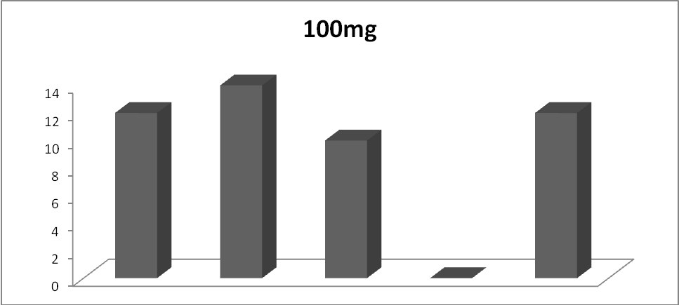
P1 P2 P3 P4 P5
Figure 1: Zone of inhibition of Moringa oleifera concentration in 100% Methanol solvent
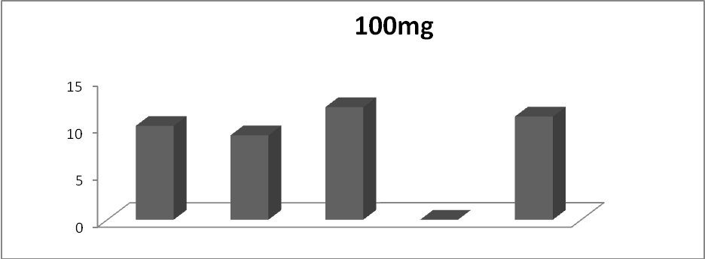
P1 P2 P3 P4 P5
Figure 2: Zone of inhibition of Moringa oleifera concentration in 100% ethanol solvent

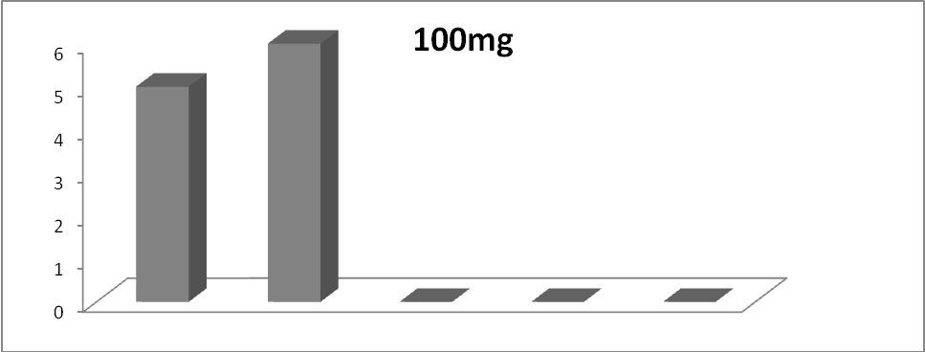
P1 P2 P3 P4 P5
Figure 3: Zone of inhibition of Moringa oleifera concentration in aqueous

4. DISCUSSION
The phytochemical analysis was carried out on the dry leaves of Moringa oleifera using three solvents. The phytochemical analysis showed the presence of some bioactive compounds in the plants. Out of the seven bioactive constituents tested for, only two was detected in all the solvents. These are flavonoids and saponins. Secondary metabolites of various chemical types present in the plant species are known to possess antimicrobial activity. Flavonoids are found to be effective antimicrobial substances against a wide range of microorganisms (Tsuchiya et al., 1996).
Phytochemical screening of ethanol extracts of M. oleifera in this study revealed the presence of flavonoids, tannins, alkaloids and saponins compounds. Bukaret al (2010), also in his research revealed the presence of flavonoids and saponins in Moringa oleifera ethanol leaf extract which is consistent with the result from this study, but tannins and alkaloids were also detected in this present study which were not reported by Bukar. Farooq et al. (2007) reported that plants occur in varying habitats and a great magnitude of variation in the concentration and composition of phytochemical ingredients in the different parts of such plant is expected. Moreover, Waller and Nowacki (1978) reported that phytochemicals are produced in response to perceived threats by the plants, therefore variation exist in the production of these phytochemicals depending on the type and amount of threat encountered by the plant.
The result from this present research showed that M. oleifera leaf methanol (MLM) extract had broadest spectrum of activity on the tested bacteria. The results showed a better activity of the extract against P1, P2, P3 and P5. The M. oleifera leaf extract was not active against P. aeruginosa (P4). P. aeruginosa isolates (P1, P2, P3 and P5) were sensitive to 100 percent grades of methanol and ethanol extracts of M. oleifera and the aqueous extract, this is in contrast to Napolean et al. (2009) research that reported resistant of P. aeruginosa to all concentrations of methanol used apart from the highest concentration of 200mg/ml MLE. P. aeruginosa is well known as a hardy and difficult organism that constitutes problems to researchers (Brooks et al., 2001).
Gentamycin and Ceftazidime were the only antibiotics that showed sensitivity to P. aeruginosa in this present study, this is in agreement with a research carried out in south west Nigeria by Akingbade et al. (2012), who recordedhigh susceptibility activities of gentamycin against P. aeruginosa obtained from wound infections. The broad spectrum antibacterial activity exhibited by Moringa oleifera in this study may be attributed to the various active components present in it, which either due to their individual or synergistic action exhibit antibacterial activity. The antibacterial effect of the Moringa oleifera on the multidrug resistant Pseudomonas aeruginosa isolates showed different zone of inhibitions to the Pseudomonas aeruginosa isolates in the different solvents. The result from this present study showed that M. oleifera leaf had broadest spectrum of activity on Pseudomonas aeruginosa.

REFERENCES
- Adesokan, A.A., M. A. Akanji, and M. T.Yakubu. 2007. Antibacterial potentials of aqueous extract of Enantiachloranthastem bark. Afr. J. Biotechnol. 6 (22): 2502-2505.
- Adriana, B., A.N.M. Almodóvar1, C.T. Pereira1, and T.A. Mariângela. 2007. Antimicrobial efficacy of Curcuma zedoariaextract as assessed by linear regression compared with commercial mouthrinses. Braz. J. Microbiol. 38:440-445.
- Akingbade O.A., Balogun S.A., Ojo D.A, Afolabi R.O., Motayo B.O, Okerentugba P.O., Okonko I.O. (2012). Plasmid Profile Analysis of Multidrug Resistant Pseudomonas aeruginosaIsolated from Wound Infections in South West, Nigeria World Appl. Sci. J., 20 (6): 766-775, 2012
- Akueshi, C.O., C.O. Kadiri, E. U. Akueshi, S. E. Agina, and B. Ngurukwem. 2002. Antimicrobialpotentials of HyptissauvedensPoit (Lamiaccae). J. Bot. 15: 37-41.
- Brooks, G.F., Butel, J.S. and Morse, S.A. (2001): Jawetz, Melnick and Adelberg's Medical Microbiology (22ndedn.). Lange Medical Books. Pp. 145-150
- Bukar, A., Zuba, A. and Loyeyi, T.I. (2010). Antimicrobial profile of Moringa oleifera lam. Extracts against some food – borne microorganisms Bayero Journal of Pure and Applied Sciences, 3(1): 43 – 48
- Chandrasekaran, M., and V. Venkatesalu. 2004. Antibacterial and antifungal activity of Syzygiumjam bolanum seeds. J. Ethnopharmarcol. 91:105-108.
- Courvalin P. Antimicrobial Drug Resistance: “Prediction Is Very Difficult, especially about the Future”. Emerg Infect Dis. 2005; 11: 1503-06.
- Dilhuydy, J.M. 2003. Patients attraction to complementary and alternative medicine (CAM): a reality which physicians can neither ignore nor deny. Bull. Cancer. 90:623-628.
- Fahey, J.W. 2005. Moringa oleifera: A review of the medical evidence for its nutritional, therapeutic, and prophylactic properties. Trees for Life Journal.1:5.
- Farooq, A., Sajid, L., Muhammad, A. and Anwarul Hassan, G. (2007): Moringa oleifera: a food plant with multiple medicinal uses. Phytotherapy Research. 21:17 – 25.
- Levy S.B (2002). Factors impacting on the problems of antibiotic resistance. J. Antimicrob Chemotherapy, 49:25-30.
- Livermore, D.M (2005): Minimising antibiotic resistance, Lancet Infect. Dis. 5:450-459.
- Mahesh B and S Satish, (2008). Antimicrobial activity of some important medicinal plant against plant and human pathogens. World J Agric Sci.; 4 (S): 839-843
- Napolean, P., Anitha, J. and Emilin, R.R. (2009): Isolation, analysis and identification of phytochemicals of antimicrobial activity of Moringaoleifera Lam. Current Biotica. 3(1): 33 – 37.
- Okigbo RN, Eme UE, and Ogbogu S (2008). Biodiversity and conservation of medicinal and aromatic plants in Africa. Biotechnol. Mol. Biol. Rev. 3, 127-134.
- Smith, S., O. Ganiyu, R. John, M. Fowora, K. Akinsinde and P. Odeigah, 2012. Antimicrobial Resistance and Molecular Typing of Pseudomonas aeruginosa Isolated from Surgical Wounds in Lagos, Nigeria. Acta Medica Iranica, 50: 433-438.
- Talukdar AD, Choudhary MD, Chakraborty M and Dutta BK: Phytochemical screening and TLC profiling of plant extracts Cyatheagigantea (Wall. Ex. Hook.) Haltt and Cyatheabrunoniana. Wallex Hook. (Cl. & Bak.). Assam University Journal of Science & Technology: Biological and Environmental Sciences 2010; 5(1):70-74.
- Tsuchiya H., Sato M., Miyazaki T., Fujiwara S., Tanigaki S., Ohyama M., Tanaka T. and Linuma M. (1996), Aprenylated flavanone from roots of Amorpha fruticosa, J. Ethnopharmacol. 50: pp27.
- Waller, G.R. and Nowacki, E.K. (1978): Role of alkaloids. Alkaloid Biology and Metabolism in Plants. Plenus Press, New York. 249pp.

7/15/2013

