Wealth ranking, Capital Assets profiling and livelihoods diversification in two Artisanal inland water Fishing Communities

¹S. I. Ovie and ²Tafida, A. A.

¹National Institute for Freshwater Fisheries Research, PMB 6006 New Bussa, Niger State, Nigeria
²Department of Agricultural Economics and Extension, Modibbo Adama University of Technology, PMB 2076 Yola, Adamawa State, Nigeria
tafjam2003@yahoo.com

Abstract:The study was conducted at Wawu on the eastern shore of Lake Kainji and Dumba on the western shore of Lake Chad. The study assesses capital assets available in the communities and ranked wealth and poverty statuses as well as livelihood portfolios of the communities’ members. The results revealed that distribution of capital assets was not even among community members and between the two communities and to a large extent, determines their wealth status and engagement in livelihoods portfolios. Overall, the people are found to engage in multiple livelihood activities such as farming, herding and trading as a strategy to improve their socio-economic well-being following the prevailing poverty situation in the areas.
[S. I. Ovie and Tafida, A. A. Wealth ranking, Capital Assets profiling and livelihoods diversification in two Artisanal inland water Fishing Communities. World Rural Observ 2013;5(3):18-22]. ISSN: 1944-6543 (Print); ISSN: 1944-6551 (Online). http://www.sciencepub.net/rural. 4

Key words: Wealth; Capital assets; Livelihood; Poverty; fishing communities.

1.Introduction
Two widely accepted facts about fisheries and indeed agriculture in Sub-Saharan Africa are that income is highly uncertain and that deep and widespread poverty exists among actors, making them highly vulnerable (Ravallion, 1988; Anderson, 2002). Unarguably, the sector is significant to livelihoods of millions of people as it serves as source of income, food/nutrition security and employment to many stakeholders (Ovie et al., 2007). However, the sector is currently being threatened due to over exploitation and other factors (FAO, 2005). Several approaches to enhance fisheries resources and alleviate poverty among the actors could apparently not see the light of the day. However, some authorities have it that approaches to rural livelihood and poverty must not necessarily be linked to natural resources base (Bebbington, 1999). Consideration should be given to livelihood diversity base on capital assets at the disposal of the fishers, which proved to be helpful in poverty alleviation and resource sustainability (Scoones, 1998; Ellis, 1999). Therefore, attempt to understand the effective approach in constructing livelihood strategy using capital assets are key pillar in an effective resources management and sustainable rural poverty reduction.
A holistic assessment and understanding of rural livelihood portfolios for the purpose of identifying, assessing and designing poverty reduction programs is the core of the Sustainable Livelihood Approach (SLA) and more specifically the Sustainable Fisheries Livelihood Program (SFLP).

1.1.Objective of the study
This study on two Nigerian fishing villages (Wawu on the eastern shore of Lake Kainji and Dumba on the Western shore of Lake Chad) was undertaken to identify the assets and livelihoods strategies available to these two rural fishing communities.

1.2.Description of the study sites
Wawu is about 45 km from the Kainji Lake Dam, it derived its name from a tributary of River Niger. It lies within 9⁰ 30’ and 10⁰ 55’N and 4⁰ 20’ and 4⁰ 40’ E. It is an active fishing village dating back to the formation of the Dam (1968). The predominant tribe is Hausa with some occasional immigrants’ fishers from other parts of Nigeria and Mali. On the other hand, Dumba is located on the Western shore of Lake Chad close to the strategic fish market of Baga Kawa. It is located on 12⁰ 48’N and 13⁰ 52’ E. The predominant tribes are Kanuris and Hausas. It is a major fishing village as well.

2.Methodology
The Rapid Rural Appraisal (RRA) technique using pre-tested questionnaires organized in a semi-structured interview (SSI) format was used for the study. The Participatory Poverty Assessment (PPA) method, which utilizes the views of poor people (in this case household interviewed) in poverty assessment and strategies for reduction through public policy, was used to assess the socio-economic status of the households. Finally, simple descriptive statistics was employed for easy presentation of the results.
3.Results and Discussion
3.1Socio-economic
The household size in Wawu ranged from 3-30 individuals, with mean of 14; comprising 6 adults and 8 children. In Dumba household size is slightly lower and ranged 5-20 with mean of 9; comprising 3 adults and 6 children (figure 1)
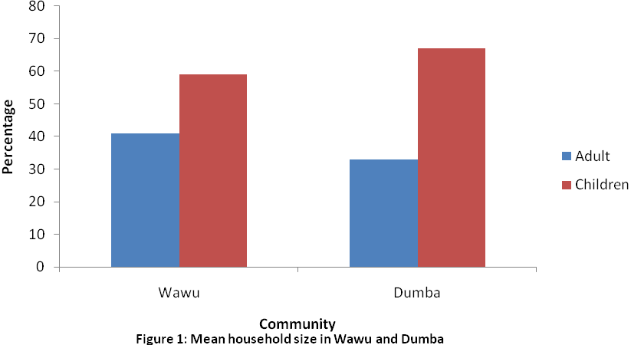
Three major wealth (poor) groups were identified in the study based on a number of criteria such as resource availability and production related factors (e.g. size and diversity of fishing gears, size of farm and livestock) and other entrepreneurial activities. The major characteristics of these groups as summarized from the different respondents are presented in Table 1.

3.2.Relative status of capital assets in Wawu and Dumba
Economically, the Wawu and Dumba rural communities are involved mainly in fishing/farming and to a limited extent, animal herding and petty trading. Attempt to assess the capital assets (physical, Natural, Social, Financial and Human) of the two communities revealed the following (Table 3).

Table 1: Characteristics of major wealth groups in Wawu , Kainji Lake , Nigeria, 2004
Wealth group | Characteristics
Group 1  (Upper Class less poor) | Larger fishing gears/crafts (6-20 bundles of gill nets i.e. 180-600m, 500-5000 hook line, 1-2 cast nets, bigger boats and out board engines (mostly 20-40 hp) for fishing in open and distant area of the Lake), larger acreage of farm land (3-5 acres for rice and guinea corn mainly), larger livestock herds (about 10-20 cows, sheep and goats) for fattening and selling. Have food almost all year round.
Group 2  (Middle Class-poor) | Less fishing inputs (2-11 bundles of net), about 500-3000 hook line, one cast net, smaller boats with smaller out board engines (15-25 hp), smaller farm size (2-3 acres), livestock herds (about 5-10 cows) and petty trading. May have food for most part of the year.
Group 3  (Lower Class-very poor) | Little subsistence farming/fishing (about 2-5 bundles of net, 100-1000 hook line), engage mainly in labour. Lack food for most part of the year or all-year-round. Operates generally at the subsistence level

Table 2: Characteristics of major wealth groups in Dumba , Lake Chad Nigeria, 2004
Wealth group | Characteristics
Group 1  (Upper Class less poor) | Possesses 6-10 boats, 3-5 outboard engines, can reach distant fishing grounds, many assistants and large acreage of farm land, a house and sometimes a motor vehicle, plenty of fishing gears (5-20 bundles of gill nets, 200-1000 of Malian traps (Goura), 3000-30000 hooks, own drag nets, livestock (10-20 cows with many goats and sheep). Have food for all year round.
Group 2  (Middle Class-poor) | Possesses 2-5 boats with 2-3 outboard engines, 4-10 bundles of gillnets, 1000 7000 hooks, 250-500 Malian traps, motor cycle, limited farm land and livestock. Have food for most part of the year.
Group 3  (Lower Class-very poor) | Posses 0-1 boat with no out board engine, 1-3 bundles of gill nets, very little traps, may not own farms and in most cases work as an assistant to those in group 1 and 2. Lack food for most part of the year.

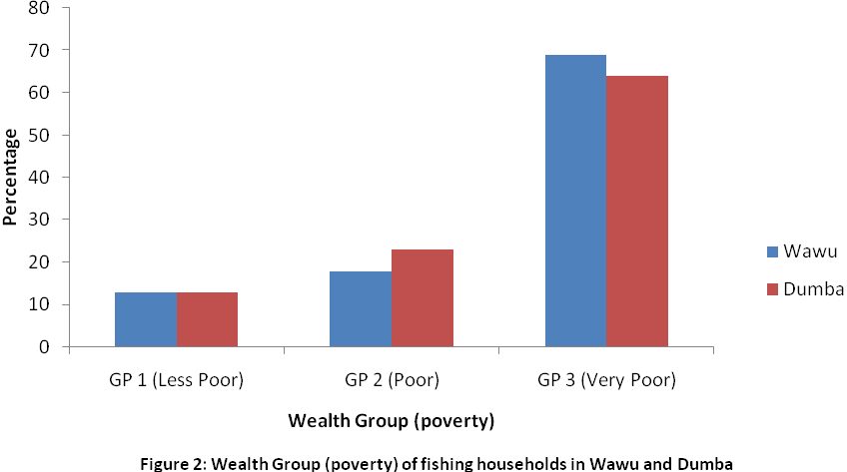

Table 3: Description of Capital Assets of Wawu and Dumba
Capital Assets | Wawu | Dumba
Physical | Fishing infrastructure or facilities were absent except for an old government built smoking kiln that is now bad; no electricity and communication networks, no water supply network except one government-built hand-operated borehole that is now out of use; very bad earthen road and a non operational health clinic. On a scale of 1-5 this asset is rated 1.3 | No cold storage facilities; only two out of 40 respondents had local smoking kiln (banda), no potable water (depend on raw Lake water), no roads, no health centers no schools, no electricity and communication. Rating =1
Natural | Water and land upon which the fishing/farming activities of the community revolve are abundant but for the high vulnerability of depleted fish stock and poor fertility of the soil. Fuel wood is also scarce but these are complemented by limited livestock. On a scale of 1-5, these asset is rated 2.5 | Abundant fisheries resources and fertile farmland for crop production. Fuel wood scarce hence charring of fish. Limited amount of animal herding represents a real source of income. Rating =4
Social | A relatively cohesion village level institutional structure with the Hakimi, Wakili and Magajin gari constituting the village council. Households comply with village norms/traditions and rules are engaged in reciprocal activities and assistance to the needy. No functional co-operative society exists. On a scale of 1-5, this assets is rated 2.8 | Cohesion among community members is apparent; members engage in mutual and reciprocal activities such as farming, construction of fishing gears, repair of earthen roads etc. strong village level institution headed by the village ward (Lawal) and assisted by the ward head (Bulama) exists. Rules, traditional and norms are generally respected. Rating =4
Financial | Low income, little or no savings, non-availability or difficult access to credit (if available) constrain the potential to develop the financial capital of the community. On the scale of 1-5, this asset is rated 1.4 | Loan/credit facilities not available. Income from fish sale and savings relatively modest but no strong co-operative society. Rating =2.3
Human | Adequate household size to cope with the major livelihood activities if the required inputs are available. Skills in fishing, farming and herding are real assets to the population. Human capital is however constrained by lack of schools and medical facilities (the only available clinic is now nonfunctional and dilapidated as termite mounds have taken over the interior. On a scale of 1-5, this assets is rated 2.5 | Adequate household size (mean =3 adults, 6 children). Adult skilled in fishing, farming and animal herding. No well established schools (only koranic education) and clinics. Rating = 2.5

3.3.Livelihood Diversity
The relative contribution of livelihood portfolios to annual income generation is shown in figure 2. In Wawu, fishing accounts for 74% of income generated annually by community households. Farming, animal herding and petty trading made up 15%, 8%, and 35 respectively, of annual income available to the rural fishing communities. The situation is similar in Dumba: fishing 96%; farming 2%; herding 1% and trading 1%. As with occupation, therefore, fishing represents the main source of income.
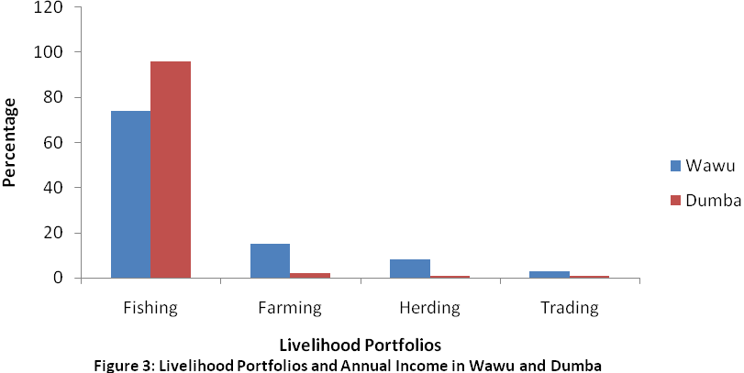

Of the estimated 140m population of Nigeria, about 75% live in the rural areas, subsisting largely on traditional agriculture (World Bank, 1996) and are associated with poverty (Ellis, 1999). The study sites (Wawu and Dumba) are characterized by numerous villages that are typically rural: temporary shelter, harsh environmental living conditions, remoteness from major cities and lacking basic amenities of life, subsistence agriculture (mainly fishing, farming, animal herding and petty trading), absence of schools, potable water, major markets, roads, health facilities etc. The mechanisms for surviving in such harsh situation, using all possible livelihood strategies, are therefore major preoccupation of the rural households and the community as a whole.
Neiland et al. (1997) and Ovie et al. (2000) examined the subject of fishing income, poverty and fisheries management in North East Nigeria including Chad Basin. The study revealed four major groups comprising the richest, the rich, the poor and the poorest. Wealth ranking in this present study revealed three major groups: group 1,2 and 3 in decreasing order of well-being. While these groups have been traditionally referred to as rich or non-poor (wealthy), the middle class and the poor, we would, in light of field experience, refer to these groups, respectively, as less poor, poor and very poor. Members of the last group are largely unable to feed themselves for most part of the year, thus depending mainly on social network for weathering the highly vulnerable conditions in these rural communities. Wealth distribution was a function of the type and degree of activities in which rural households are involved. By far, households engaged in fishing and farming were more economically secured.
Occupationally, the practice of engaging in diverse economic activities such as fishing, farming animal herding and trading constitute a major rural survival strategy and this in addition to the observed high social network (good social capital) are major strengths of the community upon which to build poverty alleviation programmes. A diversified rural economy, such as exists in the communities studied creates jobs and utilizes labour more effectively. In addition, the practice ensures alternative income in off-peak periods thus reducing the risk of income failure by “spreading risks across activities that confront different risk profiles” (Ellis, 1999; DFID, 1999)
The over 65% very poor group identified in both fishing communities clearly indicate the pervading nature of poverty among the fishing households. Local fishing communities, especially in the tropics have been associated with such level of poverty (Smith, 1979). However, it is also true that a small percentage of the rural fishing communities derive a good level of income from the fisheries for their sustenance. Irrespective of these identified wealth groups, however, we submit that every fishing household is vulnerable to a number of factors as identified in this study and therefore deserve attention in poverty alleviation.

4.Conclusion
1 Rural households in the fishing communities are large, averaging 14 and 9 persons per household in Wawu and Dumba, respectively
2 the households engage in diversified livelihoods activities of fishing, farming, animal husbandry and petty trading
3 fishing is the predominant occupation and generates the most income for the household
4 households were classified into three major wealth (poor) groups: less poor, poor and very poor. Poverty is pervading in the communities as over 60% of the households fall into the very poor group.
5 capital assets of the fishing households were generally poor (better in Dumba) and are exposed to a number of vulnerable factors
6. Intervention (public and/or private e.g. NGOs) to remove or reduce this vulnerability is required to eliminate or reduce poverty in order to bring lasting improvement to the livelihoods of the people

Correspondence to: Dr A. A. Tafida
Department of Agricultural Economics and Extension,
Modibbo Adama University of Technology, PMB 2076 Yola, Adamawa State, Nigeria
Email: tafjam2003 @yahoo.com
Phone: +234 8054504182

Acknowledgement
We wish to acknowledge the assistance of DFID for sponsoring the work

References
- Anderson J. R. Risk in Rural Development: Challenges for Managers and Policy makers. Agricultural systems 2002;(75):) 161-197
- Bebbington, A. .capitals and capabilities: A Framework for Analysisn peasant viability, Rural Livelihoods and Poverty World Development 1999; 27 (12): 2011-2044
- DFID. Sustainable livelihoods and poverty elimination: Background briefing ODI (DFID) publication 1999:6
- Ellis, F. Rural livelihood diversity in developing countries: Evidence and policy implications. Natural Resource perspectives. ODI (DFID) Publication. 1999; (40): 4
- FAO (2005). Increasing the Contribution of Small Scale-Fisheries To Poverty Alleviation and Food Security. FAO Technical Guidelines for Responsible Fisheries No.10 Rome , 2005 Pp1-18
- Neiland, A. E., Jaffry, S. and Kudaisi, K. (1997). Fishing income, poverty and fisheries management in North-East, Nigeria: Final report, CEMARE, University of Portsmouth, UK. Appendix 2005;(6): 291-304
- Ovie S.I., Raji A., Ladu, B. M.B. and Tafida A. A. Characterization of Key Stakeholders in the Kamadugu Yobe Basin of Lake Chad, Nigerian Journal of Arid Zone Fisheries 2007;3(2):66-76
- Ovie, S. I.; B. M. B Ladu; O. D. Sule; J. O. Olorkor, and N. O. Bankole. Characterization of rural livelihoods on the Nigerian shores of Lake Chad Basin. Report No 5 “Sustainable Development of African Continental Fisheries: A Regional study of policy options and policy formation mechanism for the Lake Chad Basin” NIFFR, New Bussa 2000;22
- Ravallion, M. Expected Poverty Under Risk-Induced Welfare Variability. The economic journal 1988;98(393): 1171-1182
- Scoones, I. Sustainable Rural Livelihood: A Framework for Analysis. Working paper 72 institute for Development Studies, Brighton UK 1998
- Smith, I. A research framework for traditional fisheries. ICLARM Studies and Reviews No 2 Manila Philippines 1979
- World Bank. Nigeria. Poverty in the midst of plenty. The challenge of growth with inclusion (A World Bank Poverty Assessment). Washington D.C. World Bank 1996;129.

7/21/2013

