Technical evaluation of sprinkler irrigation systems in khorramabad, Iran

Saeed. Boroomand Nassab¹, Zeinab. Mikhak Beiranvand¹, Abas. Maleki², Zahra. Izad panah¹

¹ Department of water Science Engineering, Shahid Chamran University, Ahvaz, iran
² Department of Irrigation. lorestan University, khorramabad, Iran
boroomand@scu.ac.ir

Abstract: Water use efficiency in agriculture is low in most countries. Every project must Be Examined After designing and implementing And its performance be check under field conditions. With evaluate the performance of irrigation systems Many of Their weaknesses is visible. The aim of this study evaluate the design and operation of implemented fixed irrigation systems in the city of Khorramabad in Lorestan Province. For this purpose, four fixed irrigation systems Khorramabad city were selected, tested and evaluated. Values of coefficient uniformity(CU), distribution uniformity(DU), Potential efficiency in low quarter (PELQ), Application Efficiency in low Quarter (AELQ), wind and evaporation losses (WDEL) and deep percolation losses (DP) in solid set systems are 71.24, 59.94, 47.21, 45.71, 13.12, 30.09 percent respectively. In order to better analyze was plotted Adequacy of irrigation curve. improper Design and implementation AT Studied systems were detected Reason low yield potential. From as the most important factor can be named inappropriate pressure. The simultaneous use of many sprinklers ,the use more than one sprinklers On Irrigation Laterals have been The main reason for the low uniformity coefficient and distribution Uniformity systems. The lack of proper maintenance and management have been of the main problems studied systems.
[Boroomand nassab S, Mikhak Beiranvand Z, Maleki A, Izad panah Z. Technical evaluation of sprinkler irrigation systems in khorramabad, Iran. World Rural Observ 2013;5(3):23-27]. ISSN: 1944-6543 (Print); ISSN: 1944-6551 (Online). http://www.sciencepub.net/rural. 5

Key words: sprinkler; fixed classic; distribution uniformity; Potential efficiency in low quarter; Application Efficiency in low Quarter; Adequacy of irrigation; Lorestan.

1. Introduction
Lack of water resources due to the recent drought In most parts of the country And also orientation of farmers towards mechanization of farm operations And expediting on the Operations irrigation Has led will be felt needs to be a quite high efficiency irrigation systems. Among the different systems that are used for irrigation, Sprinkler irrigation is one of the most common methods used to achieve high Application efficiencies(Mclen et al, 2000). The use of Sprinkler irrigation systems, In addition making to easier The irrigation Affair and it automatically, A means is for Raise the uniformity and Application efficiency water. Which ultimately is saves on water use and Increased crop production(Tarjuelo et al, 1999). One of the inseparable exercises in irrigation projects is to be evaluation. Irrigation evaluation is defined as analysis of any irrigation method which is based upon the measurements takes under actual conditions of a land (Anonymous, 1997). Mean coefficient of uniformity of water for a new sprinkler obtained 86 percent In different conditions (Ahaneku, 2010). Salem evaluated ten irrigation systems(5 solid set, 5wheel move). . in the evaluation, The mean values ​​of Christiansen’s uniformity coefficient (CU), distribution uniformity (DU), potential efficiency of the low quarter (PELQ), application efficiency of the low quarter (AELQ) for 5 solid set Respectively 66.88, 50.06, 44.8, 46.32, 40.44% and for 5wheel move Respectively 84.82, 78.17, 67.15, 64.09% Obtained (Salem, 2010). Molaee evaluated ten fixed irrigation systems. in the evaluation, The mean values ​​of Christiansen’s uniformity coefficient (CU), distribution uniformity (DU), potential efficiency of the low quarter (PELQ), application efficiency of the low quarter (AELQ), wind and evaporation losses (WDEL) deep percolation losses (DP) and the adequacy irrigation (ADirr) Respectively70.84, 43.64,46.85, 38.01, 8.77, 31.02, 64.66% Obtained (Molaee, 2011).

2-Methodology
four sprinkler irrigation system evaluated In the central part of Khorramabad. Table (1) reflects the characteristics of irrigation systems. These fields used of the synoptic station Khorramabad. . This study mainly focuses upon the evaluation of the performance of sprinkler irrigation systems where the influence of different factors upon both systems is not considered. All of the experiments were undertaken in moderate environmental conditions while the average wind velocity was less than 6 Km/h.

Table (1) Characteristics of the sprinkle irrigation system in the present study.
Type of system | Sprinkler Model | Crop | Area  (ha) | Water supply | Lateral pipes or sprinklers in operation | Sprinkler spacing  m×m | System  Code
Solid set | AMBOO | Wheat | 3.5 | well | 4 | 25×25 | AW₁
Solid set | KOMET | Corn | 9.5 | well | 5 | 25×25 | AW₂
Solid set | AMBOO | Alfalfa | 8 | well | 4 | 25×25 | AW₃
Solid set | VYR | Wheat | 6 | well | 5 | 25×25 | AW₄

In order to evaluate systems initial data and information were collected upon topography, features of water supplies, pumping, main pipes, semi main and lateral pipes, characteristics of the sprinklers, opening and closing values and detailed drawings of the joints. The next step was to measure the evaluation parameters of a form as follows:
Soil parameters including soil texture using hygrometry and soil texture triangle. Soil density, soil moisture before any irrigation exercise to estimate soil moisture deficit (SMD), soil moisture in farm capacity (FC) and soil permeability speed were measured.
Planting parameters including root zoon depths were also measured.
Measurements were taken for environmental parameters such as wind velocity and direction, evaporation humidity and temperature.
Measurements related to the irrigation system:
Sprinkler discharges were measured via to hoses, one measured bucket and a chronometer.
Sprinkler pressure was measured by a barometer and a Pito pipe connected to it.
Measuring water distribution one of the lateral pipes was selected initially then pooling buckets with size of 3×3 were placed between two moderate pressure sprinklers. The time of the experiment was between 1 to 2 hours depending on the farm conditions then the volume of water gathered by the buckets was measured by a scaled column. The equation below was used to obtain the distribution unity:
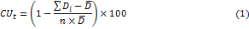
Where D_{i} represents the water depths in each bucket in mm, is the average of the water depths in mm and n shows the number of observation. In order to determine the water distribution unity in the lower quarts, the average lower quarter of observed amounts
was divided over the averaged observed amounts. Actual efficiency of the lower quarter () was calculated by dividing the average lower quarter of the lowest stored water depths in root zoon over the average depths of irrigation water. When the average water infiltration into the soil was less than the soil moisture deficit in one fourth of the samples the actual efficiency of lower quarter was calculated view dividing soil moisture deficit value over the irrigation water depths. To attain the potential efficiency of water equation was applied.

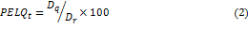
Where D_{q} is the average of one fourth the lowest water depth infiltrating into the soil which is equal to maximum discharge is mm and D_{r} represents the average irrigation water depths in mm. The values determined for the parameters above should be adjusted considering the pressure differences in the system being valid enough to be applied for the entire system. The relations are as follows:

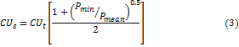

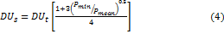

Where index (S) relates to the system and index (t) is related to testing block, P_{max}, P_{mean} and P_{min} are maximum, average and minimum pressure respectively inside the irrigation system. After the parameter required where obtained, the evaluation parameters were calculated using the related equations (Ghasem Zadeh Mojaveri, 1990). By using the irrigated area and irrigation depths, irrigation efficiency curve and from sampling network and computational network coordinates and irrigation area, water distribution curve and irrigation water co- depth curves where plotted and infiltration losses where determined from irrigation efficiency and dispersion losses using related equations.

3. Results and discussion
Tables to (2), (3), and (4) show the evaluation parameters calculated for sample systems where differences between actual efficiencies and potential efficiencies reflect the management state of the systems. Other parameters show the design and excision of the systems.

Table (2) Results of evaluation parameters in the solid set sprinkle systems
PELQ_{s} | AELQ_{s} | DU_{s} | CU_{s} | DU_{t} | CU_{t} | PELQ_{t} | AELQ_{t} | System Code
45.35 | 39.36 | 70.93 | 79.45 | 75.55 | 82.82 | 49.35 | 42.83 | AW₁
45.94 | 45.94 | 63.37 | 75.58 | 66.56 | 78.08 | 49.18 | 49.18 | AW₂
38.21 | 38.21 | 42.81 | 55.3 | 45.67 | 57.71 | 41.53 | 41.53 | AW3
59.33 | 59.33 | 62.64 | 74.62 | 64.62 | 76.18 | 61.8 | 61.8 | AW₄
59.33 | 59.33 | 70.93 | 79.45 | 75.55 | 82.82 | 61.8 | 61.8 | Maximum
38.21 | 38.21 | 42.81 | 55.3 | 45.67 | 57.71 | 41.53 | 41.53 | Minimum
47.21 | 45.71 | 59.94 | 71.26 | 63.1 | 73.7 | 50.47 | 48.84 | Mean

Table (3) Follow of table 2
The average discharge of the riser  (lit/s) | The intensity of risers discharge  (mm/hr) | The avg. intensity of the earth fracture  (mm/hr) | Fraction losses  (%) | The depth infiltration losses  (%) | The amount of water used  (mm) | The water reached to earth  (mm) | System  Code
2.88 | 16.59 | 14.45 | 12.9 | 30.08 | 24.89 | 21.67 | AW₁
2.7 | 15.55 | 11.49 | 26.12 | 10.19 | 23.33 | 17.24 | AW₂
2.34 | 13.48 | 12.26 | 9.07 | 47.47 | 26.96 | 24.51 | AW₃
2.81 | 16.19 | 15.48 | 4.4 | 32.6 | 48.57 | 46.45 | AW₄
2.88 | 16.19 | 15.48 | 26.12 | 47.47 | 48.57 | 46.45 | Maximum
2.34 | 13.48 | 11.49 | 4.4 | 10.19 | 23.33 | 17.24 | Minimum
2.68 | 15.45 | 13.42 | 13.12 | 30.09 | 30.94 | 27.47 | Mean

Table (4) Pressure variations in the solid set sprinkle systems
 | ER |  |  |  |  |  |  |  |  | System Code
40.63 |  | 0.081 | 3.2 |  | 4 |  |  | 2.7 |  | AW₁
33.23 |  | 0.066 | 3.31 |  | 4 |  |  | 2.9 |  | AW₂
40 |  | 0.08 | 2.5 |  | 3.1 |  |  | 2.1 |  | AW₃
20 |  | 0.04 | 2.5 |  | 2.8 |  |  | 2.3 |  | AW₄

Uniformity Coefficients in the testing blocks in AW₁ ، AW₂ ، AW₄ were more than 75 percent. Appropriate selection of the types of sprinklers, efficient functional pressure of sample sprinklers and ideal weather conditions during the sampling led to the increase of distribution coefficient and distribution uniformity in these systems compared to those of the other systems. Appropriate selection of the types of sprinklers, efficient functional pressure of sample sprinklers and ideal weather conditions during the sampling led to the of distribution coefficient and distribution uniformity in the systems were more than 75 percent. uniformity Coefficients in AW₃ system was much less than those of the other system which was because of crookedness of the sprinklers risers also, inefficient relation of sprinklers due to insufficient pressure and inadequate overlapping of sprinklers.
Pressure variances was acceptable range for the AW₄ system, thus the distribution and coefficient uniformity to the entire system were not lower than the measured values at sampling blocks. Pressure variance through the AW₁ ، AW₂ ، AW₃ systems were more than the maximum allowable friction losses due to the excessive length of lateral pipes despite there adequate stop to compensate for pressure losses hence the uniformity coefficient and distribution uniformity decreased throng entire system. The average Application efficiency potential and Application efficiency in the evaluated systems 47.21, 45.71 percent respectively. Equality of Application efficiency potential with Application efficiency in the AW₂, AW₃, AW₄ systems Indicating less need for irrigation and The Difference in AW₁ system Because the Irrigation had required for more than. The water deficit effects the evaluation which resulted in low irrigation of the systems. The equality of potential efficiency and actual efficiency values signifies the successful irrigation system management. Since by selecting adequate time step and sufficient irrigation the actual efficiency of the system can be enhanced enough to meet the potential efficiency. Of note is that the scarcity of water resources causes low irrigation which in turn increases the potential efficiency values. Thus an Adequacy of irrigation curve should be plotted to represent the irrigation management in different systems.
As it can be seen from fig (1) to (4). Almost no point of an irrigation area has been irrigated in AW₁ ،AW₃ and AW₄ systems thus no point of the vegetation cover has been tensioned. On the other hand, water deep percolation losses were high which can be reduced by decrease of irrigation time period. Water demands was lower in AW₂ system and in the AW₂ system the tension induced to the plants was low due to the timely irrigation exercise and the deep percolation losses were 10.19 percent.
the curve of Adequacy irrigation that shows deep percolation losses Despite the low irrigation in the AW₂ system is low, wind and evaporation losses was 26.12 percent. Also The output of sprinklers is more than soil infiltration rate That cause be runoff, that should change the type of sprinklers and Be low Sprinkler operating pressure.

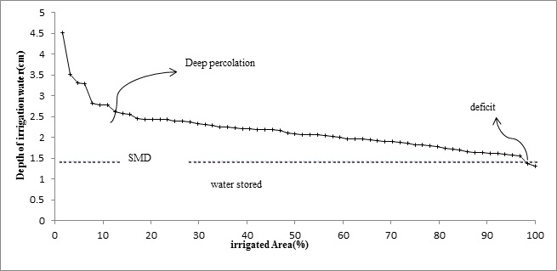

Figure 1- Adequacy of irrigation curve AW₁ System with coefficient uniformity 82.82%

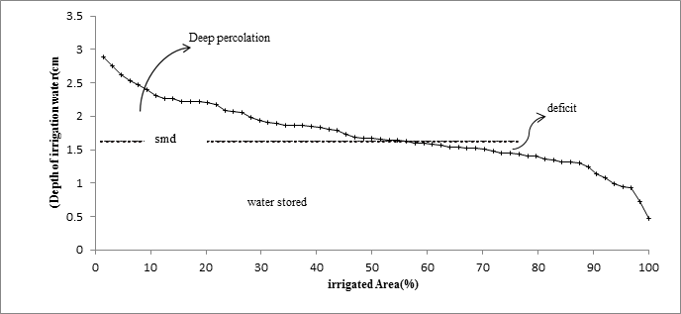

Figure 2- Adequacy of irrigation curve AW₂ System with coefficient uniformity 78.08%

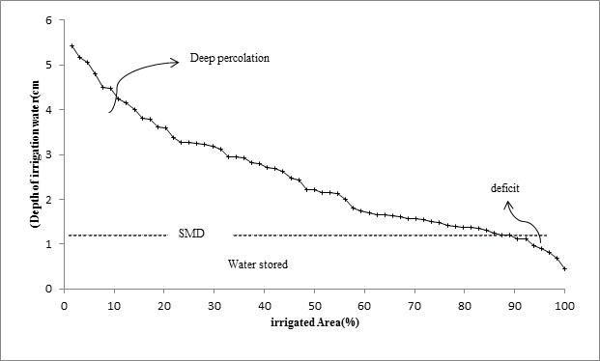

Figure 3- Adequacy of irrigation curve AW₃ System with coefficient uniformity 57.71%
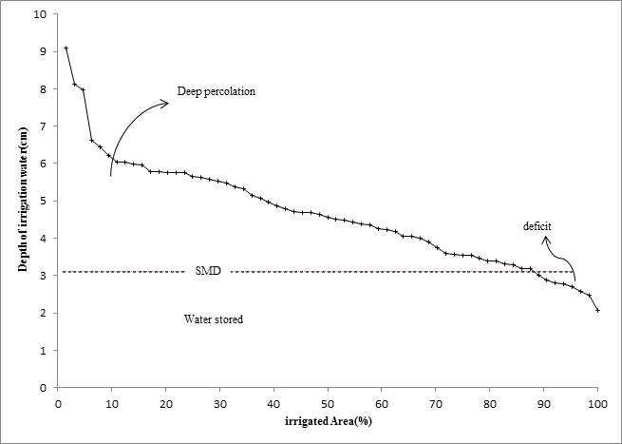

Figure 4- Adequacy of irrigation curve AW₄ System with coefficient uniformity 76.18%

4-Conclusion and policy implications
The low Potential efficiency has diagnosed poor design and implementation of the studied systems. From inappropriate pressure can be named as the most important factor. Also Inappropriate layout of the network, Use more than one Sprinkler on Irrigation Laterals and Length inappropriate Side pipes The main reason has been for the low coefficient of uniformity and Uniform distribution in systems. The results of this study showed Although There is in many cases problems in the design and executive, But a big part of the reason for the low performance of fixed irrigation systems in Khorramabad city is Poor management and operation of the system . Of the cases observed to The simultaneous use of many sprinklers by farmers, Lack of proper sprinkling distribution on The farm unit by them And lack of Due to of farm management irrigation tables that was provided by the designer can be noted.
Acknowledgments
The writers gratefully acknowledge Shahid Chamran University and Science Excellency of Irrigation & Drainage Networks Management for their financial support and assistance during the study and field works.
Correspondence to:
Saeed. Boroomand Nassab
Department of water Science Engineering, Shahid Chamran University, Ahwaz, iran.
Boroomand@scu.ac.ir

References
- Ahaneku IE. Performance evaluation of portable sprinkler irrigation system in Ilorin, Nigeria. Indian Journal of Science and Technology 2010; 3 (7): 853-857 .
- Faryabi A, MaRoufpooR E, Ghamarnia H. Evaluate irrigation systems Constant Dehgalan plain Kurdistan. Science and Technology of Agriculture and Natural Resources, Soil and Water Sciences2010; 14 (54):1-16.
- Ghasem Zadeh Mojaveri F. Assessment of Irrigation Systems. Astane Qouds Razavi publication1990.
- Mclen, R.K., R. Sriranjan and G. Klassen.. Spray evaporation losses from sprinkler irrigation systems. Can agric. Eng 2000; 42(1): 1-15.
- Molaee Z, Maroufpoor E, Maleki A. Technical evaluation of constant irrigation with moving sprinkler applied in plain Koohdasht. Master's thesis .University of Kurdistan. 2011.
- Salem A, Hooshmand A, Maroufpoor E, Behzad M. Evaluation of sprinkler irrigation systems in the fixed wheel and classic Qorveh plain .Master's thesis .University of Kurdistan. 2010.
- Tarjuelo jm, Montero j, Honrubia FT, Oritz JJ, and Ortega J.F. Analysis uniformity of sprinklerirrigation in a semi-arid area. Elsevier Science. Agricultural Water Management1999; 40: 315-331.

7/28/2013

