Length-Weight Relationship and Condition Factor of Pomadasys Jubelini in the New Calabar-Bonny River, Nigeria

Agbugui, M. O.

Department of Biological Sciences, Ahmadu Bello University Zaria, Nigeria,
marianuseni@yahoo.com

Abstract: 413 samples of Pomadasys jubelini were obtained from the New Calabar-Bonny River and examined over a period of twenty four months. The length ranged from 8.50cm - 47.60 and the weight from 17.00g - 2320g. Females were longer and heavier than males. There was a strong and positive relationship between fish length and weight (r) = 0.91 for males and 0.99 females, and b value (b<3) indicating a negative allometric growth.The monthly condition factor (K) ranged from 0.00 – 1.16 for males and 0.01 – 2.15 for females. Generally, the fish were in good condition when caught however the conditoon factor varied among different sizes of the fish.
[Agbugui, M. O. Length-Weight Relationship and Condition Factor of Pomadasys Jubelini in the New Calabar-Bonny River, Nigeria. World Rural Observ 2013;5(4):50-53]. ISSN: 1944-6543 (Print); ISSN: 1944-6551 (Online). http://www.sciencepub.net/rural. 9

Key words; Length – weight relationship, conditionn factor, Pomadasys jubelini

Introduction:
Pomadasys jubelini commonly called the grunter is of the family Pomadasyidae (curvier 1830). Three species are available to this family: Pomadasys perotiti, P. rogeri and P. jubelini. Of these species P. jubelini has been found in the New Calabar –Bonny River and constitute about 10% of its commercial catches (Idodo Umeh 2003). It is therefore necessary to provide information on the length - weight realtionship and condition factor of this species in order to provide and increase the knowledge of the stock available. The length-weight relationship of a fish is basically a measure of its growth pattern and or age. It also helps to evaluate the condition, reproduction history, life cycle and the general health of the fish species (Pauly, 1993). Growth is an important factor of biological production, which affects the overall production. Negative changes in growth rates may result in increased risk of predation and mortality (Fafioye and Oluajo, 2005). Studies on the length – weight relationship provides the basis for estimation of the average weight of fish of a given length group and also provides the understanding of morphorlogical comparisms between populations (Pauly, 1993). When the b-value is < 3, a fish has negative allometric growth, when = 3 it is said to have isometric growth, and when > 3 it has positve allometric growth. (Freose, 2006). It was further stated that for fish to maintain their shape as they grow their b-value must be equal to 3 however, the isometric value b=3 is for fishes that maintain a three dimentional equality (Froese, 2006).
Pomadasys jubelini as reported in Sierra Leone had “a’’ value of 0.0328 and “b’’ of 2.966. The fish studied exhibited a negative allometric growth (Froese, 2011).
Condition factor is an estimation of the general well being of fish, it is based on the hypothesis that heavier fish of given length are in better condition than those of lesser weight (Bagenal and Tesch, 1978 and Jones et.al., 1999). The condition factors of different populations of the same species give some information about the abundance of food environment al condition and duration of breeding (Ikomi and Odum, 1998).
The condition factor (K = 0.45) of P. pellucida of the lower Nun River revealed that the fish does not grow fast and approaches its maximum length at a relatively slow rate (Allison, 2006). He further suggested that the growth potential of a fish may be determined by factors such as genetic makeup, fishing regime and diet type.
Ogbe et al. (2006) reported a condition factor of K (1.51) for Bagrus bayed indicating that the fish were in good condition throughout the experimental period which was likely attributed to favourable environmental conditions and especially, availability of food. They also reported a b value of 3.92 which shows that the fish weight increased isometrically. Other studies on growth parameter K carried out on the Banded jewel (Auchenoglanis occidentalis) and Clarias gariepinus had + K values with b-values greater than 3. An indication that allometric growth was obtained (Oniye et al., 2006 and Useni, 2010).
The length – weight relationship of the same species may be different in the population because of feeding, reproduction activities and fishing. It is therefore necessary to know the length weight relationships of fish which are captured in a given place and given time. Information of the length - weight relationships of Pomadasys jubelini is scarce hence this study is conducted for the purpose of establishing the length weight relationship of Pomadasys jubelini in the New Calabar – Bonny River, Rivers State Nigeria.

Materials and Methods:
Pomadasys jubelini were collected from catch landings of fishermen using hooks, gill net, traps and calabashes monthly, from June 2011 to May 2013 (24) calendar months from the New Calabar-Bonny River. The fish were transported in an insulated box containing ice chips to the fisheries laboratory of Department of Fisheries and Aquatic environment, Rivers State University of Science and Technology, Porthacourt, where the fish were identified and the standard length (cm) and total length (cm) and weight (g) of the fish was determined. The length-weight relationship of the fish was estimated by the equation W = aL^{b} ; where W= weight (g), L= length of fish (cm), a and b = regression coefficient and slope respectively. The logarithm-transformed data will give the linear regression equation:

Log W = log a + b log L
Condition Factor (K) was estimated by the relationship K = W X 100
L³
Where K = condition factor, L= Total length (cm), W = Weight of fish (g)

Results
The length of Pomadasys jubelini sampled ranged from 8.50cm - 47.60cm (SL) while the weight ranged from 16.0g – 2320.0g. The largest male fish weighed 890.1g, while the largest female fish weighed 2320.0g. Females were longer and heavier than males. Correlation coefficients (r) for male and female fish were 0.68 and 0.97 respectively. The regression coefficient b for male and female fish were 0.79 and 0.59 respectively (Table 1), generally it was observed that fish weight increased as its length increased though b values were not greater than 3. The mean monthly condition factor (K) ranged from 0.01 – 1.87. The highest values were obtained in December, January and February. The variation in condition factor is given in Figure 1. Individual condition factor of fish increased with increase in size of fish irrespective of sex.

Table 1. Length – weight relationship of male and female Pomadasys jubelini
Sex a b r r²
Male 0.23 0.79 0.68 0.46
Female 0.31 0.59 0.97 0.94
Combined 0.31 0.59 0.96 0.93
a = regression intercept, b = regression coefficient, r = correlation coefficient.

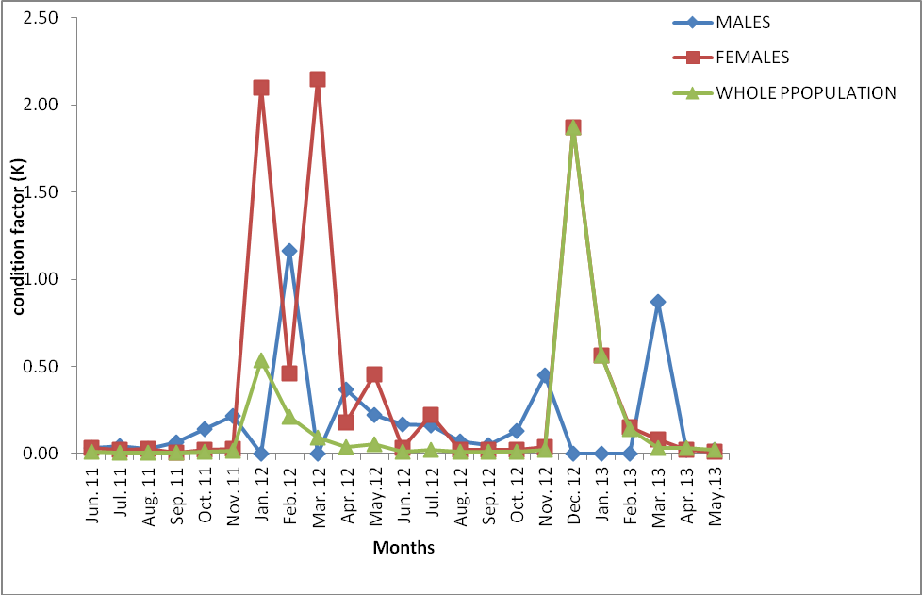
Figure 1. Condition factor for P. jubelini in the New Calabar – Bonny River

Discussion:
The maximum length of Pomadasys jubelini obtained in this study (55.30cm) and weight (2320g) are much higher than the lengths of 20 – 30cm and 50cm in Lake Kianji. In Senegal, length and weight of 32.10cm and 882.4g have also been reported in River Ase (Nigeria) (Reed et al., 1967, Idodo-Umeh, 2003, and Froese and Pauly, 2013). This variation in length and weights may be related to the growth stages, the level of exploitation of the fish species in different water bodies, predation by other fish species, nature of the aquatic environment and abundance of food for the fish species. Although King (1996) stated that the maximum size attainable for a fish is generally location specific.
The length - weight relationship of P. jubelini showed positive correlations in both sexes, indicating an increase in weight with increase in length. The regression exponent (b<3) for both sexes indicates a negative allometric growth pattern, that is the fish becomes heavier for its length as it grows longer (Tesch, 1968), or more preferably, an increase in stoutness as the fish increases in length (Pauly, 1984). Similar findings were made by Abowei and Davies (2009), and Deekae et al. (2010), where negative allometric growth (b=0.88 and b=2.88) for the studies of Clarotes laticeps in the water reaches of the lower Nun River, Niger Delta and Alectis alexandricus in Bonny River, Nigeria, respectively. Negative allometric growth pattern were also observed by Bahar et al. (2008) in the study of Arnoglossus thori and Solea solea in the Aegean Sea. This result is in contrast with the findings of Onimisi and Oniye (2010), were b (b>3) in the study of Auchenoglanis occidentalis in Zaria and that of Ikomi and Odum (1998) were isometric (b=3) growth pattern was obtained for Chrysichthys auratus in River Benin. The length-weight relationship of fish are affected by a number of factors such as season, habitat, gonad maturity, sex, diet and annual differences in environmental conditions (Bagenal and Tesch, 1978). Such differences in b values could be attributed to or combination of the difference in the number of species, sizes of species, geographical location and season (Froese, 2006).
The mean condition factor (K) varied during the different months and was higher during the dry months which coincided with the period when larger sizes but fewer numbers of fish were caught. The smaller sizes though more in number which were obtained in the wet season (May – September) had very low K values. In the study of Chrysichthys nigrodigitatus in Epe Lagoon, the K values obtained ranged from 0.15 – 0.79 (Fafioye and Oluajo, 2005) and Alectis alexandricus in Bonny River with K = 0.126 ± 0.02 (Deekae, 2010). The results of condition factor in this study did not tell the well being of the fish especially as the fish increases in stoutness as the fish grows larger. However, months with fewer samples of fish gave higher condition factor value. The condition factor of fish as stated by Bagenal and Tesch (1978) also varies among same species in different locations.

References:
- Abowei, J.F.N. and Davies, O.A. (2009). Some population parameters of Clarotes laticeps (Ruppell, 1829) from the fresh water reaches of Lower Nun River, Niger Delta Nigeria. American Journal of Scientific Research (2):10-19.
- Allison, M. E. (2006). The Ecology And Fishery Of Parailia pellucida (Boulenger 1901) (Shilbeidae) in Lower Nun River of the Niger Delta. Unpublished PhD Dissertation, Uniport. 267 pp.
- Bagenal, T. B. and Tecsh, F. W. (1978). Age and Growth. In Bagenal, T. B. (ed) Methods of the assessment of fish production in fresh waters. Oxford . Pp 75 - 89.
- Bahar, B., Tuncay, M. S. and Ertan,T. (2008). Length weight Relationship of seven flat fishes (Pisces: Pleuronectiformes) from Aegean Sea. Turkish Journal of Fishes and Aquatic Sciences, 8: 377-379.
- Deekae, S. N. Chukwu, K. O. and Awotogba, G. (2010). Length –weight relationship and Condition factor of Alectis alexandricus (Geoffroy Saint-Hilaire 1817) in Bonny River, Nigeria. International Journal of Zoology, 2(1); 83-40
- Fafioye, O. O. and Oluajo, O. A. (2005). Length-weight relationship of five fish species in Epe Lagoon, Nigeria. African Journals Online. www.academicjournal.org/ajb
- Froese, R. and Pauly, (2013). www.fishbase.com. Distribution of Pomadasys jubelini retrieved 4/2/2013
- Froese, R. (2006). Cubelaw, Condition factor and length - weight relationships: history, meta-analysis and recommendations. Journal of Applied Ichthyology, 22: 241-253.
- Idodo-Umeh, G. (2003). Fresh water fishes in Nigeria, (Taxonomy, Ecological notes, Diets and Utilization). Idodo-Umeh Publishers, Benin City. Nigeria. Pp 123-124.
- Idodo-Umeh, G. (2003). Fresh water fishes in Nigeria, (Taxonomy, Ecological notes, Diets and Utilization). Idodo-Umeh Publishers, Benin City. Nigeria. Pp 123-124.
- Ikomi, R.B. and Odum, O. (1998). Studies on aspects of the ecology of the catfish Chrysichthys auratus Geoffrey St. Hilare (Osteichthyes; Bagridae) in the River Benin (Niger Delta, Nigeria). Fisheries Research, 26: 187-198.
- Ikomi, R.B. and Odum, O. (1998). Studies on aspects of the ecology of the catfish Chrysichthys auratus Geoffrey St. Hilare (Osteichthyes; Bagridae) in the River Benin (Niger Delta, Nigeria). Fisheries Research, 26: 187-198.
- Jones, R. E., Petell, R. J., and Pauley, D. (1999). Using modified length –weight relationship to asses the condition of fish. Aquatic Engineering, 20: 261-276.
- King, R. P. (1996). Length – Fecundity relationship of Nigeria fish population. Naga ICLARMQ 20 (1): 29- 33.
- Ogbe, F.G., Obande, R.A. and Okayi, R.G. (2006). Age growth and mortality of Bagrus bayad, Macropterus (Forkalis, 1775) from Lower Benue River. Biological and Environmental Sciences Journal for the Tropics. 3 (2): 103-109.
- Onimisi, H. U., Oniye, S.J., Balogun, J.K. and Aken ‘Ova, T.O.L. (2009). The food and feeing habit of Auchenoglanis occidentalis (Vallencienee1840) in Zaria Nigeria. The Zoologist. Vol 7: 57 – 64.
- Oniye, S.J. and Onimisi, H. U. (2010). Some aspects of the reproductive biology of Hyperopisus bebe occidentalis (Gunther) in Zaria Dam, Nigeria. A paper presented at FISON conference meeting Eko, Lagos. 6pp
- Oniye, S.J., Adebote, D.A., Usman, S.K. and Makp, J.K. (2006). Some aspects of the biology of Protopterus annectens (Owen in Jachi Dam near Katsina, Nigeria. 1 (2):136 – 141.
- Pauly, D. (1984). Length converted catch curves; a powerful tool for fisheries research in the tropics Part 1. Fishbyte 1(2): 9-13.
- Pauly, D. (1993). Fishbyte section editorial, Naga the ICLARM Quarterly, 16: 26-27.
- Reed, W., Burchard, J., Hopson, A.J., Jenness, .J. and Yaro, I. (1967). Fish and Fisheries of Northern Nigeria. Ministry of Agriculture, Northern Nigeria. Pp 5-78.
- Tesch, F. W. (1968). Age and growth. In Ricker, W. E. Ed. Methods for assessments of Fish Production in Fresh Water (Ed. W. E. Ricker). International Biological Programme, Wilmer Brothers Limited Birkenhead, U.K, P. 93-123.
- Useni, M.O.A. (2010). Growth performance and feed utilization of fingerlings of Clarias gariepinus fed diets containing Pauletia monandra seed meal. Unpublished M.Sc Thesis Ahmadu Bello University Zaria. 80pp.
- Yem, I. Y., Sani, O.A., Mshelia, W. B., and Onimisi, H.U. (2007). The Length - weight relationship and condition factor of the Banded Jewel fish (Hemichromis fasciatus, PETERS) from Kianji, Lake Nigeria. In Araoye, P.A., Adikwu, I.A. and Banke, R.O.K. (ed). FISON Conference proceedings Pp 15- 18.

11/20/2013

