The Analysis on the Energy Consumption and Output Value of Harbin Electric Machinery Company Limited Based on GM (0, 2) Model

Zhang Xinyu

Actuarial and investment science, The Hong Kong Polytechnic University
Email: xinyu1991@163.com

Abstract: The influence which the ten thousand yuan total output value comprehensive energy consumption index gets should be the attention problem of company manager after the company implemented the energy-saving strategy. It can help the company to deploy and use energy rationally and increase the economic efficiency to study the relationship between the total energy consumption and the total industrial output value. This paper takes Harbin Electric Machinery Company Limited for example; it is based on the total energy consumption and the total industrial output value from 2008 to 2012 as the basis and indicates the relationship between the company's total energy consumption and the total industrial output value through using GM (0, 2) model. The time series model is built to illustrate the output change trend over time, predict the next output value, and then predict the total energy consumption value based on the forecast value. Some rationalization proposals are given to the company's long-term development in energy-saving work to make the total industrial output value of every ten thousand yuan consume the minimum amount of energy.
[Zhang Xinyu. The Analysis on the Energy Consumption and Output Value of Harbin Electric Machinery Company Limited Based on GM (0, 2) Model. World Rural Observ 2013; 5(4):61-73]. ISSN: 1944-6543 (Print); ISSN: 1944-6551 (Online). http://www.sciencepub.net/rural. 11

Keywords: GM (0, 2); Energy consumption; Industrial output value; ARMA.

Introduction
Harbin Electric Machinery Company Limited was established in June 1951 and it was reformed as a joint stock company in October 1994. As the key leading company of China on medium and large power equipment producing, Harbin Electric Machinery Company Limited owns 6000 registered staffs and produces the steam turbine generator, hydraulic generator and power plant control equipment, it’s annual producing capacity is 30 million kw and its total industrial output value totaled 5.1 billion yuan in 2012. The company’s product structure characteristics are simple piece, small patch, less repeat and variable types. The equipment characteristics are variable types. The producing process consumes electricity powers.

1. The current situation of energy consumption and output value of Harbin Electric Machinery Company Limited
1.1 The current situation of energy consumption of Harbin Electric Machinery Company Limited
1.1.1 The current situation of energy consumption management of Harbin Electric Machinery Company Limited
Harbin Electric Machinery Company Limited has been keeping saving energy accompanied with the maintaining of industrial output and balanced rapid economic advance for years. The company has established and made up the energy management system, strengthened the scientific energy management, kept management and technological innovation, accelerated the technical reform of energy equipment and facilities indeed and done a lot in pushing the production technology content. The company has established the energy management aim duty and economic obligation appraisal system. The company maintains specific and accurate procession and appraisal standards in energy-saving destination management, basic energy management, measuring management, energy factor management. The company has increased the monetary investments in recent years, constructed the energy-saving project intensively and eliminated massive energy consuming facilities. Harbin Electric Machinery Company Limited has divided the energy management organization into general company, workshop and team three levels. The energy management commission is regarded as the highest decision organization to decide the significant resolutions. The energy management ministry is regarded as the functional department in company energy management and it is obligational to routines. Every workshop owns a leading group which is responsible for energy-saving inside this unit. And an energy-saving inspector is set up in every team. The energy management organizations provide the organizational guarantee for the energy-saving works and exert the efficiency of organizational operation fully.
Harbin Electric Machinery Company Limited has established full-time energy statistical occupations, they are obligation to the statistics and analysis of company energy consumption data to come into the statistical analysis report and submit the energy statistical data to Harbin Municipal Bureau of Statistics. According to the energy consumption characteristics of the company, the classification statistics are adopted on a monthly, seasonal and yearly basis in the link of energy purchasing, energy processing, energy conversion, transportation and allocation. The energy consumption statistical parameters are constructed, the original energy statistical records are protected well and the information management is realized in all kinds of statistics and reports. During the period of the "11th five-year plan", the company has done a lot of fruitful work on the energy-saving technology, as a lot of special funds for energy-saving technological transformation are spent every year. Especially the company has done a lot of energy-saving reform work in terms of optimization of energy structure, such as canceling the boiler room, canceling the acrylic stand and shutting down the oxygen generator; The air compressor station reconstruction is made in 2009 in order to replace the piston type air compressor with advanced, energy-saving screw air compressor and the air compressor running system is optimized; The flue gas waste heat of furnace is collected; The coal-fired boiler water supply has been transformed into the electric water heater water supply and finally changed into using the heat pump of waste heat water source in 2010 in bathrooms. The company has been attaching great importance to energy-saving technical reconstruction work and it lays a solid foundation for the energy conservation and emission reduction work to the longitudinal and deepening development.

1.1.2 The energy consumption structure of Harbin Electric Machinery Company Limited
According to the Harbin Electric Machinery Company Limited energy consumption report from 2008 to 2012, it can be found that the company's energy input is mainly for heating, electricity, gasoline, diesel, kerosene, coal gas and natural gas, etc. The specific consumption is shown in table 1-1.

Table 1-1 All kinds of energy consumption table from 2008 to 2012
year | Heating (GJ) | Power (kW · h) | Gasoline (t) | Diesel (t) | Kerosene (t) | Coal gas, natural gas(m³)
2008 | 260617.34 | 37167.2405 | 1009.974 | 365.495 | 63.8 | 7780.5679
2009 | 276706.877 | 104316.0464 | 2796.868 | 1187.932 | 178.09 | 19760.56
2010 | 278544.392 | 169077.2443 | 4380.498 | 2283.76 | 273.945 | 25910.557
2011 | 283083 | 232262.7366 | 5842.689 | 3464.103 | 363.16 | 31643.808
2012 | 272851.5333 | 298036.98 | 7353.133 | 4599.63 | 469.95 | 35434.102

In order to see the overall proportion of different consumption accounted for the total energy consumption, the bar chart is drawn according to the above data, it is shown in figure 1-1.

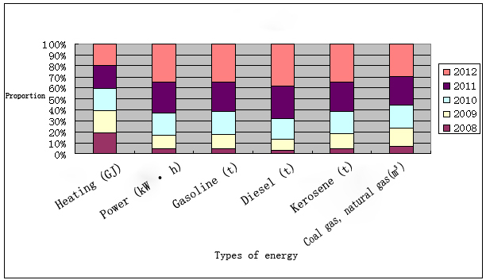
Figure 1-1 All kinds of energy consumption from 2008 to 2012

As you can see from figure 1-1, the heating consumption of each year in nearly five years is almost equal; it remains at around 270000 cokes. The rest of energy consumption shows an increased trend year by year, the growth of diesel fuel is the largest, the consumption of 2012 is about 13 times of 2008, and the electricity, gasoline, kerosene, coal gas and natural gas grow faster before 2010 and they grow slower after 2010, the consumption gradually tends to be stable.
Because Harbin Electric Machinery Company Limited implements the energy-saving strategy technology, the annual energy consumption shows a downward trend during the same period. It can be shown in table 1-2. The line chart is drawn according to table 1-2; it is shown in figure 1-2.

Table 1-2 The total energy consumption in each quarter from 2008 to 2012 Unit: tce
year | 2008 | 2009 | 2010 | 2011 | 2012
the first quarter | 8885 | 8755 | 8129 | 7709 | 8732
the second quarter | 4047 | 3545 | 3567 | 3295 | 3241
the third quarter | 2682 | 2523 | 2492 | 2585 | 2245
the fourth quarter | 6314 | 6204 | 4778 | 5291 | 5246

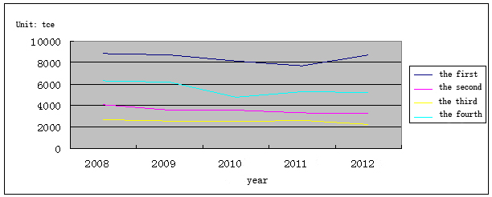
Figure 1-2The total energy consumption in each quarter from 2008 to 2012

From figure 1-2, we can see although the total energy consumption of the first quarter of 2012, the second quarter of 2010, the third quarter of 2011 and the fourth quarter of 2011 increased year on year respectively from 2008 to 2012, the total energy consumption has a downward trend on the whole in the same quarter from year to year. It can be seen the company's energy-saving measures are playing the role. From the chart we can also see the energy consumption is the biggest in the first quarter of each year and it is the smallest in the third quarter. The causes of this phenomenon are mainly the seasonal factors. As it will be the autumn and winter in the north section from October to April next year and it needs to take some energy for heating.

1.2 The current situation of industrial output value of Harbin Electric Machinery Company Limited
According to the statistical data of Harbin Electric Machinery Company Limited from 2008 to 2012, the total industrial output value is shown as table 1-3.
To see the change trend of the total industrial output value in five years intuitively, the line chart is drawn according to the above table, see figure 1-3.
From figure 1-3 we can see the total industrial output value is the highest in 2009, followed by industrial factory value declining, there is an upward trend until 2012. It may be the impact of the global financial crisis through analyzing the cause. It has affected the company production and the company took measures actively in response to the financial crisis in order to reduce losses to a minimum and the industrial output value began to rise until 2012.

Table 1-3 The total industrial output value of each quarter from 2008 to 2012
Units: ten thousand yuan
year | 2008 | 2009 | 2010 | 2011 | 2012
the first quarter | 117495 | 102943 | 67806 | 83250 | 103054
the second quarter | 171004 | 140591 | 129563 | 157221 | 164843
the third quarter | 120155 | 114507 | 76644 | 94229 | 99545
the fourth quarter | 195176 | 288412 | 201460 | 124233 | 143877
total | 603830 | 646453 | 475473 | 458933 | 511319

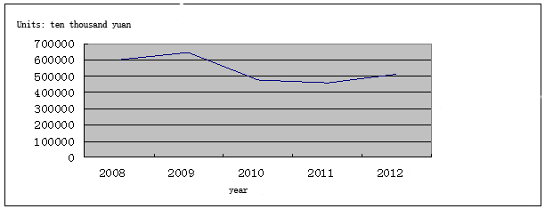
Figure 1-3 The total industrial output value change trend from 2008 to 2012

2. The analysis and prediction of total industrial output value
The industrial output data of Harbin Electric Machinery Company Limited itself has a certain trend of fluctuations over time from 2008 to 2012 each quarter; in order to study the variation trend, the single time series analysis is needed and the future development situation should be predicted based on the change trend of the past. Therefore, the ARMA model is established through using the theory of time series and combining with the actual data.
2.1 The total industrial output value analysis modeling
ARMA model is the combination of the autoregressive model (AR model) and moving average model (MA) model. AR model can be used to forecast through the linear combination, which contains the observed value in the past each phase and the current interference value. The mathematical formula is:
$y_{t}=φ_{1}y_{t−1}+φ_{2}y_{t−2}+\text{.}\text{.}\text{.}+φ_{p}y_{t−p}+ε_{t}$. MA model is used to predict through the linear combination, which contains the past interference value and the current interference value. The mathematical formula is:
$y_{t}=ε_{t}−θ_{1}ε_{t−1}−θ_{2}ε_{t−2}−\text{.}\text{.}\text{.}−θ_{q}ε_{t−q}$. The $y_{t}$ is a stationary time series, $φ_{2}$ (i=1，2，…，p)，$θ_{j}$ ( j=1，2，…，q ) is the undetermined coefficients which belong to AR and MA models separately, p and q is the order number of AR and MA models respectively, $ε_{t}$is the error. After the combination of AR and MA models, the autoregressive moving average model (ARMA) is constituted, which can describe the stationary random process, the mathematical formula is:

$y_{t}=φ_{1}y_{t−1}+φ_{2}y_{t−2}+\text{.}\text{.}\text{.}+φ_{p}y_{y−p}+ε_{t}−θ_{1}ε_{t−1}−θ_{2}ε_{t−2}−\text{.}\text{.}\text{.}−θ_{q}ε_{t−q}$.

2.1.1 The model identification
According to the original data of total industrial output value in each quarter, the sequence diagram of the total industrial output value sequence {Y} is made through using EViews software (see figure 2-1):

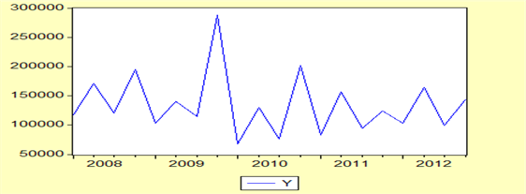
Figure 2-1 The sequence diagram of total industrial output value from 2008 to 2012

It can be concluded from the figure 2-1, the total industrial output value Y fluctuates around the mean, although it looks smooth, it still needs further instructions through the statistical tests. The ADF unit root test of sequence {Y} is done; the result is shown in table 2-1.

Table 2-1 The ADF test results to sequence {Y}
 |  | t-Statistic | Prob.*
Augmented Dickey-Fuller test statistic |  | -7.664769 | 0.0000
Test critical values: | 1% level | -3.831511
 | 5% level | -3.029970
 | 10% level | -2.655194
*Mackinnon (1996) one-sided p-values.

The ADF test results show that the null hypothesis of the unit root test is rejected under the significance level of 0.01, so the sequence {Y} is verified to be smooth. The ARMA modeling analysis is made. The ACF autocorrelation function and PACF partial autocorrelation function and their respective correlation diagram are used to judge the value p and q of the ARMA model, the analysis is shown in table 2-2.

Table 2-2 the autocorrelation coefficient and partial autocorrelation coefficient results
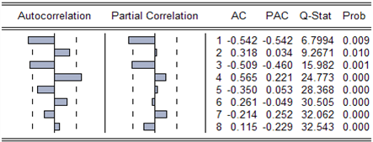

From table 2-2 we can see the autocorrelation coefficient has the fourth order truncated, it tries to fit MA (4), the partial autocorrelation coefficient is not 0 when k = 1, when k = 3 it is on the confidence belt edge of standard deviation two times, it can be considered to fit the AR (1) or AR (3), at the same time it is considered to construct the ARMA (1, 4) model or ARMA (3, 4) model. The descriptive statistical analysis is made to the original sequence; the result is shown in figure 2-2.

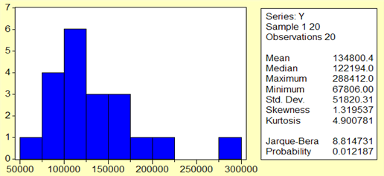
Figure 2-2 The sequence {Y} descriptive statistics

From above we can see the sequence mean is not zero, usually the zero mean stationary series are made to the modeling analysis, a new zero mean sequence {X} is generated on the basis of the original sequence. It is equivalent to making the whole shift on the basis of the original sequence {Y}, but there is no fundamental change on the statistical properties. The description statistics of the new sequence {X} are shown in figure 3-3.

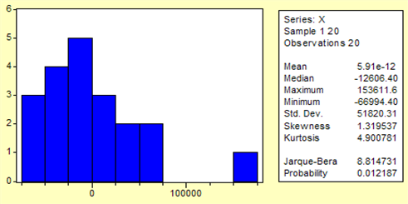
Figure 3-3 The description statistics of sequence {X} after centralized

2.1.2 The model parameter estimates
According to the identification process, it can be found the p value may be 1 or 3, q value may be 4 from a preliminary order. The ARMA (3, 4) model is constructed and the parameter estimation results are gotten through EViews, see table 2-3.

Table 2-3 The ARMA (3, 4) model parameters estimation results
Variable | Coefficient |  | Std.Error |  | t-Statistic |  | Prob.
AR(1) | -0.314083 |  | 0.306421 |  | -1.025004 |  | 0.3295
AR(2) | 0.182614 |  | 0.323772 |  | 0.564021 |  | 0.5852
AR(3) | -0.246813 |  | 0.303021 |  | -0.814507 |  | 0.4343
MA(1) | -0.121713 |  | 0.225553 |  | -0.539620 |  | 0.6013
MA(2) | -0.312710 |  | 0.289225 |  | -1.081201 |  | 0.3050
MA(3) | -0.054000 |  | 0.208253 |  | -0.259300 |  | 0.8007
MA(4) | 0.946927 |  | 0.130592 |  | 7.251015 |  | 0.0000
R-squared |  | 0.735747 |  | Mean dependent var |  | -250.1647
Adjusted R-squared |  | 0.577195 |  | S.D. dependent var |  | 55450.33
S.E. of regression |  | 36055.72 |  | Akaike info criterion |  | 24.11642
Sum squared resid |  | 1.30E+10 |  | Schwarz criterion |  | 24.45951
Log likelihood |  | -197.9896 |  | Durbin-Watson stat |  | 1.525380

From above we can see, except MA (4) item is significant, the rest are not significant, then the ARMA (1, 4) model we tried, the parameter estimation results are shown in table 2-4.

Table 2-4 ARMA (1, 4) model parameter estimation results
Variable | Coefficient |  | Std. Error |  | t-Statistic |  | Prob.
AR(1) | -0.841619 |  | 0.228554 |  | -3.682369 |  | 0.0025
MA(1) | 0.530408 |  | 0.224593 |  | -2.361641 |  | 0.0332
MA(2) | -0.389385 |  | 0.212771 |  | -1. 830063 |  | 0.0886
MA(3) | -0.340689 |  | 0.224215 |  | -1.519478 |  | 0.1509
MA(4) | 1.174581 |  | 0.224265 |  | 4.808634 |  | 0.0003
R-squared |  | 0.761307 |  | Mean dependent var |  | 910.8105
Adjusted R-squared |  | 0.693109 |  | S.D. dependent var |  | 53075.58
S.E. of regression |  | 29402.68 |  | Akaike info criterion |  | 23.63649
Sum squared resid |  | 1.21E+10 |  | Schwarz criterion |  | 23.88503
Log likelihood |  | -219.5467 |  | Durbin-Watson stat |  | 1.193946

From above we can see, the ARMA (1, 4) model accompanied probability is highly significant, compared with the ARMA (3, 4) model, $R^{2}$is relatively large, AIC and SC values are smaller, but D.W. value is relatively small. In summary, the ARMA (1, 4) is relatively better. The equation is:

$$x_{t}=−0\text{.}\text{841619}x_{t−1}+ε_{t}−0\text{.}\text{530408}ε_{t−2}+0\text{.}\text{340689}ε_{t−3}−1\text{.}\text{174581}ε_{t−4}$$

2.1.3 The model suitability test
The suitability test of the model is essentially the white noise test on model residuals, only the model residuals are the white noise sequences, we can say all the important information has been extracted. The residual of ARMA (1,4) model is analyzed and the autocorrelation coefficients and the partial autocorrelation coefficient are calculated, the result is shown in table 2-5.

Table 2-5 the residual autocorrelation and partial autocorrelation coefficient results
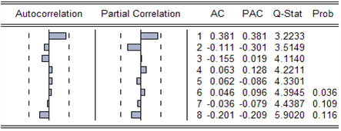

According to table 2-5 we can see that the correlation coefficient and the partial autocorrelation coefficient are 0 significantly, so that the model is appropriate.
In summary, this paper establishes the quarterly industrial output value model of Harbin Electric Machinery Company Limited from 2008 to 2012.
$$\begin{aligned}y_{t}=x_{t}+\text{134800}\text{.}4 \\ \begin{matrix} & \begin{aligned}−0\text{.}\text{841619}x_{t−1}+ε_{t}−0\text{.}\text{530408}ε_{t−1} \\ +0\text{.}\text{389385}ε_{t−2}+0\text{.}\text{340689}ε_{t−3}−\end{aligned}\end{matrix} \\ \begin{matrix} & −1\text{.}\text{174581}ε_{t−4}+\text{134800}\text{.}4\end{matrix}\end{aligned}$$
The results show that the total industrial output value in some quarter is negatively correlated with the total industrial output value in the previous quarter, while it is also affected by the random disturbances of the last four periods.
2.2 The industrial output value forecast
This paper makes the short term forecast and it predicts the next section total energy consumption through using the fitted model. It can be found that the static forecast effect of the sequence is better than the dynamic forecast effect, so the next static forecast result of sequence {X} is obtained (see figure 2-4).

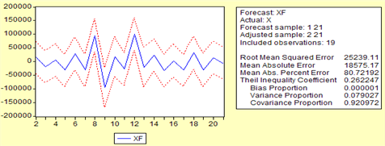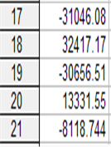
Figure 2-4 The forecast result

From above we can see the$x_{t}$ forecast value is -8118.744 in the first quarter of 2013, the mean of the total industrial output value 134800.4 is considered, the total industrial output forecast value is 1266.81656 million yuan. We can also see the total industrial output value in the first quarter of 2013 declined compared with the previous period industrial output, but it is relatively high compared with the same period of previous years.
3 The analysis and forecast on the relations between energy consumption and output value
Harbin Electric Machinery Company Limited has been implementing the energy-saving strategies in recent years, this chapter constructs GM (0, 2) model based on the total energy consumption and the total industrial output data from 2008 to 2012 to analyze how much energy should be consumed per production ten thousand yuan value, i.e. the ten thousand yuan total industrial output value energy consumption index of the company. According to the statistical data of Harbin Electric Machinery Company Limited in each quarter from 2008 to 2012, the ten thousand yuan total industrial output value comprehensive energy consumption in each quarter of the five years is calculated, it is shown in table 3-1.

Table 3-1 the energy consumption and total industrial output value in each quarter from 2008 to 2012
year | Quarter | timing | Total energy consumption  (Tce) | Industrial output  (Ten thousand yuan) | Ten thousand yuan total industrial output value energy consumption  (Tce / million)
2008 | 1 | 1 | 8885 | 117495 | 0.07562
2008 | 2 | 2 | 4047 | 171004 | 0.023666
2008 | 3 | 3 | 2682 | 120155 | 0.022321
2008 | 4 | 4 | 6314 | 195176 | 0.03235
2009 | 1 | 5 | 8755 | 102943 | 0.085047
2009 | 2 | 6 | 3545 | 140591 | 0.025215
2009 | 3 | 7 | 2523 | 114507 | 0.022034
2009 | 4 | 8 | 6204 | 288412 | 0.021511
2010 | 1 | 9 | 8129 | 67806 | 0.119886
2010 | 2 | 10 | 3567 | 129563 | 0.027531
2010 | 3 | 11 | 2492 | 76644 | 0.032514
2010 | 4 | 12 | 4778 | 201460 | 0.023717
2011 | 1 | 13 | 7709 | 83250 | 0.092601
2011 | 2 | 14 | 3295 | 157221 | 0.020958
2011 | 3 | 15 | 2585 | 94229 | 0.027433
2011 | 4 | 16 | 5291 | 124233 | 0.042589
2012 | 1 | 17 | 8732 | 103054 | 0.084732
2012 | 2 | 18 | 3241 | 164843 | 0.019661
2012 | 3 | 19 | 2245 | 99545 | 0.022553
2012 | 4 | 20 | 5246 | 143877 | 0.036462

According to the data listed in the above table, the line chart of the total energy consumption, the total industrial output value and ten thousand yuan comprehensive energy consumption over time is depicted, it is shown in figure 3-1, 3-2, 3-3.

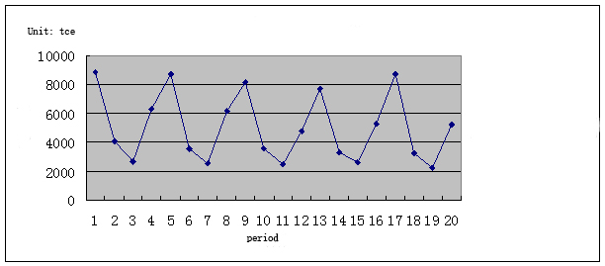
Figure 3-1 The quarterly changes of energy consumption over time from 2008 to 2012

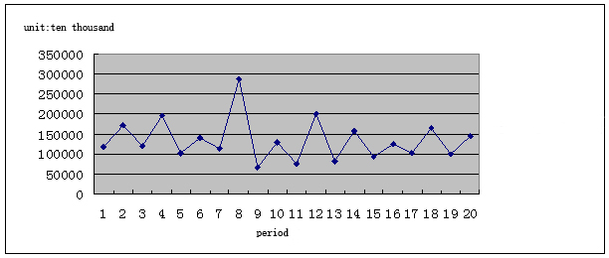
Figure 3-2 The quarterly total industrial output value over time from 2008 to 2012

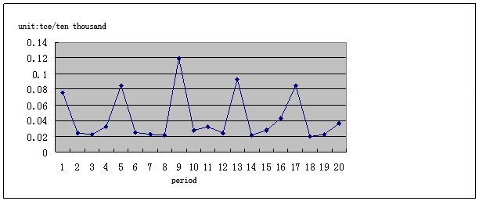
Figure 3-3 The quarterly changes of the ten thousand total output value comprehensive energy consumption over time from 2008 to 2012

From figure 3-1, 3-2, 3-3 we can see the total energy consumption, the total industrial output value and the ten thousand yuan total output value comprehensive energy consumption are always fluctuating, it is difficult to identify the internal laws between the energy consumption and output value in the original data, so it is needed to further generate the original data. The accumulated generating approach is taken here, i.e. the original data of every moment in the original series are accumulated to generate a new sequence.
3.1 The data procession
3.1.1 The accumulated generating and GM (0, 2) model
Let $x^{(0)}$ be the original data, $x^{(0)}=[x_{(1)}^{(0)},x_{(2)}^{(0)},\text{.}\text{.}\text{.},x_{(n)}^{(0)}]$, the “$n$” is the number of arguments, the new generated series are recorded as $x^{(1)}$，$x^{(1)}=[x_{\left(1\right)}^{(1)},x_{(2)}^{(1)},\text{.}\text{.}\text{.},x_{(n)}^{(1)}]$, if $x^{(1)}$ and $x^{(0)}$ meet:
$x_{(k)}^{(1)}=\sum_{i=1}^{k}{x_{(i)}^{(0)}}$; $k=1,2,\text{.}\text{.}\text{.},n$, it is called one-accumulation generating and it is settled as 1-AGO.
The accumulated generating can transfer any non-negative column swing or not, into an incrementing sequence, so the GM (0, N) model in the gray system theory can be adopted.

$$x_{1}^{(1)}=b_{1}x_{2}^{(1)}+b_{2}x_{3}^{(1)}+\text{.}\text{.}\text{.}+b_{N−1}x_{N}^{(1)}+a$$
There are only two variables of the total energy consumption and the total industrial output value in this paper, then the GM (0, 2) model is:
$$x_{1}^{(1)}=b_{1}x_{2}^{(1)}+a$$
Among them, the $x_{1}$ is the total energy consumption and $x_{2}$ is the total industrial output value. The $\overset{}{a}=(B^{T}B)^{−1}B^{T}Y$ of GM (0,2) model parameter sequence should be least squares estimation results $\overset{}{a}=[a,b_{1},b_{2}]^{T}$, in which
$B=[\begin{matrix}x_{2}^{(1)}(2) & x_{2}^{(1)}(3) & \text{.}\text{.}\text{.} & x_{2}^{(1)}(n)]^{T}\end{matrix}$,
$Y=[\begin{matrix}x_{1}^{(1)}(2) & x_{1}^{(1)}(3) & \text{.}\text{.}\text{.} & x_{1}^{(1)}(n)]^{T}\end{matrix}$.
3.1.2 The processing of original data
The original data of the total energy consumption and the total industrial output value are accumulated according to the above theory. The new sequence is generated after one-accumulation, meanwhile, the ten thousand total output value comprehensive energy consumption after one-accumulation is calculated based on the new sequence. The calculation results are listed in table 3-2.

Table 3-2 the situation of energy consumption & output value in each quarter from 2008 to 2012
number | The total energy consumption  (tce) | The industrial output value  (ten thousand yuan) | The ten thousand total output value comprehensive energy consumption  (tce / ten thousand yuan)
1 | 8885 | 117495 | 0.07562
2 | 12932 | 288499 | 0.044825
3 | 15614 | 408654 | 0.038208
4 | 21928 | 603830 | 0.036315
5 | 30683 | 706773 | 0.043413
6 | 34228 | 847364 | 0.040394
7 | 36751 | 961871 | 0.038208
8 | 42955 | 1250283 | 0.034356
9 | 51084 | 1318089 | 0.038756
10 | 54651 | 1447652 | 0.037751
11 | 57143 | 1524296 | 0.037488
12 | 61921 | 1725756 | 0.035881
13 | 69630 | 1809006 | 0.038491
14 | 72925 | 1966227 | 0.037089
15 | 75510 | 2060456 | 0.036647
16 | 80801 | 2184689 | 0.036985
17 | 89533 | 2287743 | 0.039136
18 | 92774 | 2452586 | 0.037827
19 | 95019 | 2552131 | 0.037231
20 | 100265 | 2696008 | 0.03719

According to the data listed in table 3-2, the line charts of the total energy consumption after one-accumulation, the total industrial output value and the ten thousand yuan total output value comprehensive energy consumption have been drawn up. The accumulated trend of each variable is analyzed and the accumulated effect on the data has already been described further, the line charts are shown in figure 3-4, 3-5, and 3-6.

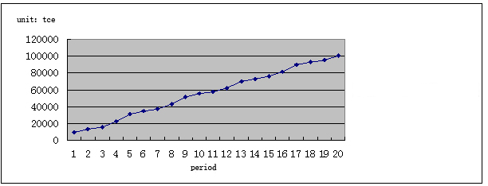
Figure 3-4 The change situation over time of quarterly total energy consumption after one-accumulation from 2008 to 2012

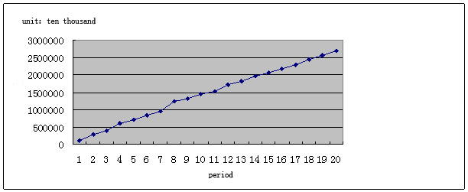
Figure 3-5 The change situation over time of quarterly total industrial output value after one-accumulation from 2008 to 2012

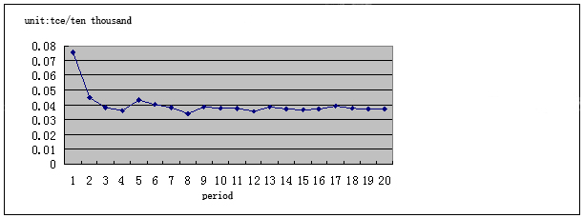
Figure 3-6 The change situation over time of quarterly ten thousand yuan total output value comprehensive energy consumption after one-accumulation from 2008 to 2012

From figure 3-4, 3-5 we can see the one-accumulation eliminates the fluctuations of the total energy consumption and the total industrial output value and makes them similar to the linear growth trend, it can be seen from figure 3-6, the ten thousand yuan total output value comprehensive energy consumption gradually stabilizes over time. Therefore, we can make a linear regression to the one-accumulation data to analyze the law between the one-accumulation total industrial output value and the total energy consumption.
3.2 The analysis of the relations between the total energy consumption and the total industrial output value
3.2.1 The GM (0,2) model analysis
The GM(0,2) model $x_{1}^{(1)}=b_{1}x_{2}^{(1)}+a$ is analyzed through the EViews software, among them the $x_{1}^{(1)}$ represents the total energy consumption after one-accumulation (tce), the $x_{2}^{(1)}$ represents the total industrial output value after one-accumulation (ten thousand yuan), according to the data in table 3-2, we make a simple regression analysis on $x_{1}^{(1)}$, $x_{2}^{(1)}$, the results are shown in table 3-3.

Table 3-3 The linear regression of the total energy consumption after one-accumulation to the total industrial output value
Variable | Coefficient |  | Std. Error |  | t-Statistic |  | Prob.
C | 1382.081 |  | 1101.630 |  | 1.254578 |  | 0.2266
X2 | 0.036783 |  | 0.000650 |  | 56.62430 |  | 0.0000
R-squared |  | 0.994726 |  | Mean dependent var |  | 57702.47
Adjusted R-squared |  | 0.994416 |  | S.D. dependent var |  | 27624.82
S.E. of regression |  | 2064.356 |  | Akaike info criterion |  | 18.20233
Sum squared resid |  | 72446631 |  | Schwarz criterion |  | 18.30174
Log likelihood |  | -170.9221 |  | F-statistic |  | 3206.311
Durbin-Watson stat |  | 2.167784 |  | Prob(F-statistic) |  | 0.000000

According to the results shown in figure 3-3, the regression equation can be concluded as:
$$x_{1}^{(1)}=0\text{.}\text{036783}x_{2}^{(1)}+\text{1382}\text{.}\text{081}$$
3.2.2 The model test
From the regression results in figure 3-3, we can see the model fitting effect is better. Its specific embodiment is the coefficient of determination $R^{2}=0\text{.}\text{994726}$, it indicates the total energy consumption change 99.4726% can be explained by the change of the total industrial output value. In the t-test value of the slope term, the concluded result 56.62430 is greater than the critical value 2.11 of the freedom degree $n−2=\text{17}$ at the 5% significance level. So t test is passed. The slope value is 0.036783, it indicates that if the total industrial output value is increased by ten thousand yuan after one-accumulation, the energy consumption should be increased to 0.036783 tons of standard coal in respondence. As the significance level is 5%, the critical value of F statistics $F_{0\text{.}\text{05}}^{(1\text{.}\text{17})}=4\text{.}\text{45}$, it is much smaller than 3206.311, it indicates that the linear relationship exists under the confidence level of 95%. In addition, the DW value is 2.167784; it indicates that an order autocorrelation does not exist in the model.

3.3 The total energy consumption forecast
3.3.1 The reliability test of GM (0, 2) model forecast
Since the original data fluctuated, this article used the new data result after one-accumulation to analyze the relationship between the total energy consumption and the total industrial output value. In order to illustrate the accumulated generating new data have the representativeness further, the forecast test method is now used to illustrate the use of GM (0,2) model has a certain reliability in processing accumulated data. To illustrate the forecast equation can be adapted to the actual forecast after one-accumulation, the latter two data are regarded as the waiting data, the previous 18 data are fitted renewedly to the GM (0,2) equation, the results have been shown in table 3-4.

Table 3-4 A linear regression equation result which is fitted by the forecast test
Variable | Coefficient |  | Std. Error |  | t-Statistic |  | Prob.
C | 1291.543 |  | 1249.118 |  | 1.033964 |  | 0.3175
X2 | 0.036869 |  | 0.000806 |  | 45.76098 |  | 0.0000
R-squared |  | 0.992888 |  | Mean dependent var |  | 53003.71
Adjusted R-squared |  | 0.992414 |  | S.D. dependent var |  | 25195.40
S.E. of regression |  | 2194.502 |  | Akaike info criterion |  | 18.33543
Sum squared resid |  | 72237606 |  | Schwarz criterion |  | 18.43345
Log likelihood |  | -153.8511 |  | F-statistic |  | 2094.067
Durbin-Watson stat |  | 2.150691 |  | Prob(F-statistic) |  | 0.000000

According to the results shown in table 3-4, $x_{1}^{(1)}=0\text{.}\text{036869}x_{2}^{(1)}+\text{1291}\text{.}\text{543}$ regression equation can be concluded. The total industrial output value in 19 and 20 period can be 99545 ten thousand yuan and 143877 ten thousand yuan separately and the total industrial output value is 2552131 ten thousand yuan and 2696008 ten thousand yuan after one-accumulation. They are substituted into the forecast test equations and the total energy consumption is 95,386 and 100,691 tons of standard coal in 19 and 20 periods respectively, the total energy consumption is 2612 tons of standard coal and 5,305 tons of standard coal before one-accumulation. The actual energy consumption should be 2245 tons of standard coal and 5246 tons of standard coal separately and the difference between the forecast value and the actual value is narrow, consequently, the forecast test result can certify it has the reliable degree through using the one-accumulation process data.
3.3.2 The total energy consumption forecast based on GM (0,2) model
The relation equation between the total energy consumption and the total industrial output value which is fitted by GM (0,2) model is $x_{1}^{(1)}=0\text{.}\text{036783}x_{2}^{(1)}+\text{1382}\text{.}\text{081}$. According to the forecast value of the correspondent total industrial output value in the third chapter, the total industrial output value is 1266.81656 million yuan in the first quarter of 2013, the accumulative value is approximately 28226.89656 million yuan, it is substituted into GM(0, 2) relation equation, the accumulative forecast value of correspondent total energy consumption is 105,209.0746 tons of standard coal, the total energy consumption forecast value in the first quarter of 2013 should be 4944.0746 tons of standard coal.
It can be found that the total energy consumption in the first quarter of 2013 of Harbin Electric Machinery Company Limited is not only smaller than the last quarter, but also smaller than the same period in previous years through the predictive analysis. At the same time, the ten thousand yuan total output value comprehensive energy consumption index is 0.039, it is smaller than the average 0.043 of the ten thousand yuan total output value comprehensive energy consumption of the past five years, it indicates the energy-saving works are effective.
From above we can see that there are some relations between the total energy consumption and the total industrial output value of Harbin Electric Machinery Company Limited, furthermore, the next total energy consumption can be predicted according to the forecast of the total industrial output value which exists the time change itself. During the "Twelfth Five-Year Plan" period, the energy-saving goal of Harbin Electric Machinery Company Limited is the energy consumption will fall to 15000-16000 tons of standard coal in case the annual output value of the company is maintained at 4-4.5 billion yuan. According to the analysis and forecast results of this paper, it can be found that the output value in the first quarter of 2013 is about 1.27 billion yuan, the total energy consumption is approximately 4,944 tons of standard coal. In accordance with the company's previous production, the industrial output value of the first quarter is lower than other quarters and the total energy consumption is higher than other quarters, it can be estimated that the company is able to achieve the stated objectives in 2013 through combining the company’s energy-saving target during the "Twelfth Five-Year Plan" period.

4. Conclusions
This paper regards Harbin Electric Machinery Company Limited as an example and analyzes the relations between the total energy consumption and the total industrial output value based on the data of the total energy consumption and the total industrial output value of each quarter from 2008 to 2012. It finds the accumulative linear relations through applying one-accumulation method, describes the trend over time of the total industrial output value, predicts the next total industrial output value and the total energy consumption and reveals the situation of energy management of Harbin Electric Machinery Company Limited to provide some references on the energy inputs and the output value trend for the company in future. The main conclusions of this paper are as follows:
This paper illustrates the energy, the energy consumption and management, the energy-saving measures and significance, the related concepts of the company total industrial output value and its components. The current situation of the energy consumption and the total industrial output value from 2008 to 2012 has been stated in general. The total industrial output value trend over time has been revealed and the auto-regressive moving average model of the total industrial output value has been built. It also predicts the total industrial output value in the first quarter of 2013. The accumulated generating methods have been utilized to process the total energy consumption and the total industrial output value in the past five years and both of them are fitted into the GM (0, 2) model to certify that the fitted model has certain reliability on the forecast of the actual energy consumption. And the energy consumption is predicted according to the total industrial output value in the first quarter of 2013 and the total energy consumption in the first quarter of 2013 has been gotten. According to the preliminary understanding and the related analysis on Harbin Electric Machinery Company Limited, some suggestions was proposed to the energy-saving through combining the ten thousand yuan total industrial output value index. The conclusion that the company can achieve the stated goal of energy conservation during the "Twelfth Five-Year Plan" is drawn.

References
[1] Wang Haoliang. The energy consumption research on China's industrial company[D]. Jiangsu University, master's thesis, 2009
[2] Yu Lei. The energy conservation research on the industrial company[D]. Guizhou: Guizhou University, 2005
[3] Fang Liguo. The energy-saving technologies and evaluation[M]. Beijing: Chemical Industry Press, 2008
[4] Li Zinai, Pan Wenqing. Econometrics [M]. Beijing: Higher Education Press, 2010
[5] Yi Danhui. The data analysis and Eviews application[M]. Beijing: China Statistics Press, 2008
[6] Wang Liming, Wang Lian, Yang Nan. The applied time series analysis [M]. Shanghai: Fudan University Press, 2009
[7] Liu Sifeng, Dang Yaoguo, Fang Zhigeng. The gray system theory and its application[M]. Beijing: Science Press, 2011.

11/27/2013

