Investigation the effect of percent and ratio of length to diameter (l/d) in steel fiber on the compressive strength of fiber concrete

Kazem Yavari nasab¹, Elahe sadat Mirkhalili²

^{1.} Department of Civil Engineering, Technical University, Sadoughi Faculty of Engineering, Yazd, Iran
^{2.} Department of Architecture, University of Payam Noor, Bandar Abbas Branch, Iran
yavari_nasab@yahoo.com

Abstract: Conventional concrete is a relatively brittle material, while the fibrous concrete in the construction of the addition of cement, aggregates, water and additives, the fibers in the concrete mix used, because it has a higher strength and has the property to prevent cracking and fiber strands are actively involved in limiting the crack width and increasing capacity utilization is concrete, it is superior compared to conventional concrete. The use of fibers in concrete to changes in compressive strength, tensile strength, flexural strength, shear strength, resistance to dynamic loads, cross-resistance against cracking, the rate of energy absorption, the rate of shrinkage, creep and wear of the surface. As a result of the behavior of fiber concrete strength should be studied. This paper is the result of laboratory research on the effects of the length to diameter ratio of steel fiber $(ℓ/d)$ concrete compressive strength of the fiber is analyzed.
[Kazem Yavari nasab, Elahe sadat Mirkhalili. Investigation the effect of percent and ratio of length to diameter (l/d) in steel fiber on the compressive strength of fiber concrete. World Rural Observ 2014;6(3):50-56]. ISSN: 1944-6543 (Print); ISSN: 1944-6551 (Online). http://www.sciencepub.net/rural. 7

Key words: fiber concrete, steel fiber, Compressive strength, ratio of length to diameter of the fibers

1. Introduction
Implementation of a project using appropriate materials and cost are the main factors considered resistant. One of the cheapest and most widely used materials in the world of concrete. The main advantages of concrete can be used in most geographic regions, using natural materials and its construction cost, relatively low cost compared to high volume operations, shaping it according to geometric designs, the possibility of mechanizing the operation does not require costly maintenance building during life operation. [1] Because of its tenderness naked except for the concrete application of the weighting factors are not applied in practice. [2] The major disadvantage of reinforced concrete, it actually goes through with reinforcement steel bars. But since it is only a small part of the section comprises reinforcing the notion that a concrete cross sections and isotopic homogeneity is not very accurate. In order to create conditions for a weakness isotopic and reduces the brittle concrete object as much as possible the last few decades, relatively long, thin fibers that are scattered throughout the volume of concrete is a homogeneous and mixed will be used. [3] To the problem of concrete, a brittle material with low tensile strength and resolve will be concrete crack control. [4] In recent years a new generation of fiber-ductile concrete entitled "Engineering of composite materials based on cementations’ materials has been developed by Mr. Li. [5]
Fibers increases the cohesion, tensile strength, reduce cracks in concrete and concrete plasticity is increased. Fibers in concrete gel are a gel fiber for concrete, polypropylene fiber used in order to create the gel used in concrete [6] [7]. Conventional concrete is a relatively brittle material, such as concrete fibers have high strength and has the property to prevent cracking; it is compared to conventional concrete. [8] Positive effects of the use of steel fibers in concrete include increased flexural strength, shear strength, tensile strength, and increased resistance to shock loads, especially dynamic loads, increase the level of resistance against cracking, and increase in energy, a decrease in the rate of contraction, creep and wear of the surface. [9]
The use of natural fibers can also improve the mechanical properties of concrete. [10] Although fiber concrete has several advantages, it has specific concerns that are not yet fully resolved. [11] There is also the influence of steel fibers on the permeability of concrete has been done in the presence of fibers reduces the permeability of concrete. [12]
With synthetic fibers for concrete cracking can be controlled and long-term durability of concrete have. The use of fibers plays an important role in designing and manufacturing many different types of projects, including airports, tennis courts, swimming pools, warehouses and public schools played. [13]
The results of laboratory investigations at the University of Tabriz show that the effect of steel fibers in concrete is very impressive, and it's important to raise and tracheal lesions using steel as steel fibers is important not only from the increase in net concrete properties economically and to reduce environmental pollution but also a very positive effect on yield satisfactorily. According to statistics provided by an expert Tabriz Machine Factory, 7-6 in just over an area of ​​400 × 500 square meters and a depth of 4 meters by these steel chips filled. [14]
Flexibility fiber concrete, plastic materials such as concrete, fiber failure can be sudden. Because of steel fibers in concrete is the three-dimensional object and the next few scattered other words, if a crack is usually expected deformation in different directions, the fibers create connections and prevents cracks from spreading. The fiber strands are actively involved in limiting the crack width and the formation of micro-cracks in the concrete operational capability much further cooperation and thereby increases [15]. The types of fibers used in concrete fibers can be plastic, glass, natural, polyethylene, asbestos, nylon and steel have been named in various shapes and sizes are produced. [16] The properties of the fibers are given in Table 1.

Table 1: Characteristics of fibers used in fiber concrete
Type of fiber | Tensile strength | Young's modulus | maximum elongation | Specific Gravity | Type of fiber
Asbestos | 80-140 Ksi | 12-20×10-3 ksi | ~ 0.6 % | 3.2 gr/cm3 | Asbestos
Glass | 150-550 Ksi | 10×10-3 ksi | 1.5-3.5 % | 2.5 gr/cm3 | Glass
PE | ~ 100 Ksi | 0.02-0.06×10-3 ksi | ~ 10% | ].95 gr/cm3 | Polyethylene
Steel | 40-400 Ksi | 29 ×10-3 ksi | 0.5-35% | 7.8 gr/cm3 | Steel

Steel fibers with different materials, in terms of tensile strength as well as simple right or hook to enhance adhesion to concrete stress can be built [3]. Steel fibers having a high modulus of elasticity and strain at failure was due to the good formability and high tensile strength of the fibers is considered the best and most economical. [17] Types of steel fibers can be seen in Figure 1, and their characteristics are given in Table 2.

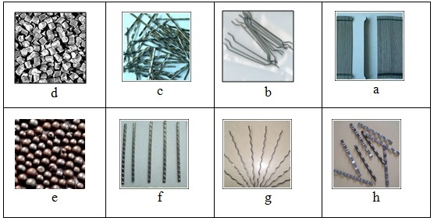
Figure 1: Types of steel fiber

Table 2: Types of steel fiber
Row | name | Description | Recommended Dosage
a | Adhesive | After mixing glue dissolved in water, and be equally distributed. | $$\text{15}−\text{20}\text{kg}/m^{3}$$
b | Single hook | $ℓ/d$Higher density phenomenon is caused | $$\text{15}−\text{20}\text{kg}/m^{3}$$
c | corrugated | With a high degree of dispersion, and can be easily combined. | $$\text{35}−\text{40}\text{kg}/m^{3}$$
d-e | Steel Shot | Shot is applicable to concrete. | $$\text{20}−\text{30}\text{kg}/m^{3}$$
h | Raging Belt | Used for asphalt concrete bridge deck. | $$\text{30}−\text{40}\text{kg}/m^{3}$$
g | Wavy tube | Has a high tensile strength. | $$\text{20}−\text{25}\text{kg}/m^{3}$$
f | Matches | Such as cold rolled steel is produced. | $$\text{20}−\text{25}\text{kg}/m^{3}$$

The annular fibers which affected the fiber strength and the fiber tail, broad, wavy course and fine toothed sections with rectangular, triangular and circular fibers used in concrete. [22] Best design for balancing fiber diameter, length, draft and maintain their shape, since these parameters affect the performance of the fiber. [14] The appropriate parameter that defines a set of fibers, the ratio of fiber length to diameter ratio is apparent fiber. Apparent ratio $(ℓ/d)$is usually among 30 to 150, with a length of 0.6 to 7.5 cm [23].
Overall quality of concrete fibers can mix proportions, geometric properties of steel fiber length to diameter ratio of mechanical containment and surface roughness of fibers [24], the steel fibers depends on their physical properties. [14] Other factors in fiber strength, fiber orientation angle is. [25] The elastic modulus of the fiber and the fiber strength is affected. [24]
A quick look at area landfills and adjacent roads in the industrial hub of the country, large size of these chips, the chips are made ​​of steel shows how huge the country is on behalf of their rot and pollute the environment and due to the large size of land is occupied by games [26].

Background:
The first major attempt by the placement of concrete reinforced by steel fibers Ramualdi and Baston took place in the United States. After a lot of researches, the industrial applications on steel fiber done for reinforced concrete. [27] The use of fiber reinforced concrete began four decades ago. Fibers in concrete reduce the brittleness of concrete and provide ductile behavior instead. [8] Fibers may be of plant species, which are synthetic and metal mechanical properties of concrete under compressive loads, tensile, flexural, shear, dynamic and impact, and creep resistance to freezing, abrasion and erosion of a cohesive material improves the evoke [1].
In times past, the fibers were used to reinforce brittle mortar, the most famous and popular due to its cheapness and availability of straw is brick and mortar, bricks and thatch to enhance the coating against cracking after drying occurs and now also the cheapest type of mortar used in rural areas of the country. [28] The use of straw or horsehair or goat especially in old buildings throughout history is of particular domes insight and information about the properties of the fibers show fan owners. [12] And is currently the asbestos fiber (asbestos) for reinforced Portland cement is used. [28]
Joseph Lambot in 1847 suggested that adding continuous fiber concrete as a building material, new wire can be produced. [30] In 1911, a series of tests for strength of concrete with short fibers was conducted by Porter. Adding her stud to concrete, concrete to gain strength in tension and fragmentation is considered. [31] LA Qureshi et al. Properties of high strength concrete with steel fibers was investigated. The results showed that with the increase of steel fiber tensile strength linearly increases the speed increase is higher in the first 7 days [32].
MN Hadi, an experiment to compare the behavior of concrete slabs reinforced with steel fibers and polypropylene did. The results show that an increase of 1% by volume of steel fibers has the best effect on ductility signifiers. [33] Pour Moghaddam et al. in an article distribution and orientation of fibers in steel fiber reinforced concrete subjected respectively. [34] Vazife khah et al. in a paper tensile strength of concrete with steel fibers was subjected. [35] Sandesh D. Deshmukh et al. carried out Experimental study on properties of concrete with synthetic fibers and steel fibers made ​​from rice husk ash, which results in greater improvement in concrete properties were reported. [36]
The use of steel fibers in the middle of the last century and was the exact date is not available using this method. However, different people using different methods such as the use of wire or cut pieces of metal inside the concrete, points to his name this type of filing. [29] Extensive use of concrete with steel fibers from the mid-1960s for road pavements, industrial floors, wall ovens, etc. has been done. [2] The experience gained from fibrous concrete using steel fiber, ordinary portland cement, aggregates, mainly in the United States. Only the application of fiber concrete spillway dam in Iran Amir Kabir is limited only by the foreign companies have been implemented. [37] Saeed Ahmed and colleagues in a paper consisting of polypropylene fibers on compressive strength, tensile cracking, shrinkage, etc., were examined and did not observe any change in compressive strength [7]

Experimental Program
The sand used in making concrete, sand, fibers with a maximum diameter of 5.9 millimeters. Sand and ordinary Portland cement was also kind. The amount of aggregate, cement and water to prepare various samples are given in Table 3. Specific gravity of sand and gravel in 1510 was 1430 kilograms per cubic meter.

Table 3: Value of fiber cement materials and water samples
Type of sample | Cement $\text{kg}/m^{3}$ | Sand $\text{kg}/m^{3}$ | gravel $\text{kg}/m^{3}$ | Water-cement ratio
Compressive | 350 | 1057 | 715 | 4.0

First concrete for sand and cement according to the respective proportions were weighed and then mixed together and then also with respect to the required fiber and weighing on aggregate and cement mixture was sprayed. After thorough mixing and re-mixing, water was added to the mixture and after stirring the mixture was poured onto water remaining and the mixture was stirred until the mixture is quite homogeneous in terms of moisture. In all cases the mixing process manually. Concrete vibrating table vibrating action of all samples was performed in parallel to produce a series of samples, 3 examples of pure concrete compressive cube molds of 15 cm were sampled to determine concrete strength due to changes in the aggregate.
Steel fibers used in this research is a set of redundant chip Steel the maximum diameter of 0.1 mm is equivalent to the fiber type and fiber length can be provided according to need. Since the diameter of the different fibers and is virtually inseparable. Therefore, as in the case of research and testing has been long but it is customizable. The compressive strength of net concrete is given in Table 4.

Table 4: Results of the compressive strength of concrete examples of pure
Sample base | Compressive Strength $\text{kg}/{\text{cm}}^{2}$ | average compressive strength $\text{kg}/{\text{cm}}^{2}$
Compressive | 7.448, 6.420, 1.435 | 8.434

Survey results:
A test specimen to determine the compressive strength of concrete fibers JSCE Japan-based regulation is that the height is twice the diameter. If the fiber length of 40 mm and the cylinder diameter of 10 cm or less and if the fiber length is greater than 40 mm, the diameter of the cylinder is 15 cm. Both high and low pressure samples are placed in the jaw pressure device is necessary in order to avoid the occurrence of stress concentration, completely flat. Based on the recommendations of the bylaws JSCE, the maximum surface roughness should be 0.2 mm. The cylindrical form is used for this specific type of both the upper and lower surfaces are perfectly smooth and polished, lead. The minimum numbers of samples in accordance with this Regulations 3 Compressive strength of three specimens indicate that the average compressive strength of the series. In determining the compressive strength, the samples can also be used to determine the fiber concrete compressive power. Hence it is necessary to change the shape of the sample along the compressive force is measured by a special device.
Compressive strength of fibrous concrete specimens can be determined based on Equation 1, which in this equation:
$σ_{C}$: Compressive strength by $\text{kg}/{\text{cm}}^{2}$
$P$: The maximum force to rupture the specimen by $\text{kg}$
$D$: The maximum force to rupture the specimen by $\text{cm}$
(1) $σ_{C}=\frac{4P}{{πD}^{2}}$
In Figure 1, the results of tests on concrete strength for fibers $φ\text{152}×\text{305}\text{mm}$with 80 and 120 kg per cubic meter of concrete in front of the Descent of bulk fibers$ℓ/d$, yarns are of the catalog.
In Figure 2, the results of tests on concrete strength at high fiber volume fraction of fibers $φ\text{152}×\text{305}\text{mm}$are given. In Figure 3, the ratio of net concrete compressive strength of concrete fiber by taking fiber volume fraction is given. In Figure 4 the comparison with regard to the amount of fiber in terms of $\text{kg}/m^{3}$states.

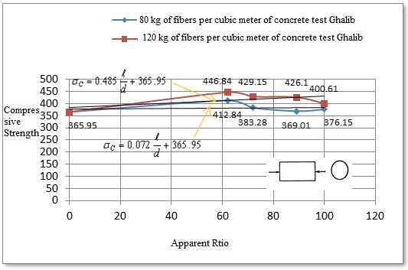
Figure 1: Compressive strength of concrete fibers with$φ\text{152}×\text{305}\text{mm}$
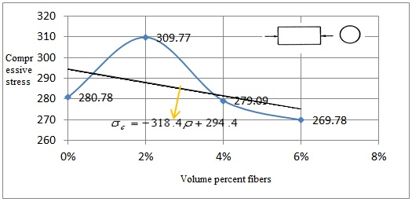
Figure 2: Compressive strength of concrete fibers with $φ\text{152}×\text{305}\text{mm}$
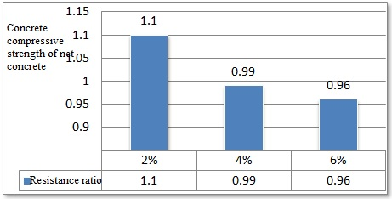
Figure 3: Proportion of fiber concrete compressive strength to net concrete

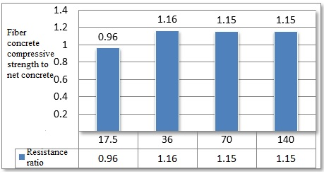
Figure 4: Proportion of fiber concrete compressive strength to net concrete

Conclusion:
If a very small percentage of steel fibers in concrete are used, the effect of fiber on the current level or the strength of fibrous concrete cracks will be too small. The results of the test Compressive is evident, concrete strength fibers are the fibers are not only improved, but in some cases a decrease in resistance as well. Although some sources of fiber concrete compressive strength parallel to the increase in the percentage of fibers increase, but according to the results of experiments performed with a plethora of fibers, fiber concrete compressive strength may be associated with increased or decreased resistance, so it is not possible to make a certain percentage of fiber volume per what percentage of steel fiber commented that, what percentage increase in resistance and each resistance will arise. The only effect of steel fibers in concrete compressive fiber samples, it can be a relative increase in resistance to cracking. On the role of steel fibers in concrete strength and the results of the research findings is probably the best use of steel fibers in Compressive levels must be avoided due to the reduction in compressive strength as accidental necessity of the application, unless a specific purpose, such as the use of steel fibers resistant parts used in wall ovens, etc. should be considered.

References:
1-http://www.sakhtemoon.com:80/Handlers/HGetArticle/441.ashx.
2- ACI 544.1R-96, State-of-the-art report on fiber rein-forced concrete, Farmington Hills, Michigan: American Concrete,Institute, 1996.
3- Behaviour of fiber reinforced concrete with steel fibers, Mohammad Taghi Zadeh National Conference of structures, roads, Architecture, 2011.
4- Modern Concrete Technology Series, Arnon Bentur, Department of Civil Engineering University of British Columbia, Canada.
5- Introducing the powerful properties of concrete ductile fibers, Fourth National Conference on Civil Engineering, R. Ahmadi and Mehdi Sharifi, 2008.
6-http://fa.wikipedia.org/wiki.
7- http://www.fabirco.com.
8- http://amir-pic.persianblog.ir.
9-http://www.brighthubengineering.com/.
10- Natural Fiber Reinforced Concrete,Ben Davis CEE8813,Dr. Kurtis4/2/2007.
11- http://www.civilengineeringgroup.com.
12- Permeability of Cracked Steel Fiber–Reinforced Concrete,Julie Rapoport,1 Corina–Maria Aldea,2 Surendra P. Shah,1 Bruce Ankenman,3 and Alan F. Karr4.
13-http://www.forta-ferro.com/.
14- Keyvani, Abdullah. The principles and technology of steel fiber reinforced concrete. Tehran: Rudaki, 1990.
15-HAREX-stahlfasertechnik Information GmbH & Co. KG 1986.
16- http://www.sakhtbetongharb.com.
17- Khalou, A., "Behavior of concrete and fiber applications", Proceedings of First Conference on Concrete Technology Fiber, Sharif University of Technology, Iran, 1999.
18-http://www.qrsteelfiber.com/index.htm.
19-http://www.indiamart.com.
20-www.bikudo.com.
21-infobuilding@bekaert.com.
22- Evaluation of steel fiber reinforced concrete, Behdad Aghili M. Moghadam, Eleventh International Conference on Civil Engineering Students, 2004.
23- Introduction to Composite Materials,Structural Composite Materials Copyright © 2010, ASM International®,F.C. Campbell All rights reserved.www.asminternational.org.
24- Performance of Hybrid Fiber Reinforced Concrete with Steel Fibers and Polypropylene Fibers, Pu Wang; Zhen Huang; Jing Jiang; Yongjun Wu, International Conference On Civil Engineering And Urban Planning 2012 Yantai, China.
25- Effect of inclination angle on fiber rupture load in fiber reinforced cementitious composites, Jun Zhanga,* Victor C. Lib, Ann Arbor, MI 48109, USA. 2001.
26- http://www.omran-mb.com.
27- Darwish et al,(2008),"Influence of fiber ratio in the size effect", Proceedings.Int Conference Concrete: Constructions sustainable option,Dundee.UK, PP 123-130.
28- Mehta, P.k,(1986), "Concrete:structure,properties, and materials", prentice-hall inc.,Englewood cliffs, New Jersey
29- http://tebyan-zn.ir
30- Antoine, E.N.,(1985),"Fiber reinforced for concrete", Concrete international,March 1985,PP 21-25
31- Beddar, M, (2008), "Development of steel fiber reinforced concrete from antiquity until the present day", Proceedings. Int Conference Concrete: Constructions sustainable option, Dundee, UK.
32- Quresh L A et al, (2008),"Effect of mixing steel fibers and silica fume on properties of high strength concrete", Proceedings.Int Conference Concrete: Constructions sustainable option, Dundee.UK, PP 173-185
33- Hadi M et al, (2008),"An investigation of steel and polypropylene fiber reinforced concrete slabs", Proceedings.Int Conference Concrete Constructions sustainable option,Dundee.UK, PP 233-244.
34- Investigate the distribution and orientation of fibers in steel fiber reinforced concrete, Amir Moghadam, H. holiness, Fatollah Mahmoodzadeh, Muhammad Shekarchizadeh, College of Engineering, Volume 39, Number 3, September 2005, pages 311 to 318.
35- Experimental Investigation of the tensile strength of concrete with steel fibers, whether duty N. and A. Manaf Ali, the Fifth National Congress on Civil Engineering, 4 to 16 May 2010, Ferdowsi University of Mashhad, Mashhad, Iran.
36- Experimental Study on Strength of Concrete by Using, Sandesh D. Deshmukh, Pravin V.Domke, Satish D. Kene, R.S.Deotale/ International Journal of Engineering Research and Applications (IJERA) ISSN: 2248-9622 www.ijera.com Vol. 1, Issue 3, pp.571-581.

3/10/2014

