Evaluation and assessment of job stresses and its relation with employees’ performance in not-for-profit organizations working in rural settings of Northern Pakistan.

Razia Bano¹, Tika Khan¹*

¹Integrated Mountain Area Research Centre, Karakorum International University Pakistan.
*Corresponding author: Tika Khan, tika.khan@kiu.edu.pk

Abstract: Stress plays a critical role in performance of employees of any organization and therefore, organizational standing rests with the overall effective delivery of its employees. Study was aimed at investigation of stress caused by organizational culture and policies on job performance of employees working in nongovernmental organizations across mountainous region of Gilgit-Baltistan. Hypothesis so framed shows the relationship between existing stress level and performance of employees. Using stratified random sampling techniques, organizations, their locale (geography) and management’s tiers were tested using a structured instrument. Results reveal that performance level of employees is indirectly proportional to the stress level.
[Bano R, Khan T. Evaluation and assessment of job stresses and its relation with employees’ performance in not-for-profit organizations working in rural settings of Northern Pakistan. World Rural Observ 2014;6(3):91-95]. ISSN: 1944-6543 (Print); ISSN: 1944-6551 (Online). http://www.sciencepub.net/rural. 13

Keywords: NGOs, Stress, Job performance, Gilgit-Baltistan, Civil society, policies, Gender

- Introduction
According to Ivencevich and Matteson (1987), stress is "the interaction of the individual with the environment”, but then they go on to give a more detailed working definition, as follows: "an adaptive response, mediated by individual differences and/or psychological process, that is consequences of any external (environmental) action, situation, or event that places excessive psychological and/or physical demands upon a person". Job stress can be defined as "a condition arising from the interaction of people and their jobs and characterized by changes within people that force them to deviate from their normal functioning" (Beehr and Newman, 1978).
National Institute of Occupational Safety and Health view job stress as harmful physical and emotional responses that occurs when the requirement of job do not match the capabilities, resources or needs of the workers (NIOSH, 1999). It is recognized world-wide as a major challenge to individual mental and physical health, and organizational health (ILO, 1986). By some estimates work-related stress costs the national economy a staggering amount in sick pay, lost productivity, health care and litigation costs (Palmer et al. 2004). The concept of job stress is often confused with challenge, but these concepts are not the same.
Challenge energizes us physically and psychological, and it motivates us to learn new skills and master our jobs. When a challenge is met, we feel relaxed and satisfied (Kalia, 2002). Thus, challenge is an important ingredient for health and productive work (Lowe, 2003). The importance of challenge in our work lives is probably what people are referring to when they say, "A little bit stress is good for you" (Chapman et al. 1990). High level of stress may be accompanied by anger, anxiety, depression, nervousness, depression, irritability, tension and boredom (Canetti et al. 2002). Stress is the strongest factor impacting on aggressive action, such as sabotage, interpersonal aggression, hostility and complaints (Chen and Spector, 1992). These types of psychological problems from stress, in turn, are especially relevant to poor job performance, lower self-esteem, resentment of supervision, inability to make decision and job dissatisfaction (Mclean, 1980).
Behavioral unit may be the most helpful in analyzing the effects of job stress. Direct behavior that may accompany high level of stress include under-eating or over eating, sleeplessness, increased smoking and drinking, drug abuse (Charbonneau, 2010). Like the psychological problems resulting from the stress, the behavior problems are often not attributed to stress by coworkers or supervisors and generate little sympathy. But, also like the psychological and physical symptoms of stress, the behavior problems can be controlled, more effectively managed and even prevented by the individual and the organization.
The study provides an appraisal of the stress factors and problems raised due to stress in organization. This study will obviously prove extremely useful to different organizations because they will be enlightened about the stress factors, which affect the level of performance of employees. Thus firstly, the companies will be aware of the existence or absence of the stress and factors in their corporate culture; secondly, the degree of importance, which should be attached with the performance of employees due to stress. The most important revelation of the study is that, which stress factors generally are common and affect the performance of the employees more than others. Whether stress is due to lack of money, recognition, work, over load, benefits etc; in short, it depicts exactly which stress factors affect the job performance. This will be very beneficial to the management of organizations as they may utilize the findings of the study and basically be able to prove the employees with the precise motivation or incentives that will encourage the willingness of work and eliminate stress.

- Material and Methods
  - Study area
Gilgit Baltistan was formerly known as the Northern Areas (APP. 2009). It is the northernmost territory of Pakistan (Weightman 2005). It borders Azad Kashmir to the south, the province of Khyber Pakhtunkhwa to the west, the Wakhan Corridor of Afghanistan to the north, the Xinjiang autonomous region of China to the east and northeast and Jammu and Kashmir to the southeast and covers an area of 72,496 km² (Wiki, 2014). It is the meeting point of the world's four famous mountain ranges i.e. the Himalayas, the Karakorams, the Hindukush and the Pamirs (PTDC 2014).

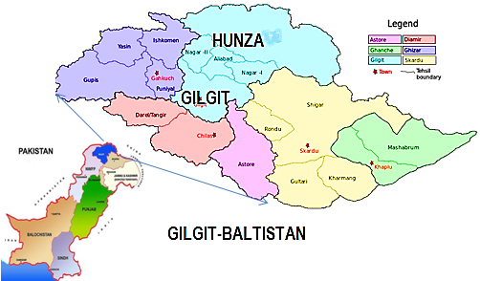

  - Research Objectives:
Study was design to assess stress and its factors affecting employees’ performance level in nongovernmental organizations working in Gilgit-Baltistan. More specifically, this study was aimed at;
- To assess whether employees have enough knowledge of stress and perceptions about stress factors in an organizational culture.
- To determine the stress factors and their mode of impact on job performance.
- To gauge stress and stressors and its influence on employees and organizations performance.

  - Sampling and data collection:
The data for the study was collected through the structured questionnaire. The sample size was forty (n=40) and sampling technique adopted was stratified random sampling with a blend of convenient sampling. 80 questionnaires were distributed out of which 50 were returned however, 40 were apt to opt for research. The data was subjected for computer analysis by using SPSS v. 16.1.

  - Analysis:
Data analysis was carried out using SPSS v. 16.1. The analysis is divided in following stages:
- Test the correlation between the dependant variable and two independent variables.
- Factor analysis
- To test the model
- Descriptive statistics

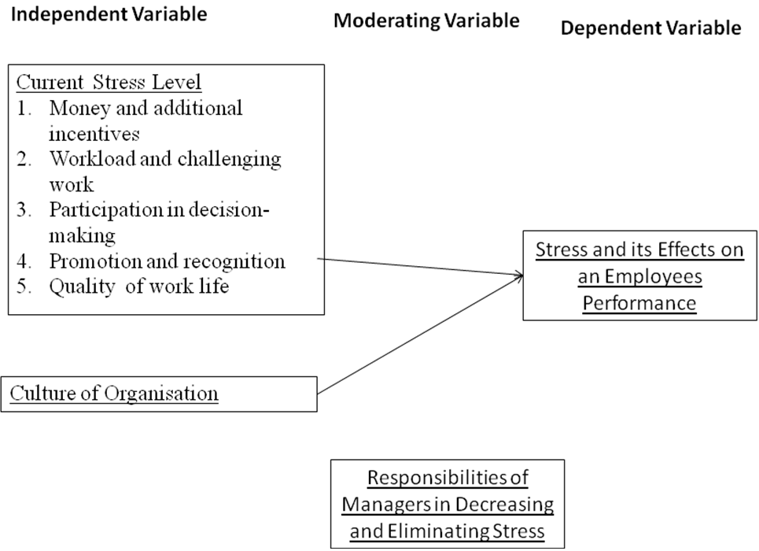

  - Theoretical Framework
The empirical research seeks to find the stress level and how it is affecting the job performance of employees' in an organization. The existence and significance of stress depends on the existing stress level and the presence of strong corporate culture. Thus "Presence of stress" is the dependant variable, which is dependant on the current stress level and the culture of the organization. The perception and views of the employees' in regard to stress is moderating factor that has an impact on this dependant-independent variable relationship. The performance level of employee is indirectly proportional to the stress level. The higher the stress level the lower will be the performance and the lower the stress level the higher the performance of employees.

  - Hypothesis
The following hypotheses are going to be raised in the study:
Ho 1: There is no relationship between the existence of stress level and employees' job performance.
Ho 2: There is no relationship between a strong or weak corporate culture and the level of stress among the employees.

- Results and Analysis:
  - Correlation
The correlation between culture and performances is .94 and correlation between stress and performance is .88. This indicates a strong correlation between cultures of the organization upon the employees' performance. However, the stress level has also has a strong correlation but it is less than the other independent variables (table 1).

Table 1: Table shows correlation and its level of significance across parameters
Correlations
 |  | Performance | Culture | Stress
Pearson Correlation | Performance | 1.000 | .948 | .883
Pearson Correlation | Culture | .948 | 1.000 | .687
Pearson Correlation | Stress | .883 | .687 | 1.000
Sig. (1-tailed) | Performance | . | .000 | .000
Sig. (1-tailed) | Culture | .000 | . | .000
Sig. (1-tailed) | Stress | .000 | .000 | .
N | Performance | 40 | 40 | 40
N | Culture | 40 | 40 | 40
N | Stress | 40 | 40 | 40

  - The Model of ANOVA

Table 2: shows regression analysis
ANOVA^{b}
Model |  | Sum of Squares | Df | Mean Square | F | Sig.
1 | Regression | 11.955 | 2 | 5.978 | . | .000ª
1 | Residual | .000 | 37 | .000
1 | Total | 11.955 | 39
a. Predictors: (Constant), Stress, Culture
b. Dependent Variable: Performance
From the table given above, it is evident that p-value is less than ∞. The table rejects the Ho and concludes that the model is fit for prediction.

  - The Reliability Analysis:
The reliability analysis is showing a strong internal consistency among the questions asked in the questionnaire that is the value (Cronbach's Alpha) .89.

  - Descriptive Statistics:
Majority of the people while tapping the independent variable seemed to have been giving highest importance to money. Whereas, participation in decision making, promotion and recognition, quality of work life and challenging work were the priorities respectively.

- Discussions and Conclusion
The research reveals that the culture in an organization is comparatively more influencing. Employees on their priority want to have the culture to be enabling and conducive. However, when the question regarding workload was asked, which is the dimension of stress level; majority (more than 60%) either disagreed or strongly disagreed workload to be a cause of stress. 68% respondents did not seem to be satisfied with their salaries. As the attached appendix show that a considerable No. of employees are working for monetary reasons. Promotion and recognition have also shown a contributed factor in stress level.
However, the participation in decision making improves the work life as employees feel a sense of ownership. However, the pressure of work and the challenges of the work is the reason of high stress level. In short, the culture of the organization is mutually given highest importance over other factors in an organization.

- Recommendations
On the basis of this limited research it is suggested that the most direct ways to increase job performance in NGOs of Gilgit-Baltistan would be by several reasons. Administrators' efforts, the manager's role and leadership style appeared to be most important in enhancing employee’s job performance. Since NGOs are consisted of small groups, and enough workload has to be faced by employees but all this could be rationalized through strong organizational culture.

References
- APP. 2009. Associated Press of Pakistan. Cabinet approves ‘Gilgit-Baltistan Empowerment and Self-Governance Order 2009 on 29 August 2009.
- Beehr T.A. and Newman.J.E. (1978), job stress, Employee Health and organizational effectiveness, Winter, pp.5-18.
- Canetti, L., Bachar, E., & Berry, E. M. (2002). Food and emotion. Behavioural processes, 60(2), 157-164.
- Chapman, A., Mandryk, J. A., Frommer, M. S., Edye, B. V., & Ferguson, D. A. (1990). Chronic perceived work stress and blood pressure among Australian government employees. Scandinavian journal of work, environment & health, 258-269.
- Charbonneau, A. (2010). Stress, Mood, Eating, and Craving (Doctoral dissertation, Carleton University).
- ILO. 1986. International Labour Organization. Retrieved from www.ilo.org/public/english/bureau/leg/amend/faq1986.htm on September 8, 2014.
- Invancevich, J. y Matterson, M. (1987): “Mental technologists and laboratory technicians: sources of stress and coping strategies”, Stress in health professionals. Chinchester, Ed. J.Wiley and Sons.
- Kalia, M. (2002). Assessing the economic impact of stress [mdash] The modern day hidden epidemic. Metabolism, 51(6), 49-53.
- Lowe, G. S. (2003). Healthy workplaces and productivity: a discussion paper. Minister of Public Works and Government Services Canada.
- NIOSH, 1999. National Institute of Occupational Safety and Health-1999. Retrieved from wwwn.cdc.gov/pubs/niosh.aspx on September 8, 2014.
- Palmer M, Babko-Malaya O, Dang HT. 2004. Different Sense Granularities for Different Applications, 2nd Workshop on Scalable Natural Language Understanding.
- PTDC 2014. Pakistan Tourism Development Corporation. Retrieved from http://www.tourism.gov.pk/northern_areas.html on September 8, 2014.
- Weightman, Barbara A. 2005. Dragons and Tigers: A Geography of South, East, and Southeast Asia (2nd ed.). John Wiley & Sons. p. 193. ISBN 978-0-471-63084-5.
- Wiki 2014. Wikipedia. Gilgit–Baltistan. Retrieved from http://en.wikipedia.org/wiki/Gilgit%E2%80%93Baltistan on September 8, 2014.

9/20/2014

